**FaceGym – Web-Based Gym System with Face Recognition**

Name: Yong Chun Yee

Coventry Student ID: 9658886

Supervisor Name: Mr. Light Lau

Bachelor of Science (Hons) in Computing, 3+0 in Collaboration with Coventry University

School of Engineering and Technology, INTI

International College Penang

5th November 2021

**303COM Declaration of Originality**

I declare that this project is all my own work and has not been copied in part or in whole from any other source except where duly acknowledged. As such, all use of previously published work (from books, journals, magazines, internet etc.) has been acknowledged by citation within the main report to an item in the References or Bibliography lists. I also agree that an electronic copy of this project may be stored and used for the purposes of plagiarism prevention and detection.

**Statement of copyright**

I acknowledge that the copyright of this project report, and any product developed as part of the project, belong to Coventry University. Support, including funding, is available to commercialise products and services developed by staff and students. Any revenue that is generated is split with the inventor/s of the product or service. For further information please see www.coventry.ac.uk/ipr or contact ipr@coventry.ac.uk.

**Statement of ethical engagement**

I declare that a proposal for this project has been submitted to the Coventry University ethics monitoring website (https://ethics.coventry.ac.uk/) and that the application number is listed below (Note: Projects without an ethical application number will be rejected for marking)

Signed:  Date: 5th November 2021

Please complete all fields.

|  |  |
| --- | --- |
| First Name: | Chun Yee |
| Last Name: | Yong |
| Student ID number | 9658886 |
| Supervisor Name | Mr. Light Lau |

This form must be completed, scanned and included with your project submission to Turnitin. Failure to append these declarations may result in your project being rejected for marking.

# Acknowledgement

The success of this project required a lot of the assistance from many people around me and also from through online tutorial. I would like to express my appreciation to them throughout the whole project.

First of all, I would like to express my appreciation to my supervisors – Miss Kavitha and Mr. Light Lau. Miss Kavitha had helped me through the first phase of my project which is defining and researching for the project. Miss Kavitha will provide valuable feedback and guidance during the meetings. Mr. Light Lau had also provided me a lot of guides for the development phase and the concept of writing the report during every week meetings.

Besides that, I would like to express my appreciation to my lecturer of the project – Miss Usha Jayahkudy. Miss Usha assisted us in the content of the reports and the format to write the reports through the two semesters. She will answer every questions we asked patiently.

Moreover, I would like to express my appreciation to my friends who provided me a lot of guidance during the development phase to let me understand that the logic problem in the development.

Lastly, I would like to express my appreciation to my family throughout my degree’s life. The supporting of them really helps me a lot.

# Abstract

In the traditional method of the gym center, the members need to clock in and clock out by writing their attendance on the paper of recording the data of clock in and clock out. The members also need to pay for their membership fees in front of the counter in the gym center on the spot with cash. The members cannot know the availability of the slots in the gym center, it will waste their time waiting in the gym center. To solve the problems, the web-based gym system with face recognition will be implemented in this project. The system can let the members clock in and clock out through face recognition with the minimum touching due to the Covid-19. Besides that, the system can let the members pay their membership fees online easily without needing on the spot of the gym center, the members can know the currently available slots in the gym center from their house to save their time. The gym system named FaceGym has been successfully developed as a website after the researches and plans to let the users experience the features provided by the gym center on the website. The users can log in to check for the facilities, classes, real-time data, join the membership, top-up, and others. On the side of admin, the admin can login to check to total members joined, payment status, view the comments easily through the dashboard. The admin can let the members clock in and clock out with face recognition. The testing is also tested successfully and completed for the features developed.

Table of Figures

Figure 1.7.1 Waterfall Model 6

Figure 1.7.2 Phases conducted in the project with Waterfall Model 8

Figure 2.1.1 Logo of Windy City Fitness 9

Figure 2.1.2 Homepage of Windy City Fitness 10

Figure 2.1.3 About Us on Homepage 11

Figure 2.1.4 Classes on Homepage 11

Figure 2.1.5 Motivational Story on Homepage 12

Figure 2.1.6 Contact on Homepage 12

Figure 2.1.7 Booking Page 13

Figure 2.1.8 Detail Page of the booking 14

Figure 2.1.9 Booking Date Page 14

Figure 2.1.10 Membership Plans Page 15

Figure 2.1.11 Payment Page of the membership plan 16

Figure 2.1.12 View staff page 17

Figure 2.1.13 View Gallery Page 18

Figure 2.1.14 Testimonials Page 19

Figure 2.1.15 Facebook page of the gym 19

Figure 2.1.16 Sign Up Page 20

Figure 2.1.17 Login Page 20

Figure 2.1.18 My Bookings Page 21

Figure 2.1.19 My Wallet Page 21

Figure 2.1.20 My Account Page 22

Figure 2.2.1 Icon of CHI-Fitness 23

Figure 2.2.2 Homepage of CHI-Fitness 24

Figure 2.2.3 Clubs of the gym on the homepage 24

Figure 2.2.4 Mission and Value of the gym on the homepage 25

Figure 2.2.5 Dropdown menu of the clubs 26

Figure 2.2.6 CHI-Fitness Page 27

Figure 2.2.7 CHI-X Page 28

Figure 2.2.8 Facilities Page 29

Figure 2.2.9 PT Testimonial Page 31

Figure 2.2.10 Location Page 32

Figure 2.2.11 Classes Page 33

Figure 2.2.12 Timetable Page 34

Figure 2.2.13 Individual Membership Page 36

Figure 2.2.14 Corporate Membership Page 37

Figure 2.2.15 CHI Privilege Page 37

Figure 2.2.16 Virtual PT Page 38

Figure 2.2.17 Free Trial Page 39

Figure 2.2.18 Recipe Page 40

Figure 2.2.19 BMI Calculator Page 41

Figure 2.2.20 Enquiries Page 41

Figure 2.2.21 Sign Up Page 42

Figure 2.2.22 Login Page 43

Figure 2.3.1 Logo of Orient Fitness 44

Figure 2.3.2 Homepage of Orient Fitness 44

Figure 2.3.3 Briefly explanation about the gym on the homepage 45

Figure 2.3.4 Trainers and classes on Homepage 46

Figure 2.3.5 Show location on the homepage 47

Figure 2.3.6 About Us Page 48

Figure 2.3.7 Detail of the trainers on about us page 49

Figure 2.3.8 Classes Page 51

Figure 2.3.9 Pricing & Promo Page 52

Figure 2.3.10 Gallery Page 53

Figure 2.3.11 Dropdown list of contact us 54

Figure 2.3.12 Contact Us Page 54

Figure 2.3.13 Fill in contact information on the contact page 55

Figure 2.5.1 Basic face recognition building blocks 66

Figure 2.5.2 Bounding boxes found by the face detector 66

Figure 2.5.3 Types of Haar-like features 68

Figure 2.5.4 Calculation of haar value 69

Figure 2.5.5 Calculation in Integral Image 70

Figure 2.5.6 The flow of the eigenfaces algorithm 72

Figure 2.5.7 Face recognition using Fisherfaces algorithm 74

Figure 2.5.8 The process of Local Binary Pattern (LBP) 76

Figure 2.5.9 Mathematical formulation of LBP operator 76

Figure 2.5.10 Calculation of total histograms 77

Figure 2.6.1 Logo of PyCharm Community Edition 78

Figure 2.6.2 Logo of Flask 79

Figure 2.6.3 Logo of OpenCV 80

Figure 2.6.4 Logo of phpMyAdmin 81

Figure 3.1.1 RBS Diagrams of user and admin 87

Figure 3.1.2 Gantt Chart of the project 89

Figure 3.1.3 Development Requirement 90

Figure 3.1.4 Use Case Diagram for register and login module 92

Figure 3.1.5 Use Case Diagram for user homepage 93

Figure 3.1.6 Use Case Diagram for user facilities 94

Figure 3.1.7 Use Case Diagram for user real time 95

Figure 3.1.8 Use Case Diagram for user classes 96

Figure 3.1.9 Use Case Diagram for user memberships 97

Figure 3.1.10 Use Case Diagram for user payment 98

Figure 3.1.11 Use Case Diagram for user about-us 99

Figure 3.1.12 Use Case Diagram for user top up 100

Figure 3.1.13 Use Case Diagram for user profile 101

Figure 3.1.14 Use Case Diagram for the admin login 102

Figure 3.1.15 Use Case Diagram for the admin homepage 103

Figure 3.1.16 Use Case Diagram for the member clock in and clock out 104

Figure 3.1.17 Use Case Diagram for the admin dashboard 105

Figure 3.1.18 Use Case Diagram for the admin comment 106

Figure 3.1.19 Use Case Diagram for the admin view members 107

Figure 3.1.20 Use Case Diagram for the admin payment status 108

Figure 3.1.21 Activity Diagram of user sign up 109

Figure 3.1.22 Activity Diagram of user login 110

Figure 3.1.23 Activity Diagram of member clock in 111

Figure 3.1.24 Activity Diagram of member clock out 112

Figure 3.1.25 Activity Diagram of user checkout 113

Figure 3.1.26 Activity Diagram of admin dashboard 114

Figure 3.1.27 Activity Diagram of admin view member status 115

Figure 3.1.28 Activity Diagram of admin view payment status 116

Figure 3.1.29 Entity Relationship Diagram (ERD) 120

Figure 3.1.30 Table of the registered users in the gym 122

Figure 3.1.31 Database configuration in the PyCharm 123

Figure 3.1.32 Code snippet of method “userRegistration” for user registration 124

Figure 3.1.33 Code snippet of method “userLogin” for user login 126

Figure 3.1.34 Code snippet of method “userLogout” for user logout 127

Figure 3.1.35 Code Snippet of forget password function 128

Figure 3.1.36 Email of users inserted in the webpage 128

Figure 3.1.37 Output of token inserted into database 129

Figure 3.1.38 Code Snippet of the reset password function 130

Figure 3.1.39 User inserting the new password in the reset webpage 131

Figure 3.1.40 Output of the password reset successfully 132

Figure 3.1.41 Code Snippet of method “adminLogin: for admin login 133

Figure 3.1.42 Libraries installed in the PyCharm 135

Figure 3.1.43 Code snippet of storing and retrieving the face images 136

Figure 3.1.44 Output of the myList after converted 136

Figure 3.1.45 Code snippet of load images from path file 137

Figure 3.1.46 Output of the data in the classNames 137

Figure 3.1.47 Code snippet of encoding the images in path 138

Figure 3.1.48 Output of one of the encoded face image 139

Figure 3.1.49 Code Snippet of video capture 140

Figure 3.1.50 Code Snippet of image frame 140

Figure 3.1.51 Code Snippet of detecting face and encoding face in webcam 141

Figure 3.1.52 Output of face location and encoded face in webcam 141

Figure 3.1.53 Code Snippet of comparing the encoded faces 142

Figure 3.1.54 : Output of the matches and the face distance 143

Figure 3.1.55 Code snippet of showing the recognized faces in the webcam 144

Figure 3.1.56 Code Snippet of showing webcam on webpage 144

Figure 3.1.57 Output of the face showing in the webcam 145

Figure 3.1.58 Code snippet of storing the clock in name and time 146

Figure 3.1.59 Output of name and time in Attendance.csv 147

Figure 3.1.60 Code snippet of removing the name and time in the ClockOut.csv 147

Figure 3.1.61 Output of ClockOut.csv 147

Figure 3.1.62 Code snippet of storing the clock out name and time 148

Figure 3.1.63 Code snippet of removing the name and time in the Attendance.csv 148

Figure 3.1.64 Code snippet of function performing face recognition in clock out 149

Figure 3.1.65 Code Snippet of the real-time function 153

Figure 3.1.66 Output of the real-time function 154

Figure 3.1.67 Interface of the user real time webpage 155

Figure 3.1.68 Code snippet of membership package checkout with card method function 158

Figure 3.1.69 Code snippet of storing the front face image of the member 159

Figure 3.1.70 Code snippet of the path storing the image file 159

Figure 3.1.71 Code snippet of storing the data into the database 160

Figure 3.1.72 Output of image stored into the path 160

Figure 3.1.73 Output of the retrieved data 161

Figure 3.1.74 Table of member_joined in the database 161

Figure 3.1.75 Table of payment_status in the database 162

Figure 3.1.76 Code snippet of membership package checkout with wallet method function 162

Figure 3.1.77 Code snippet of deducting the money in the wallet 163

Figure 3.1.78 Code snippet storing data into the database 163

Figure 3.1.79 Output of the wallet deducted 164

Figure 3.1.80 Table of users in the database 164

Figure 3.1.81 Tables of members_joined and payment_status in the database 165

Figure 3.1.82 Code snippet of user top up function 166

Figure 3.1.83 Output of the top up function 167

Figure 3.1.84 Users table in the database 167

Figure 3.1.85 Interface of the user top up webpage 168

Figure 3.1.86 User Interface design of user register webpage 169

Figure 3.1.87 Code snippet of error checking 170

Figure 3.1.88 Code snippet of interface design of the user sign-up page 171

Figure 3.1.89 User Interface design of user register webpage 172

Figure 3.1.90 Code snippet of error checking in user login 173

Figure 3.1.91 Code snippet of the user had logged in 173

Figure 3.1.92 Code snippet of interface design of the user login page 174

Figure 3.1.93 Interface of the admin login interface 175

Figure 3.1.94 User Interface design of user membership packages webpage 176

Figure 3.1.95 Code snippet of one package in membership package interface 177

Figure 3.1.96 User Interface design of user checkout with card method webpage 178

Figure 3.1.97 User Interface design of user checkout with wallet method webpage 179

Figure 3.1.98 Code Snippet of tabs user checkout with card method interface 180

Figure 3.1.99 Code snippet of form in the user checkout with card method interface 180

Figure 3.1.100 Code snippet of showing the cart information in the user checkout with card method interface 181

Figure 3.1.101 Code snippet of the user checkout with wallet method interface 182

Figure 3.1.102 Interface of the user homepage 185

Figure 3.1.103 Side navigation bar of the user homepage interface 186

Figure 3.1.104 Code snippet of the interface user homepage 187

Figure 3.1.105 Code snippet of flash messages 187

Figure 3.1.106 Code snippet of navigation bar 188

Figure 3.1.107 Code snippet of the home section in user homepage interface 189

Figure 3.1.108 Code snippet of the style.css file 189

Figure 3.1.109 Code snippet of JavaScript function of the dropdown button 190

Figure 3.1.110 Code snippet of the about section on the user homepage interface 191

Figure 3.1.111 Code snippet of the start section on the user homepage interface 192

Figure 3.1.112 Code snippet of the gallery section on the user homepage interface 192

Figure 3.1.113 Code snippet of the contact section on the user homepage interface 194

Figure 3.1.114 Interface of the admin homepage 195

Figure 3.1.115 Side navigation bar of the admin homepage 196

Figure 3.1.116 Code snippet of the admin homepage interface 196

Figure 3.1.117 Code snippet of the real time clock function in JavaScript 198

Figure 3.1.118 Code snippet of the interfaces routing 199

Figure 3.1.119 Interface of the user facilities webpage 200

Figure 3.1.120 Interface of the user classes webpage 201

Figure 3.1.121 Interface of the user about us webpage 202

Figure 3.1.122 Code snippet of the profile interface routing 203

Figure 3.1.123 Interface of the user profile webpage 204

Figure 3.1.124 Code snippet of the user profile interface 205

Figure 3.1.125 Code snippet of the routing admin dashboard 207

Figure 3.1.126 Interface of the admin dashboard interface 208

Figure 3.1.127 Code snippet of the routing the interfaces 209

Figure 3.1.128 Code snippet of the generating the reports 213

Figure 3.1.129 Interface of the admin view members webpage 214

Figure 3.1.130 Interface of the admin view payment status webpage 214

Figure 3.1.131 Interface of the admin view comments webpage 215

Figure 3.1.132 Interface of generated comments PDF file 215

Figure 3.1.133 Interface of generated members status PDF file 216

Figure 3.1.134 Interface of generated payment status PDF file 216

Figure 4.1.1 5 image faces to test 218

Figure 4.1.2 Comparison of calculated face distance of the encoded webcam face image 218

Figure 4.1.3 Face of the person recognized with 5 images testing with showing the name 219

Figure 4.1.4 15 image faces to test 220

Figure 4.1.5 Comparison of calculated face distance of the encoded webcam face image 220

Figure 4.1.6 Face of the person recognized with 15 images testing with showing the name 221

Figure 4.1.7 30 image faces to test 222

Figure 4.1.8 Comparison of calculated face distance of the encoded webcam face image 223

Figure 4.1.9 Face of the person recognized with 30 images testing with showing the name 224

Figure 4.2.1 Code snippet of inputs and output of successful unit testing 225

Figure 4.2.2 Code snippet of inputs and output of unsuccessful unit testing 226

Figure 4.3.1 Interface of the user homepage 236

Figure 4.3.2 Interface of the second section of user homepage 237

Figure 4.3.3 Interface of the third section of user homepage 237

Figure 4.3.4 Interface of the fourth section of user homepage 238

Figure 4.3.5 Interface of the footer section of user homepage 239

Figure 4.3.6 Interface of the user login webpage when the user sending messages unsuccessfully 239

Figure 4.3.7 Interface of the user homepage when the user sending messages successfully 240

Figure 4.3.8 Interface of the user sign up webpage 241

Figure 4.3.9 Interface of inserting existing email address 241

Figure 4.3.10 Interface of showing error when the email existed 242

Figure 4.3.11 Interface of the inserting not matching passwords 242

Figure 4.3.12 Interface of showing error when the password not matched 243

Figure 4.3.13 Interface of showing sign up successfully on user homepage 243

Figure 4.3.14 Interface of the user login webpage 244

Figure 4.3.15 Interface of showing error when the password incorrect 244

Figure 4.3.16 Interface of not inserting in the user login form 245

Figure 4.3.17 Interface of showing error message when no information inserted 245

Figure 4.3.18 Interface of showing login successfully on user homepage 246

Figure 4.3.19 Interface of showing logout successfully on user homepage 246

Figure 4.3.20 Interface of user profile webpage 247

Figure 4.3.21 Interface of user login webpage 247

Figure 4.3.22 Interface of top up webpage 248

Figure 4.3.23 Interface of inserting negative top up amount 248

Figure 4.3.24 Interface of showing error message when negative amount inserted 249

Figure 4.3.25 Interface of showing error when the password incorrect on top up webpage 249

Figure 4.3.26 Interface of showing top up successfully on user homepage 250

Figure 4.3.27 Interface of user profile webpage 250

Figure 4.3.28 Interface of user profile webpage 251

Figure 4.3.29 Interface of user checkout with card webpage 251

Figure 4.3.30 Interface of user checkout with wallet webpage 252

Figure 4.3.31 Interface of user login webpage 252

Figure 4.3.32 Interfaces of the showing error messages 254

Figure 4.3.33 Interface of filling the new member information 255

Figure 4.3.34 Interface of membership checkout successfully 255

Figure 4.3.35 Interface of user real time webpage 256

Figure 4.3.36 Interface of performing clock in 256

Figure 4.3.37 Interface of user real time webpage 257

Figure 4.3.38 Interface of the admin login webpage 258

Figure 4.3.39 Interface of showing error when the password incorrect 258

Figure 4.3.40 Interface of showing error when the not filling credential 259

Figure 4.3.41 Interface of showing login successfully on admin homepage 259

Figure 4.3.42 Interface of admin login webpage after logout 260

Figure 4.3.43 Interface of the admin homepage 261

Figure 4.3.44 Interface of the admin login webpage 261

Figure 4.3.45 Interface of the admin dashboard 262

Figure 4.3.46 Interface of the admin other interfaces 264

**Table of Table**

Table 1 Comparison between Windy City Fitness, CHI-Fitness, and Orient Fitness 58

Table 2 Priority Level (User Interface) 87

Table 3 Priority Level (Admin Interface) 87

Table 4 Unit Testing in user login module 227

Table 5 Unit Testing in user sign up module 227

Table 6 Unit Testing in user homepage module 228

Table 7 Unit Testing in user facilities module 228

Table 8 Unit Testing in user classes module 229

Table 9 Unit Testing in user about us module 229

Table 10 Unit Testing in user membership module 230

Table 11 Unit Testing in user checkout with card module 230

Table 12 Unit Testing in user checkout with wallet module 231

Table 13 Unit Testing in user profile 232

Table 14 Unit Testing in user top up 233

Table 15 Unit Testing in admin homepage module 233

Table 16 Unit Testing in admin dashboard module 234

Table 17 Unit Testing in admin view members module 234

Table 18 Unit Testing in admin view payment status module 234

Table 19 Unit Testing in admin view comments module 235

Table 20 Unit Testing in admin login module 235

**Contents**

1 Introduction 1

1.1 Problem Statement 2

1.2 Detailed Research Questions 3

1.3 Research Objectives 4

1.4 Keywords 4

1.5 Project Title 4

1.6 Client, Audience and Motivation 5

1.7 Primary Research Plan 6

2 Literature Review 9

2.1 Windy City Fitness 9

2.2 CHI-Fitness 23

2.3 Orient Fitness 44

2.4 Critical Analysis of Windy City Fitness, CHI-Fitness, and Orient Fitness 56

2.5 Facial Recognition 61

2.5.1 Introduction to Facial Recognition 61

2.5.2 Application of Face Recognition 63

2.5.3 Operation of the face recognition 66

2.5.4 Algorithms of face detection and face recognition 68

2.6 Project Development Tools 78

3 Research Methodology 82

3.1 Methodology 82

3.1.1 Requirement Analysis 82

3.1.2 System Design 91

3.1.3 System Implementation 121

4 Testing 217

4.1 Face Recognition Testing 218

4.2 Unit Testing 225

4.3 GUI Testing 236

4.3.1 User Homepage 236

4.3.2 User Sign Up 241

4.3.3 User Login 244

4.3.4 User Profile 247

4.3.5 User Top Up 248

4.3.6 User Membership & Checkout 251

4.3.7 User Realtime 256

4.3.8 Admin Login 258

4.3.9 Admin Logout 260

4.3.10 Admin Homepage 261

4.3.11 Admin Dashboard 262

4.3.12 Admin other interfaces 263

5 Discussion 265

5.1 Achievement 265

5.2 Limitation 267

5.3 Future Enhancement 268

6 Reflection 269

6.1 Strength in development 269

6.2 Issues countered and solution 269

6.3 Weakness and self-improvement 270

7 Conclusion 271

Appendix **Error! Bookmark not defined.**

References 271

# 

# Introduction

In this technology era, everyone in this world can do a lot of things through the Internet. The Internet makes it possible to let people quickly find information, communicate with people around the world, manage the business efficiently, and others (gcfglobal, 2021). Some companies are using the traditional method to manage their systems, manual systems may cause some problems such as large ongoing staff training costs, lack of security, time-consuming to produce reports, and others. Some gyms are using the traditional method to manage their whole system such as the gym will need staff in front of the registration counter to monitor the member’s clock in and clock out, registering the new member with paperwork, generate the report of the business with paperwork and others. It may cause the loss of the paper due to human error.

The proposed system consists of a web-based gym system for the members, employees, and the administration panel for the gym center. The web-based system is aimed to automate the management of the gym instead of the paper-based method. By using this system, the members and employees can clock in and clock out in the gym through a biometric identification feature which is more secure. The members also can check for the current availability slot of the gym room at their house and pay their member fees online through the system. The admin can generate the sales reports and the member reports easily through the system to know the sales of the business at the current month and track the member fees outstanding by the members. The system can also reduce the cost and time to hire the employee in the registration center because all can be done by the system automatically.

## Problem Statement

Nowadays, there are a lot of young people who are falling under stress due to busy working and the hectic work schedule or mismanaged lifestyle (Bell, 2012). The lifestyle will cause them major health-related issues, this issue is growing in the age group of 20 to 40 years old. The reason that may lead to the stress of the hectic lifestyle is lack of physical fitness to release their anxiety. However, there is no doubt that people are realized that a healthy lifestyle is very important for themselves to curb the side-effects that come with a hectic urban lifestyle. They will seek ways to maintain their healthy body such as eating healthy food and going to the gym center. Physical fitness is needed to promote strong muscles and bones to ensure having a healthy body. An exercise can benefit respiratory, cardiovascular health, and overall health, it may help to prevent a heart attack and stroke (Myers, 2003). In addition, a regular workout will help to reduce stress, depression, anxiety, and others (Jackson, 2013).In this case, the rise of health issues derives the demand of people toward to the gym center.

When people want to enter the gym center to use its equipment to have their workout, they need to register as a member to join the gym. In the traditional method, things are done mostly physically and personally. There is some gym are managing their system manually, they register the information of the new members through paperwork, they record the date that the members paid for their monthly fees and search for their records manually. It may increase the cost and burden of paperwork or employees, and the risk of disappearing off the member’s record because of human error (Nkosi, 2020). The manual management system may cause difficulty for the members to get admission in the gym when the slot of the gym room is full because they cannot know about the current slot of the gym room unless they reached the gym center. It will cause them to waste their time waiting for the slot to enter the gym center because of the limited slot due to the disease Covid-19 (Blocken, 2020). Besides that, it may have the risk that the membership card which lets the members clock in and clock out through the gym room lost (Kak, 2018), it will cause the member to pay the penalty fee to recreate a new membership card.

Therefore, there is a web-based gym system with biometric identification and automated member count will be developed to reduce the cost and the times of the members and employees which is better than the traditional method. It may also enhance the revenue of the business because of high satisfaction for the members. The web-based gym system can allow the users to register as members of the gym, pay the monthly fees through the system, book for gym slots, check the availability of the gym, and others. In this web-based system, it uses the AI to detect and recognize the face of the members through the database when they clock in or clock out in the gym center. It is more secure and efficient compared to the method clock in and clock out with the membership card (Kak, 2018) It can also automatically increase or reduce the number of members currently in the gym room to let the members check the availability of the gym room at their house, it will save a lot of time.

## Detailed Research Questions

To implement the situation with a better helper, the research will be conducted based on the following questions in this project:

1. How does the face recognition feature with AI technology can detect and recognize the members or employees when they clock in or clock out in the gym?
2. Does implement the web-based gym system can bring convenience to the members with the automation?
3. How does the web-based gym system can generate revenue for the business?

## Research Objectives

This project will be conducted with the following objectives:

1. To develop a system that able to capture the clock in and out of the member through facial recognition.
2. To develop a system that allows admin to generate reports such as sales reports and member reports.
3. To develop a web-based gym management system that allows the automation of gym management instead of paper-based.

## Keywords

Gym system; Face Recognition; Automation; Image processing; Algorithms

## Project Title

Facegym- Web-based gym system with biometric identification and automated member count

## Client, Audience and Motivation

In this project, the client is the company of the gym center who wished to reduce the cost of paperwork and employees and generate the revenue of the business. Besides that, the target audience for this project will be the members of the employees of the gym center. This project will allow the members to manage the progress of the gym automatically without paperwork, allow the members or the employees to clock in or clock out by using the face recognition feature, and allow the admin to generate the sales report and member report for the company to check the profit of the gym center.

With this project being successfully conducted, it will benefit both the members, employees, and the company of the gym center. It is especially very important and useful for the members or the employees in providing them a securer platform to let them clock in and clock out properly with the face recognition feature rather than using the membership card to clock in and clock out with the risk of losing it. The A.I technology in the face recognition feature will be able to quickly detect and recognize the face of the people through the database for the registered face of the people and let them go in or go out the gym once it matched with the face of the people. Besides that, the current number of the members in the gym room will automatically increase or decrease once they clocked in or clocked out, the time and the effort will be saved for the people who are planning to the gym center can choose for the other times to go the gym center when the slot is full.

Moreover, most of the available web-based gym management system has the features which alike to this project, but most of them may not be effective and secure enough, the system may not automate the number of the current members in the gym room. Hence, the motivation of this project is not only to provide a time-saving and paperless platform, but it can also provide more secure and more efficient matchmaking of the members or employees by only detecting and recognizing their faces through the A.I.

## Primary Research Plan

This project that is aimed to produce a web-based gym system with biometric identification and automated member count. As there are computer devices with different types of operating systems such as Windows, Linux, macOS, and others, Windows is the operating system which is used commonly in the computer device on today. Thus, the project will be developed based on the Windows Operating System.

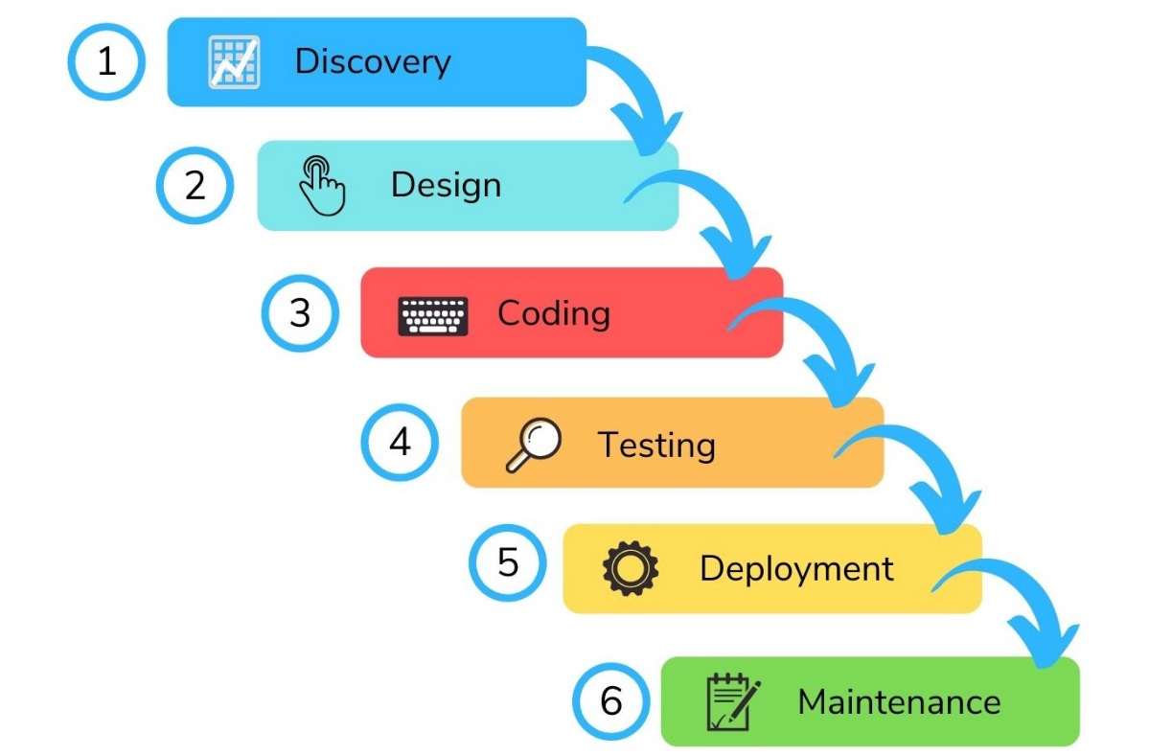

Figure . Waterfall Model

According to Figure 1.7.1, the waterfall model will be used as the methodology in this project. Waterfall Model is the first Process Model as known as the linear-sequential life cycle model. It is the earliest SDLC approach used for software development. The model illustrates the development process in a linear sequential flow, any phase in the development can begin when the previous phase is complete and the phases do not overlap (tutorialspoint, 2021). This project aimed to develop a web-based gym system step by step, so the waterfall model is the best choice because it is easy to use and can be done by an individual, unlike the other methodology such as agile needs a team to work for the project (Kashyap, 2021).

According to Figure 1.7.1, some sequential stages will be used in the development, which are the discovery and research stage, design stage, coding stage, testing stage, deployment stage, and maintenance stage. Thus, the web-based gym system development needs to be done in all the stages of the model sequentially without the previous stage undone.

Besides that, this project will be developing a web-based gym system with biometric identification and automated member count which is very complex and requires a lot of researches and studies to be done before the coding stage. For biometric identification, it will implement the face recognition feature which required A.I to work on this project. It needs to work on the researches on face detection, image processing, and face recognition with A.I to deliver the result successfully in the phase research stage. After having heavy research in the research stage, it may help a lot in the coding stage without any unnecessary delay because already having enough knowledge about the A.I technology due to the researches. In this project, all stages will be processed sequentially with a clear plan to do by using the Waterfall model.

There are several life cycles in the model mentioned above, which is consisting 6 phases which are Discovery and Research Stage, Design Stage, Coding Stage, Testing Stage, Deployment Stage, and Maintenance Stage. The stages allow for departmentalization and control, a schedule can be set with deadlines for each stage of development and the project can proceed step by step which is suitable with the semester timeline. Some phases will show how the project going to be conducted with the waterfall model based on Figure 1.7.2.

1. **Discovery and Research Stage**

* Research on existing system
* Research on A.I Facial Technology analysis
* Development platform analysis

**2. Design Stage**

* Work on UML diagram
* Design sketch of User Interface

**3. Coding Stage**

* Website UI development with the sketch design
* Coding and implementing the features of the system
* A.I Technology development
* Database development

**4. Testing Stage**

* Website testing and debug
* Features testing
* Face recognition testing

**5. Deployment Stage**

* Project documentation
* Deliver project result and documentation

Figure . Phases conducted in the project with Waterfall Model

# Literature Review

**Existing web-based gym system**

In this section, it will compare three(s) existing web-based gym system which are from good ratings and reviews. The websites will only discuss the gym website, which is used by the member or non-member user because the gym system which is used by the admin is confidential to the public. The gym website will be evaluated and reviewed in its features and functions. The comparison will be made between three existing websites to evaluate the features that are provided to help in the new implementation of the facial recognition feature in the gym system.

## Windy City Fitness



Figure . Logo of Windy City Fitness

According to Figure 2.1.1, Windy City Fitness is a gym website used for the member or non-member user to browse the website which is located in the United States. The website comes with a lot of features such as understanding the membership plans and prices, check for the classes, book the classes online, check for the staff of the gym, and others. The website has a rating of 4.2 out of 5 on Facebook which is considered high.

#### Homepage of Windy City Fitness

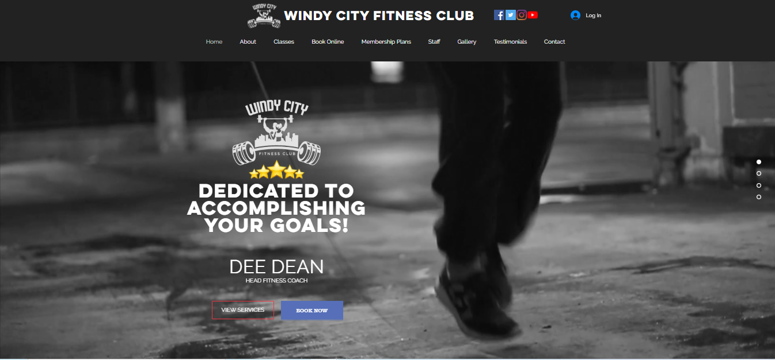

Figure . Homepage of Windy City Fitness

According to Figure 2.1.2, the design of the website is very interactive and attractive when the users entered the website. It will show a motivation clip on the homepage. On the header of the website, it will list out all of the options clearly to let the users choose. There is a login button on the top right side of the homepage which can let the member of the gym log in to check their status. Besides that, there are four dots on the right side of the homepage which is consisting of the About Us, Classes, and the Contacts to let the users choose the options from the header or the dots on the homepage.

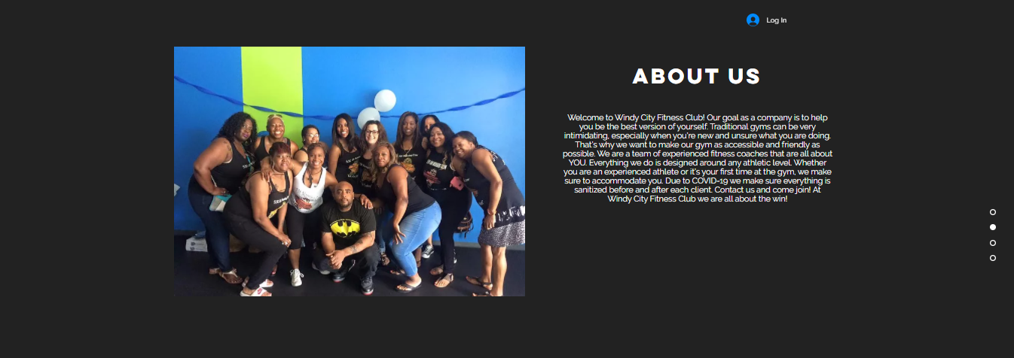

Figure . About Us on Homepage

According to Figure 2.1.3, this is the background story and the aim of Windy City Fitness after pressing the About option from the header or the dots.



Figure . Classes on Homepage

Figure 2.1.4 above is showing the workout provided by the gym after pressing the Classes option from the header of the dots. There is an option of Download Zoom Free which guides the users to join the class online because the physical classes of the gym are close due to Covid-19 and it will be held online, it also has the option that lets the users book for the online classes through the website.



Figure . Motivational Story on Homepage

Figure 2.1.5 showed some success stories of the members from the gym to let the users get motivated and join the gym when they browse the website.

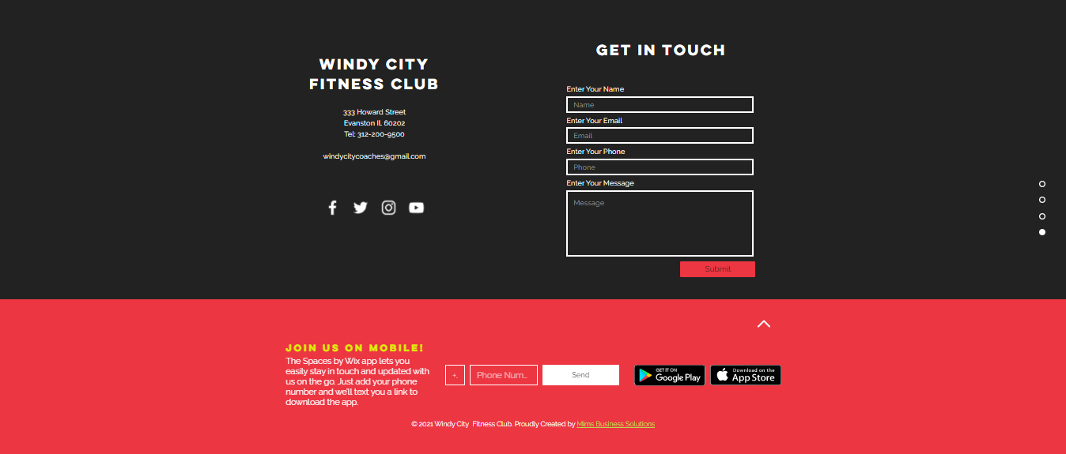

Figure . Contact on Homepage

Figure 2.1.6 above is showing the way for the users to get in touch with the gym after pressing the Contact option from the header of the dots. There are some options such as email, phone call the gym, and go to social media to get in touch with the gym.

#### Book Online Function

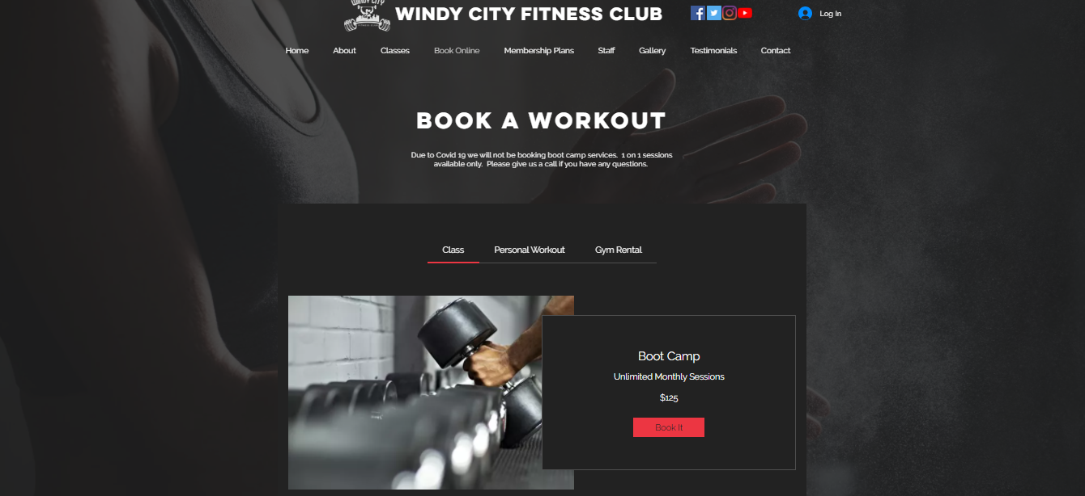

Figure . Booking Page

Figure 2.1.7, it showed that the website can let the users book workout classes, personal workouts, and the rental of the gym room. The booking page will show the information and the price of the classes or facilities to the users. It will let them book it online easily instead of the traditional method which is going to the gym center to book the classes or facilities.

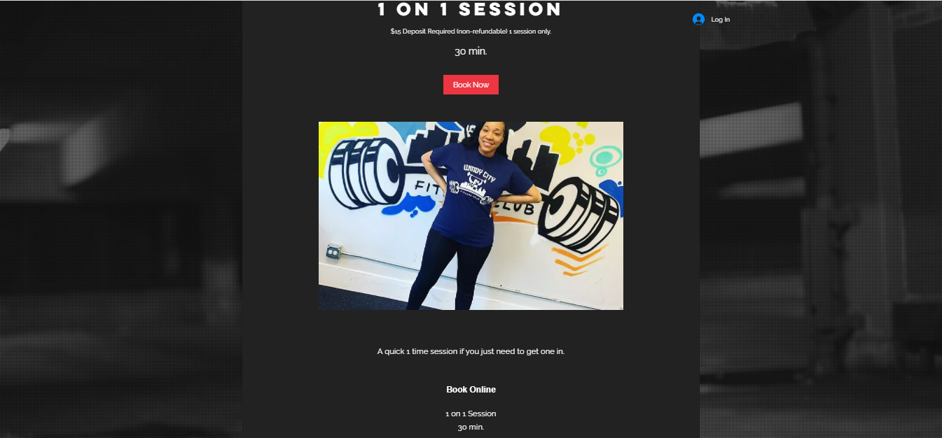

Figure . Detail Page of the booking

Figure 2.1.8 showed detailed information of the personal workout for the users after clicked it.

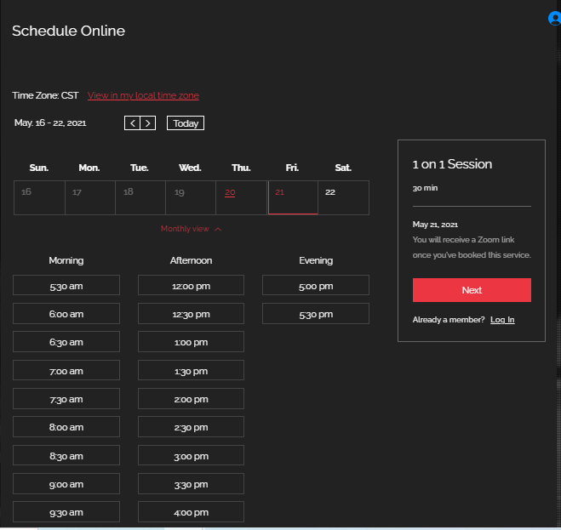

Figure . Booking Date Page

According to Figure 2.1.9, it lets the user schedule the date and time of booking the 1 on 1 session online.

#### View Membership Plans

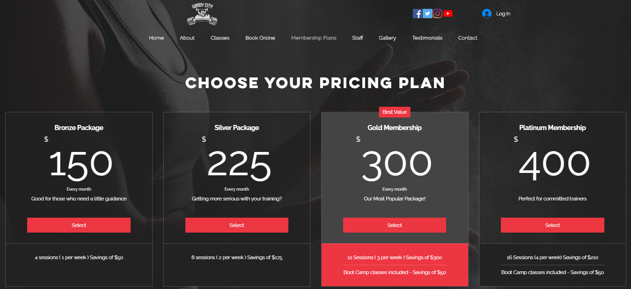

Figure . Membership Plans Page

Figure 2.1.10 lets users understand the membership packages of the gym on the website. According to the research (Hudson, 2020), The page used the marketing phrases such as saving a certain amount of money and the word “best value” which can attract and let the users felt that they are worth it to join the package provided by the gym.

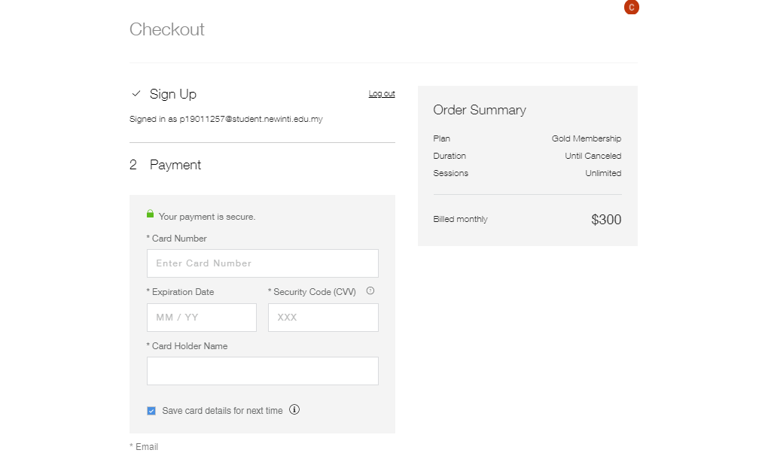

Figure . Payment Page of the membership plan

According to Figure 2.1.11, the payment page will show the plan chosen by the user and the monthly fee that needs to be paid by the user. The user just needs to fill in their payment information on the payment tab to pay for the package easily.

#### View staff detail

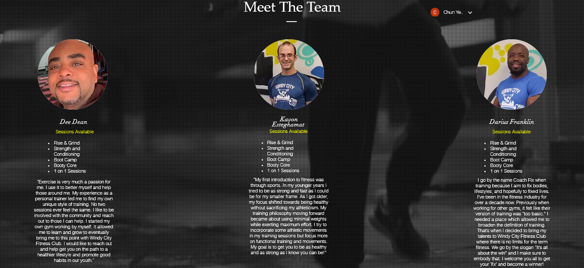

Figure . View staff page

According to Figure 2.1.12, the staff page will show all of the staff who are working in the gym. It will show all the sessions provided by each of the staff to let the users know when choosing their trainer, the page also shows the courage words from the staff.

#### View Gallery Page

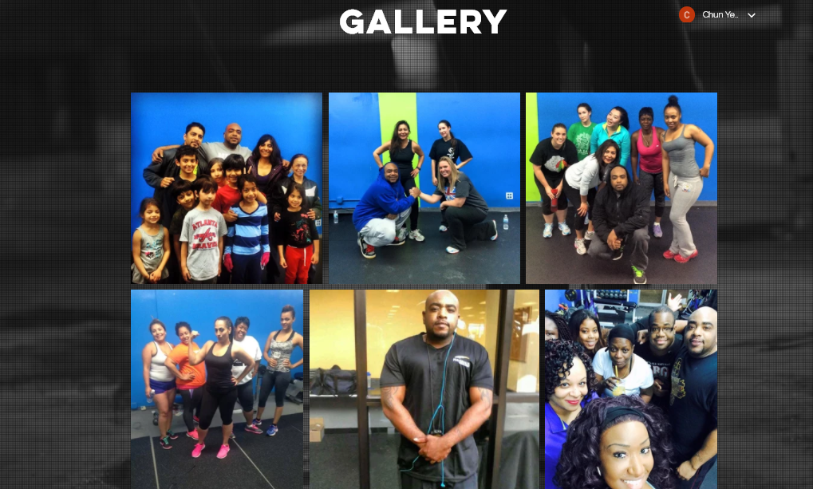

Figure . View Gallery Page

Figure 2.1.13 showed some of the pictures of the interaction between the members and the staff on the gallery page to attract the users to join the gym because of the good collaboration.

#### View Testimonials Page



Figure . Testimonials Page

According to Figure 2.1.14, it can let the users do review and rate the gym through social media.

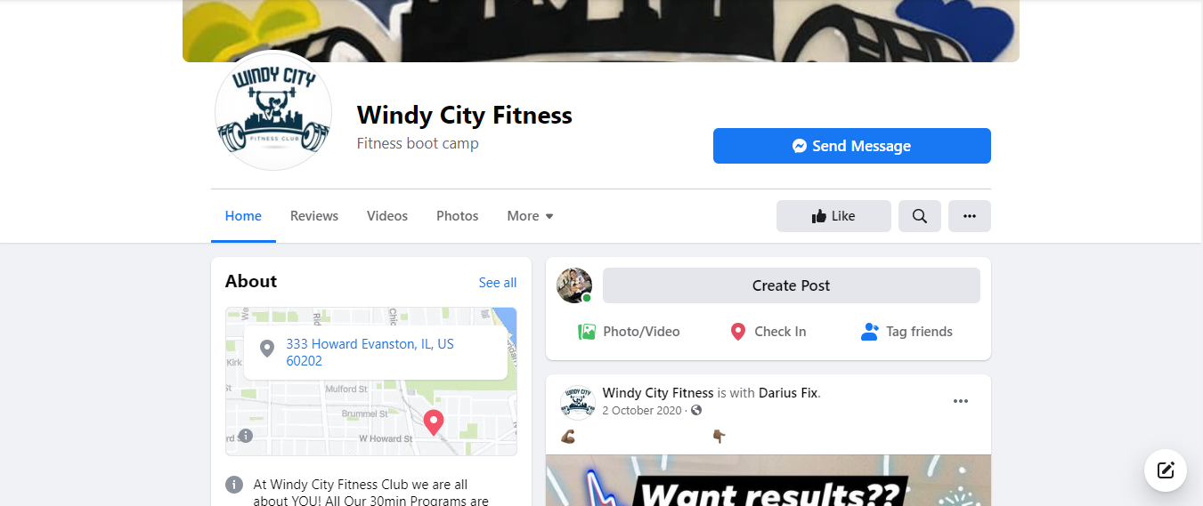

Figure . Facebook page of the gym

Figure 2.1.15 showed the Facebook page after clicking the icon on the testimonials page, it lets the users rate and review the gym, they also can know the latest news from the Facebook page.

#### Sign Up Page

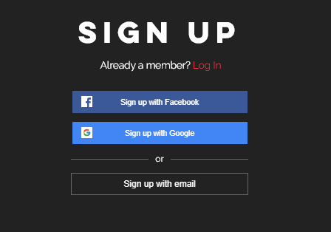

Figure . Sign Up Page

According to Figure 2.1.16, the sign-up page lets the non-member user sign up as a member to use the convenience features of the website. The sign-up page has three options to let the user to sign-up.

#### Login Page

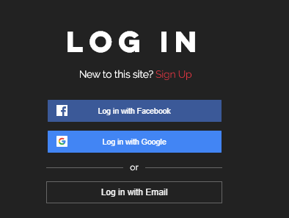

Figure . Login Page

According to Figure 2.1.17, the login page lets the member user log in to use the convenience features of the website. The login page has three options to let the user to login.

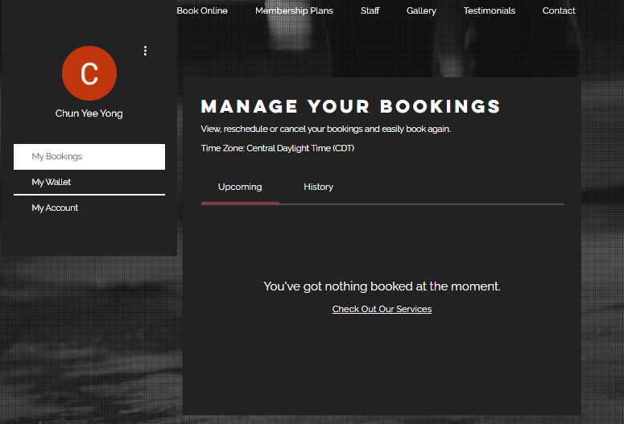

Figure . My Bookings Page

According to Figure 2.1.18, the page lets the logged-in user check their upcoming booking information, they also can check back their previous booking information.

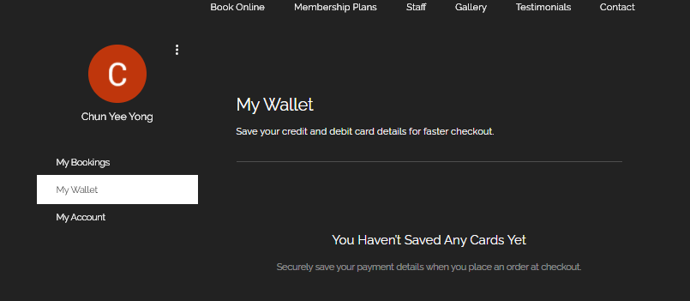

Figure . My Wallet Page

According to Figure 2.1.19, the page lets the logged-in user check the balance of their wallet.

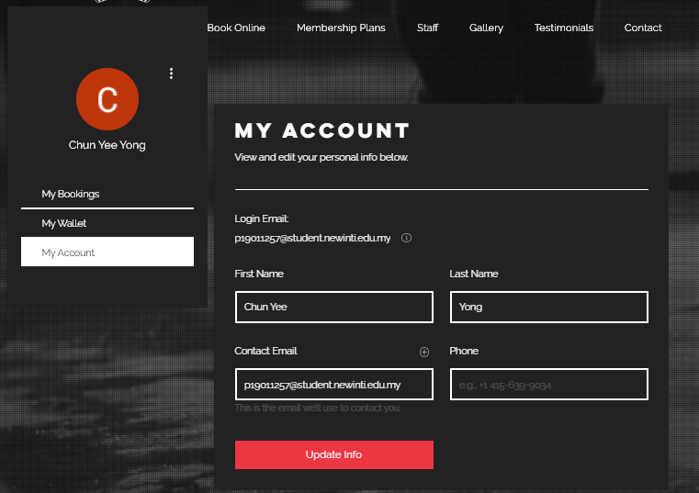

Figure . My Account Page

According to Figure 2.1.20, the page lets the logged-in user view and edit their personal information online easily.

## CHI-Fitness



Figure . Icon of CHI-Fitness

According to Figure 2.2.1, CHI-Fitness is one of the largest gyms in Malaysia. CHI-Fitness provides a gym website used for the member or non-member user to browse the website. The website comes with a lot of features such as understanding the membership plans and prices, check the location nearby the gym, book the classes online, check for recipes or BMI, and others.

#### Homepage of CHI-Fitness



Figure . Homepage of CHI-Fitness

According to Figure 2.2.2, the design of the website is very interactive and colorful when the users visited the website. It promotes its current promotion on the homepage to attract users. On the header of the website, it will list out all of the options clearly to let the users choose. There is a sign-in button on the top right side of the homepage which can let the member of the gym log in to check their status.



Figure . Clubs of the gym on the homepage

According to Figure 2.2.3, the homepage will show the clubs provided by the gym, CHI-Fitness provides CHI Fitness, and the CHI-X in its gym.

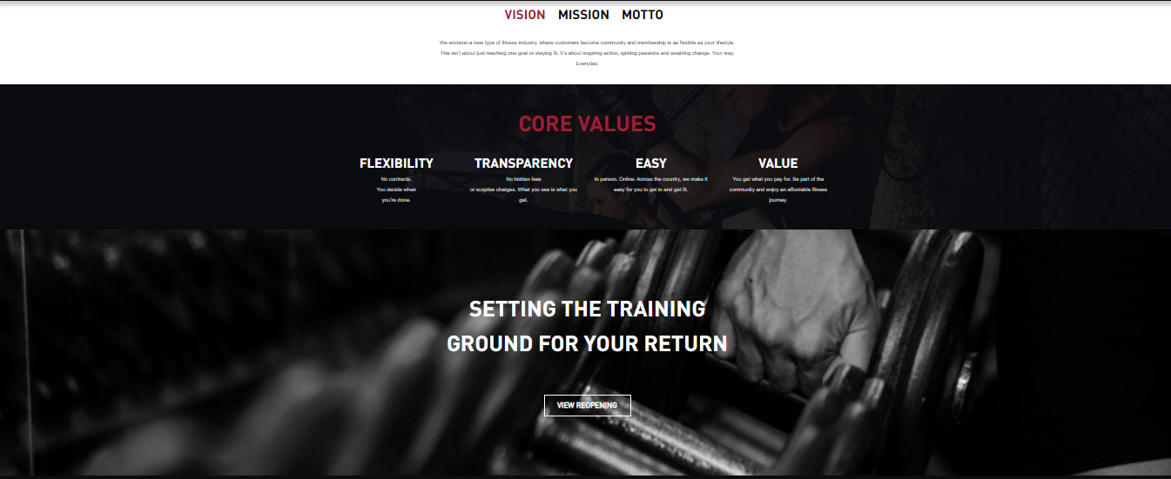

Figure . Mission and Value of the gym on the homepage

Figure 2.2.4 showed the vision and the values provided by the gym on the homepage to motivate the users who visited its website.

#### Club Page

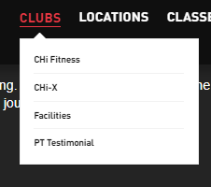

Figure . Dropdown menu of the clubs

According to Figure 2.2.5, the website provides four options which are CHI-Fitness, CHI-X, Facilities, and PT Testimonial in the dropdown menu of the Clubs.



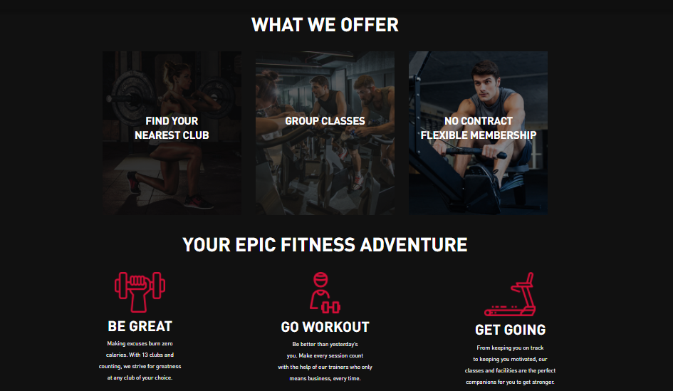

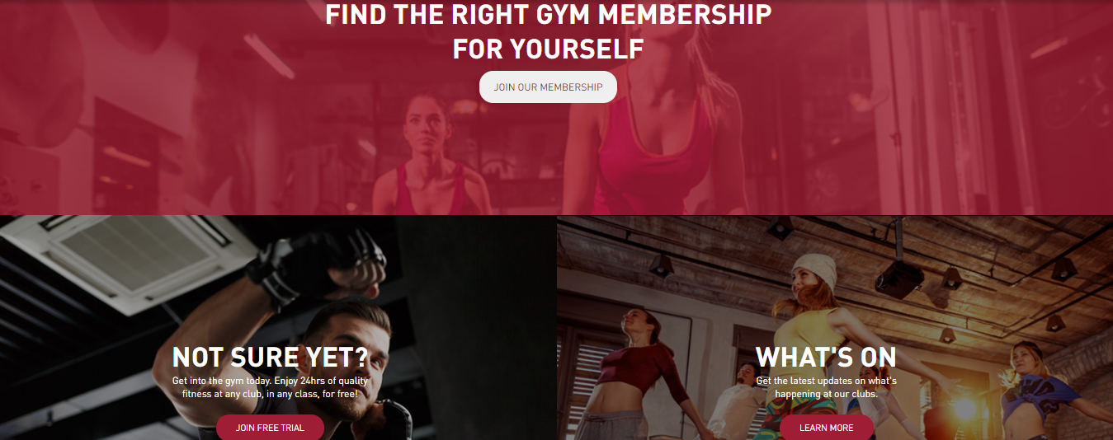

Figure . CHI-Fitness Page

According to Figure 2.2.6, the page shows detailed information about CHI-Fitness to the users to understand, it also provides free trials and the latest updates about the club on the CHI-Fitness Page.









Figure . CHI-X Page

According to Figure 2.2.7, the page shows the detailed information about CHI-X to the users to understand, it shows the users all the locations of the CHI-X outlet and it also provides group classes in the CHI-X to let the users join.



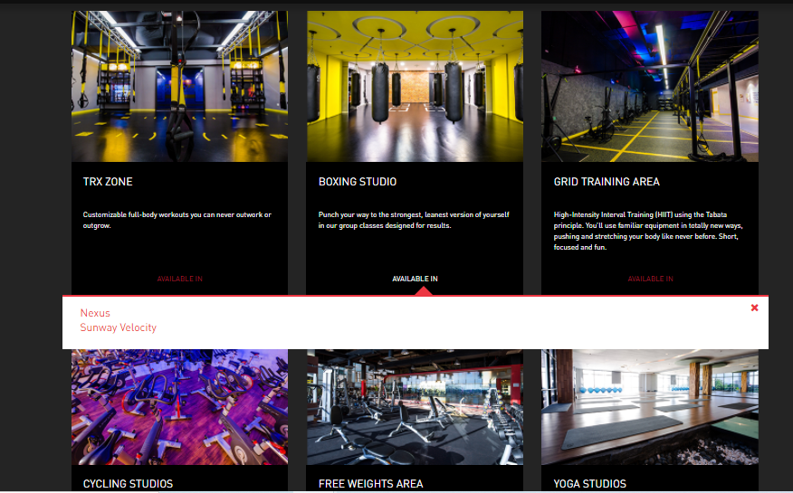

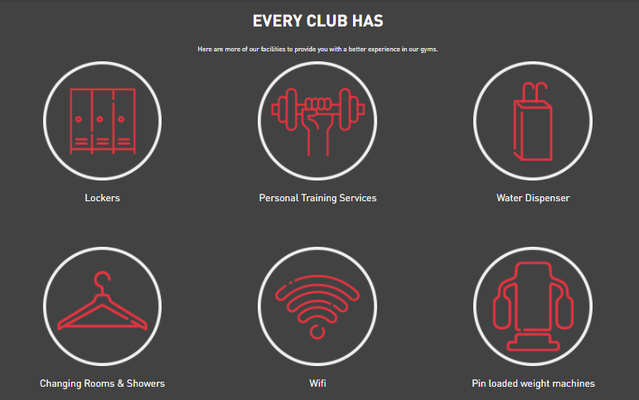

Figure . Facilities Page

According to Figure 2.2.8, the page showed all the facilities provided by the gym and it will let the users know that some facilities only available in some specific gym centers only. Besides that, the page also will let the users knowing that there are a lot of facilities such as lockers, personal training services, water dispensers, free Wi-Fi, and others in every club to attract the users.





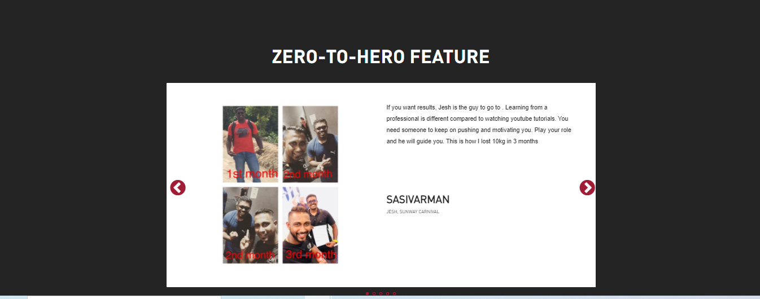

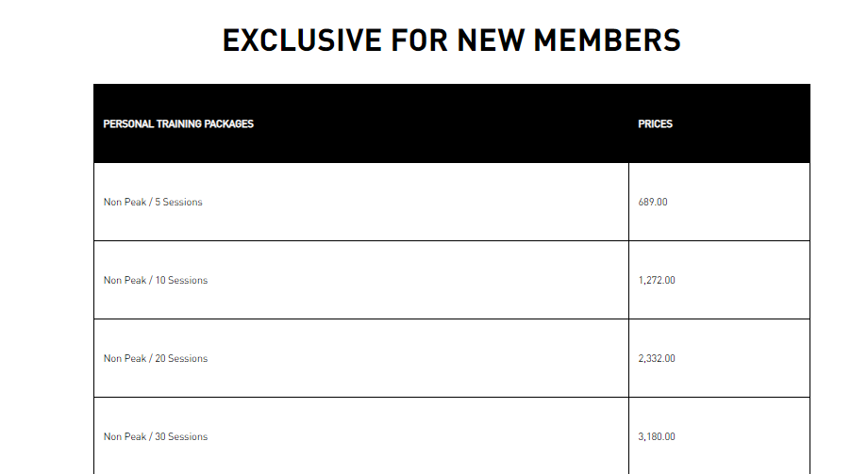

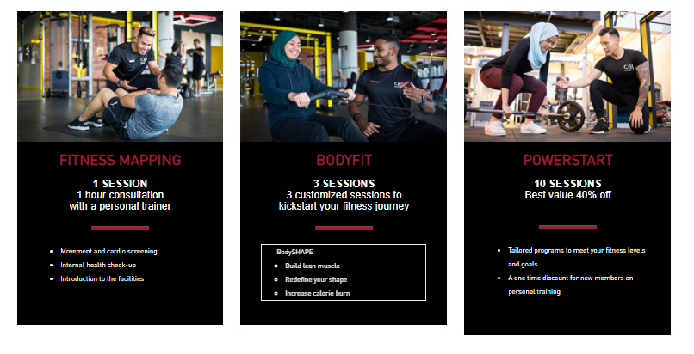

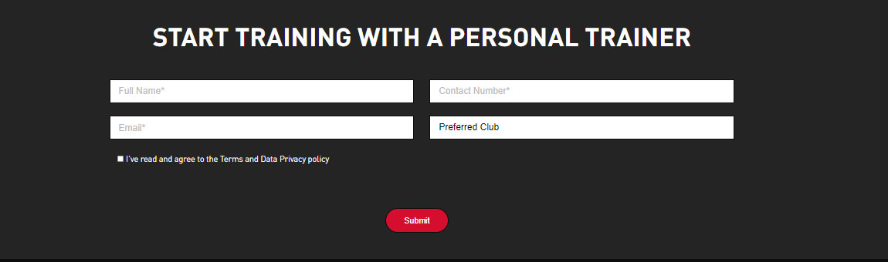

Figure . PT Testimonial Page

According to Figure 2.2.9, the page will let the users understand the information of the personal training. It will show some members’ success stories to motivate the users to join the club, it also shows the session prices and the packages provided by the gym on the page. At the bottom of the page, it will let the users who are interested in hiring a personal trainer fill in their personal information after they saw all the information above.

#### View Location Page

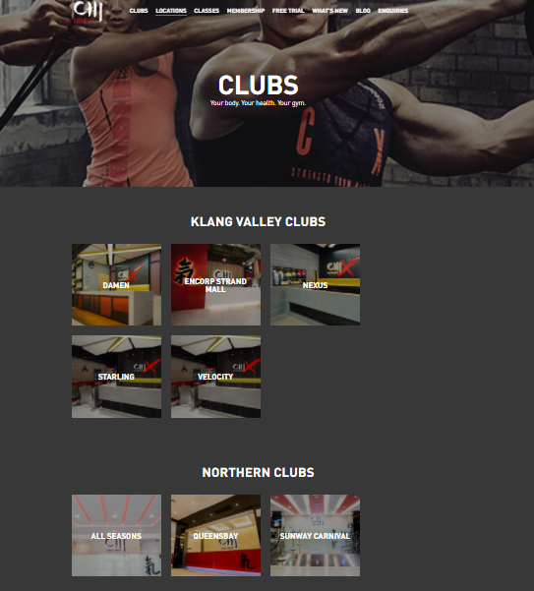

Figure . Location Page

According to Figure 2.2.10, the page shows all the fitness available in Malaysia which are Klang Valley Clubs and Northern Clubs to the users to let them know the club nearby them.

#### View Classes Page



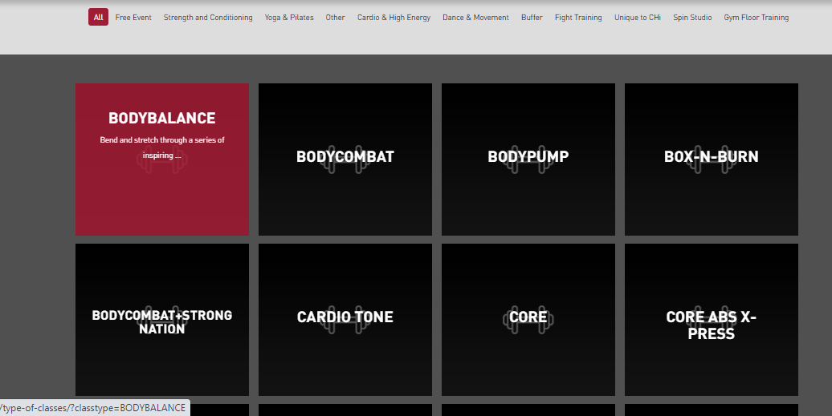

Figure . Classes Page

According to Figure 2.2.11, the page shows the users all types of classes provided by the gym. Besides that, the page also lets the users categorize and select the type of classes they desired.

#### View timetable of classes page



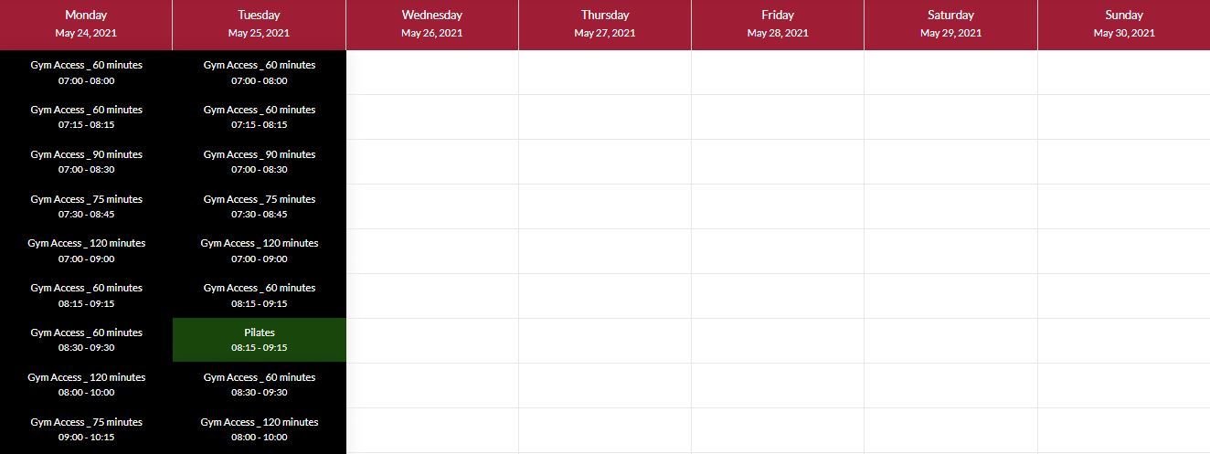

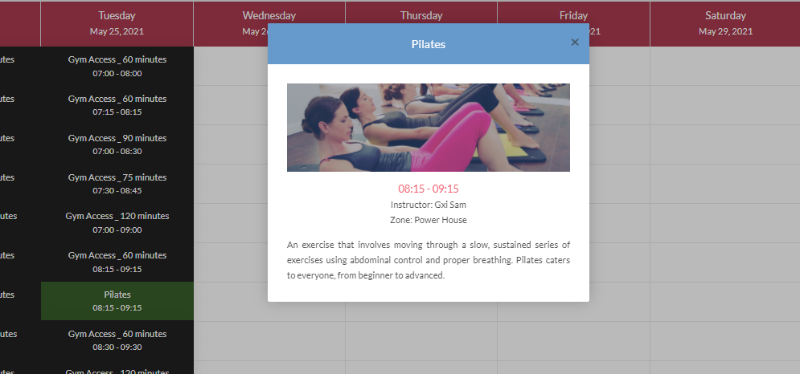

Figure . Timetable Page

According to Figure 2.2.12, it lets the users choose the clubs and the classes they wished to see. The timetable will show the classes and the time of the classes to the users, it will show the detail of the classes after clicked on a class the users wishing to understand.

#### Membership Plans Page

On the membership plans page, there are Individual Membership, Corporate Membership, CHI Privilege, and the Virtual PT provided by the gym.

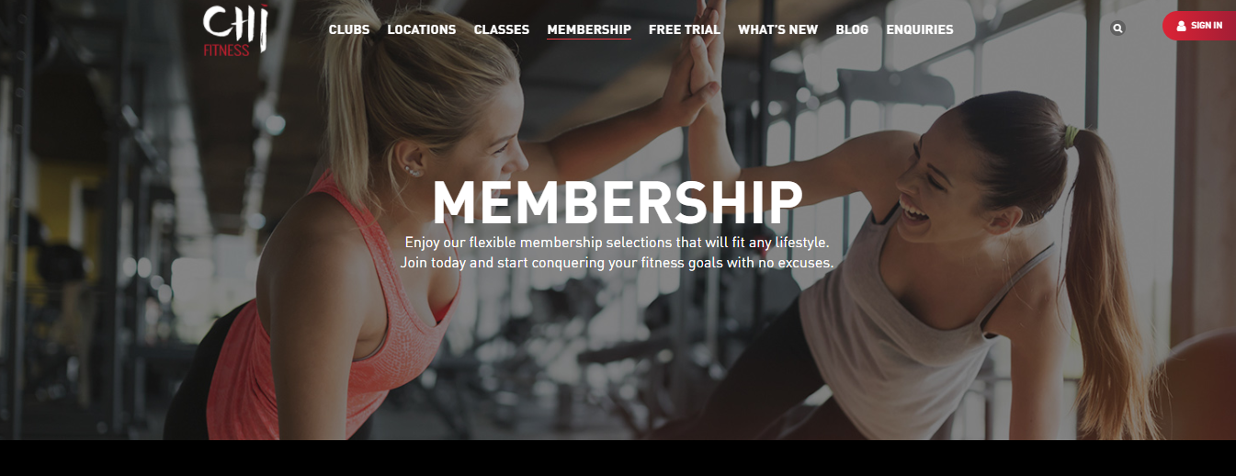

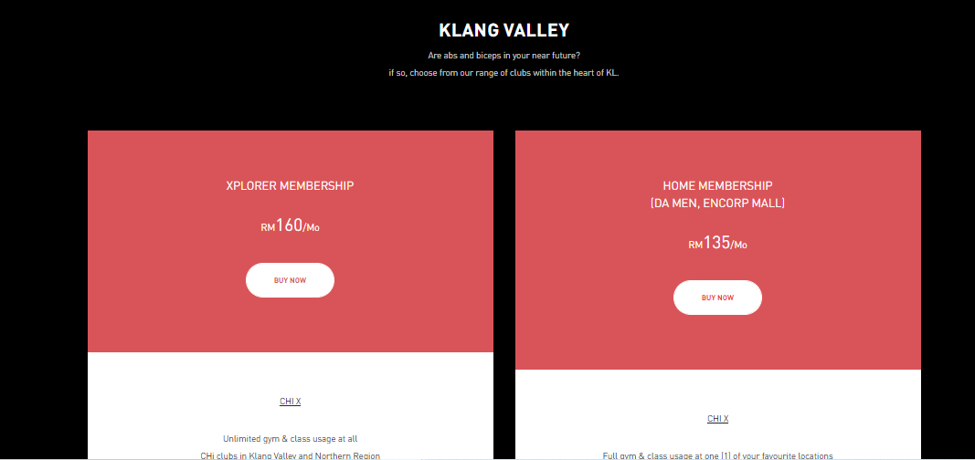

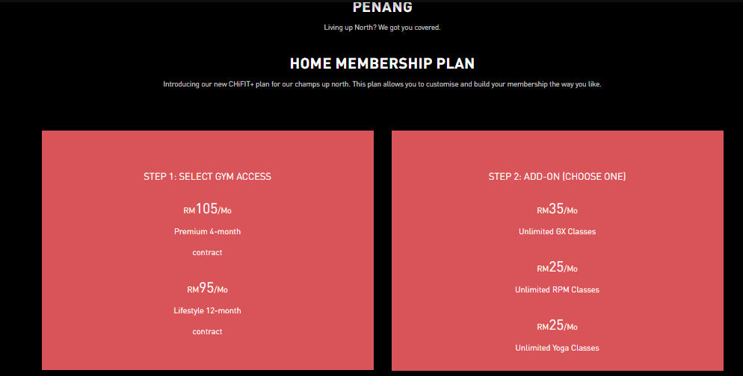

Figure . Individual Membership Page

Figure 2.2.13 showed the plans and the prices of the individual membership plan in Klang Valley and Penang to the users, the users can buy the plan they wanted by online through the website.

 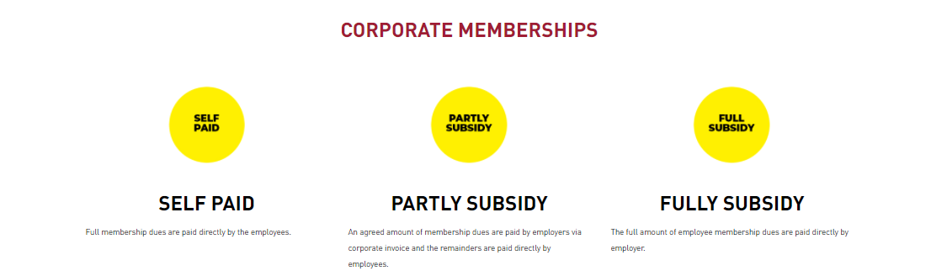

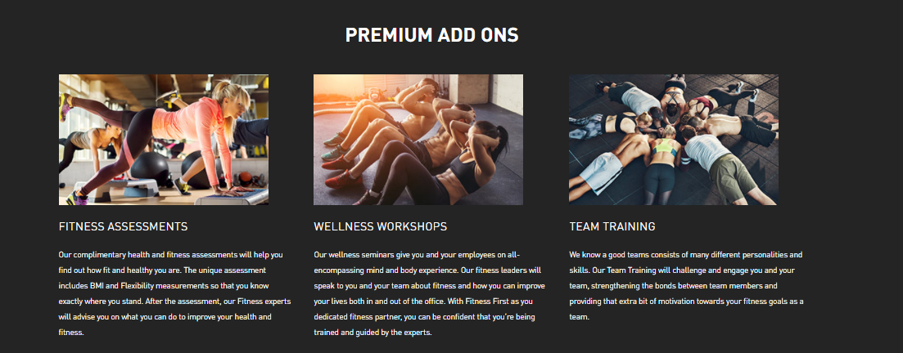

Figure . Corporate Membership Page

Figure 2.2.14 showed the add-ons and special offers provided by the corporate membership compared to the individual membership.

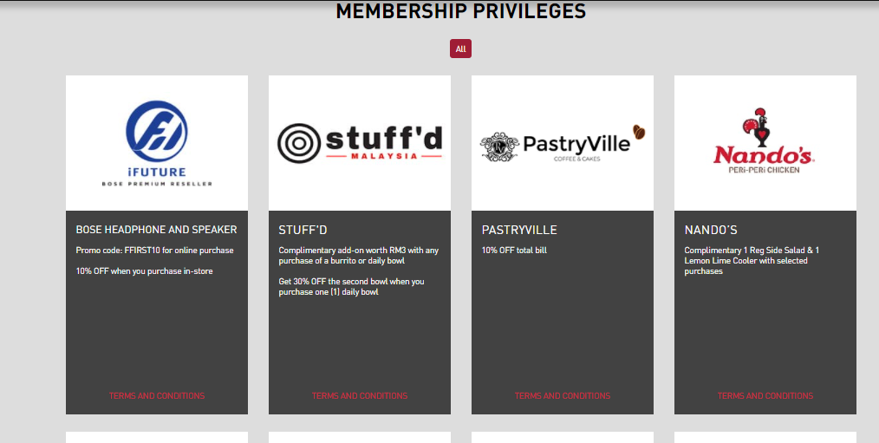

Figure . CHI Privilege Page

According to Figure 2.2.15, the page shows that the benefits provided by the gym for the members such as the members can enjoy a 10% discount in PastryVille.

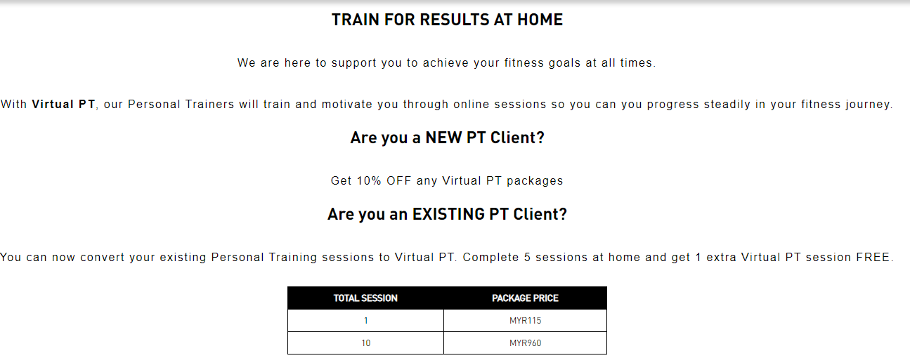

Figure . Virtual PT Page

According to Figure 2.2.16, the page shows the plan and the price of the virtual personal training for the users to understand.

#### Free Trial Page



Figure . Free Trial Page

According to Figure 2.2.17, the gym provides a free trial to the users who are interested to take a look and try the gym which is one way of marketing its gym. The users only need to fill in their details online through the page easily without going to the gym center to register.

#### Recipe Page

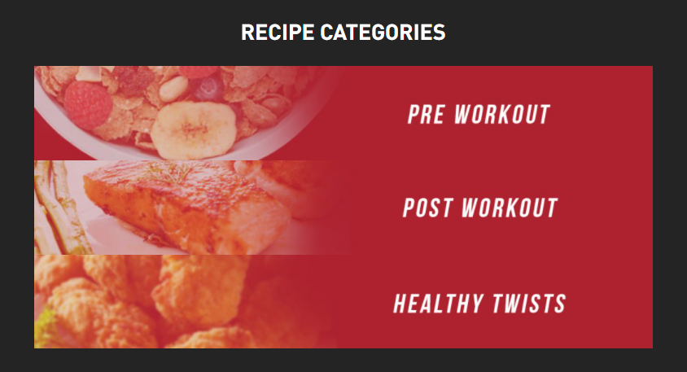

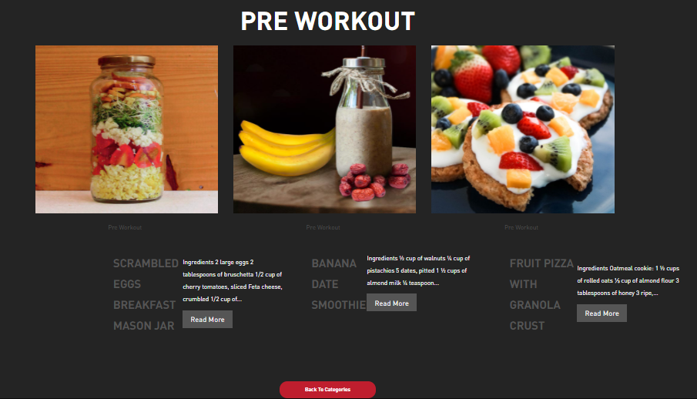

Figure . Recipe Page

According to Figure 2.2.18, the page provides the recipe for the beginners who just started for the gym, it will guide them with detailed foods and drinks before the workout and after the workout. This kind of page will highly attract beginners who are new to the gym and they will feel the professional of the gym and join as a member of the gym after they browse the website of the gym.

#### BMI Calculator Page



Figure . BMI Calculator Page

Figure 2.2.19 provides the function of letting the users calculate their BMI easily through the website of gym.

#### Enquiries Page

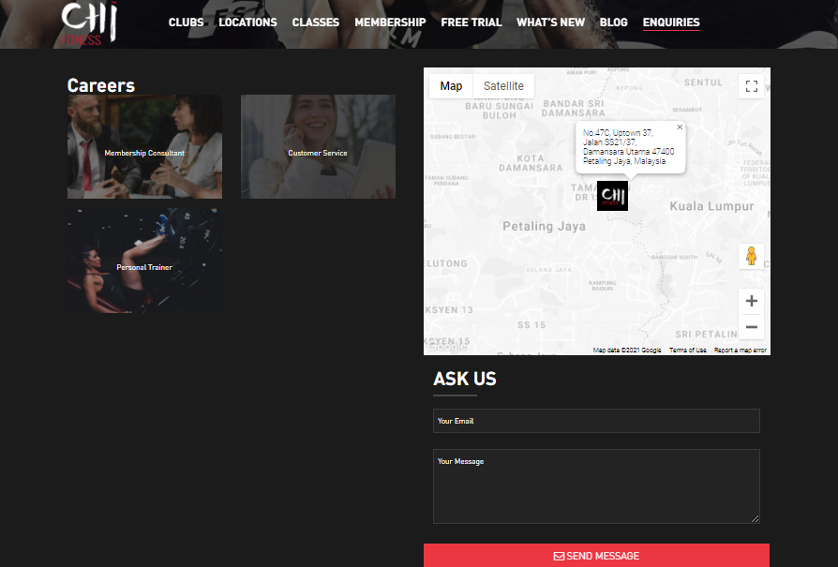

Figure . Enquiries Page

Figure 2.2.20 provides some ways for the users to enquire more detailed information about the gym.

#### Sign Up Page

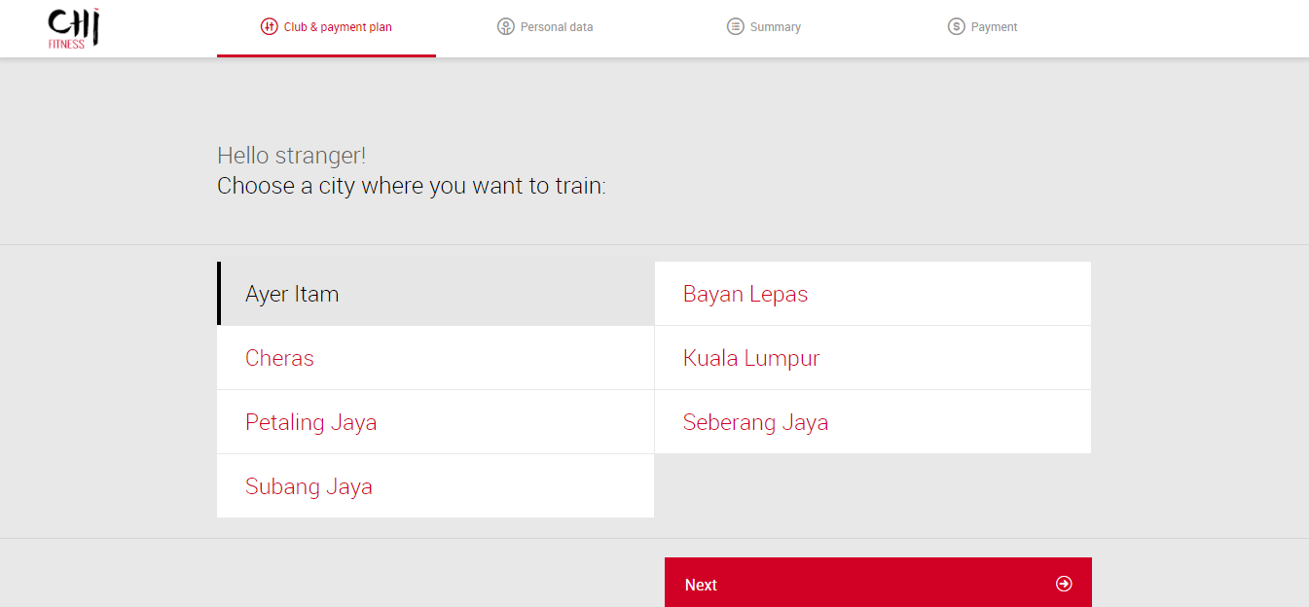

Figure . Sign Up Page

According to the Figure 2.2.21, the page will let the non-member users to sign-up as a member through online. The page will ask the users to fill in and check the club & payment plan, personal data, summary, and payment.

#### Login Page

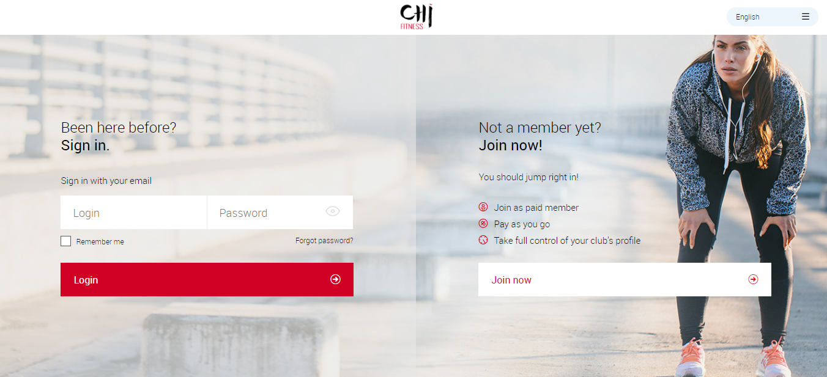

Figure . Login Page

According to Figure 2.2.22, it lets the member users sign in to use the website platform provided by the gym.

## Orient Fitness



Figure . Logo of Orient Fitness

According to Figure 2.3.1, Orient Fitness is one of the largest gyms in Malaysia. Orient Fitness provides a gym website used for users who are interested to browse the website. The website comes with a lot of features such as understanding the membership plans and prices, check the location nearby the gym, check for the classes, and others.

#### Homepage of Orient Fitness

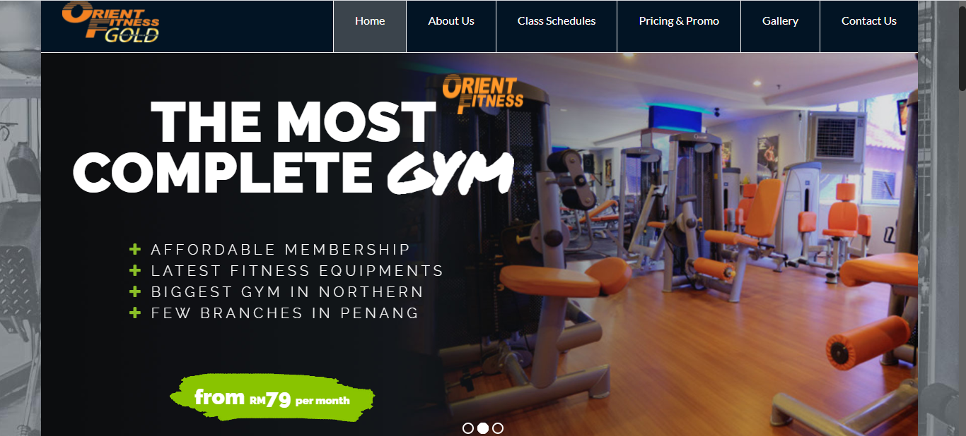

Figure . Homepage of Orient Fitness

According to Figure 2.3.2, the design of the website is quite attractive enough to attract users when they entered the website. On the homepage, the webpage will show the benefits provided by the gym and the motivation words for the users. Besides that, the header will list out all the options clearly to let the users choose.

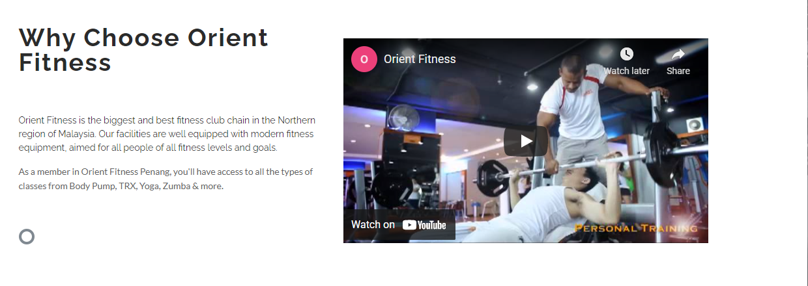

Figure . Briefly explanation about the gym on the homepage

Figure 2.3.3 will show the users about a brief introduction to the gym and a video clip about the gym.



Figure . Trainers and classes on Homepage

Figure 2.3.4 above is showing the trainers and the classes provided by the gym on the homepage. It will briefly show some of the trainers and the classes for the users, the users can click the see all trainers or see all classes understand the more detailed information about them.

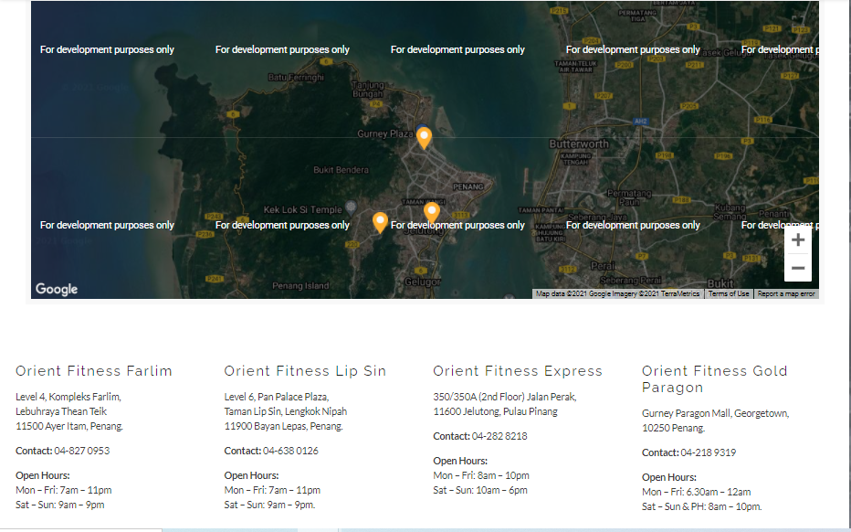

Figure . Show location on the homepage

Figure 2.3.5 shows the users a map which is the available gyms nearby them. It will show the users every gym’s contact number for any inquires and it will show the operation hours of every gym.

#### About Us Page

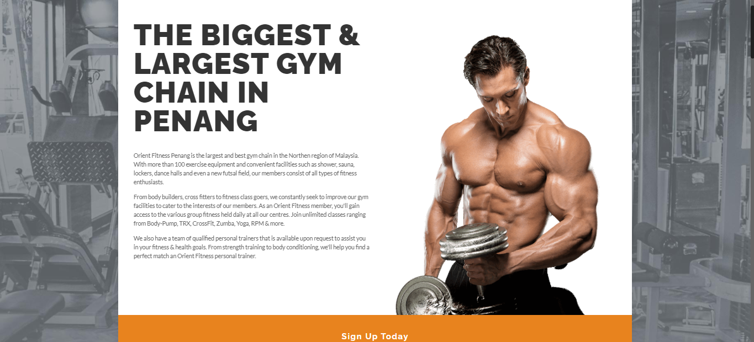

Figure . About Us Page

Figure 2.3.6 shows the users detailed information about the facilities and benefits provided by the gym to attract them to join the gym. It lets the users who are interested to join the gym sign up on the website.

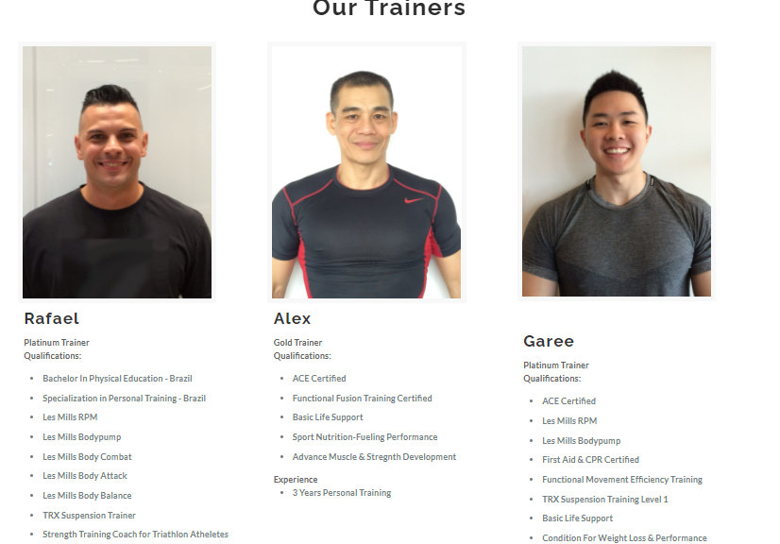

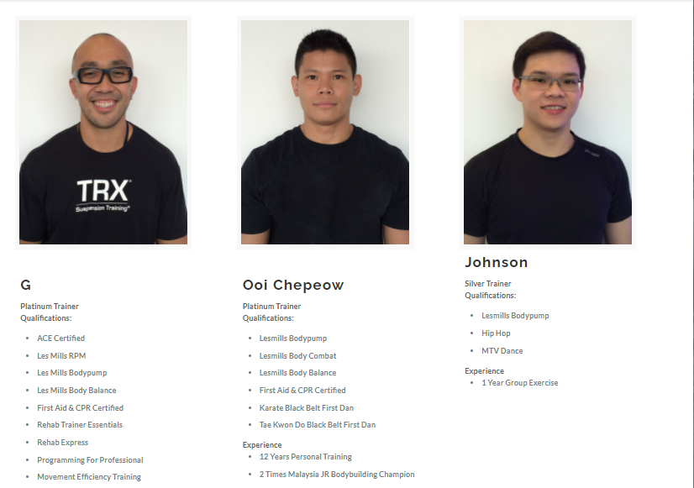

Figure . Detail of the trainers on about us page

Figure 2.3.7 will show the users all information about the trainers who are working in the gym. It will show the qualifications and the experiences of all the trainers for the users, it can let the users understand and choose the trainer they desired.

#### Classes Page

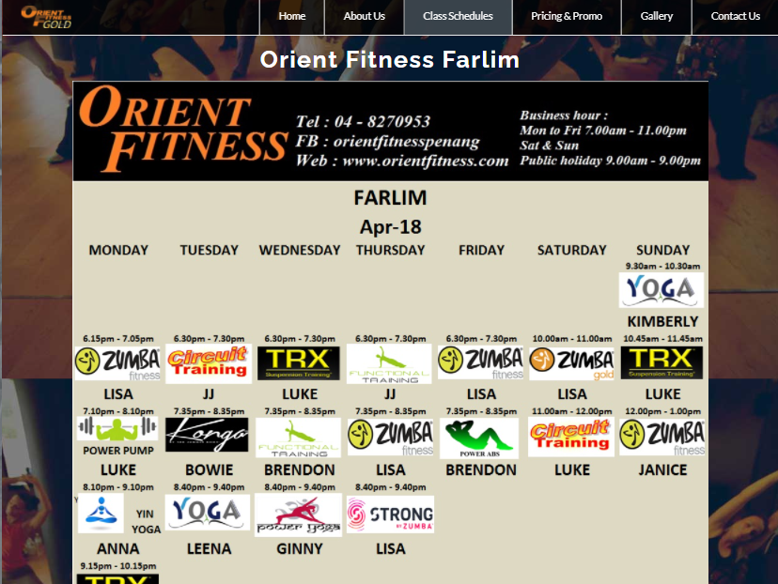

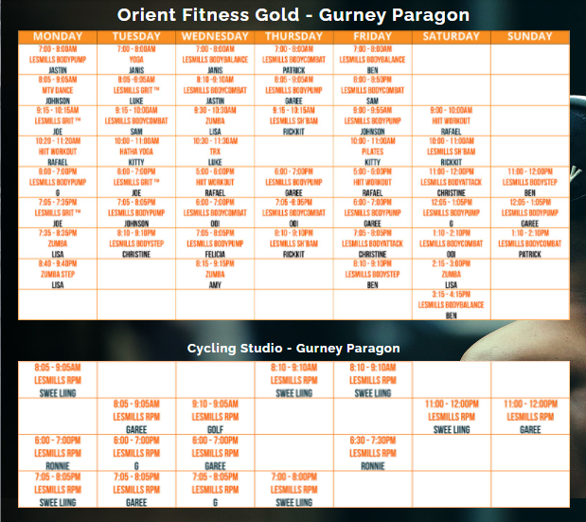

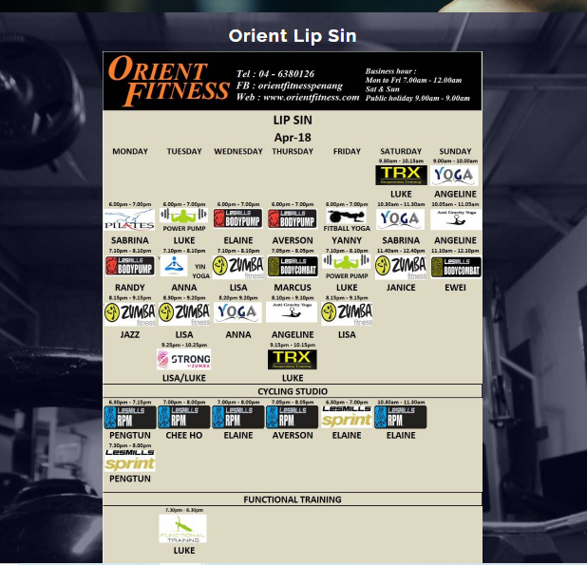

Figure . Classes Page

According to Figure 2.3.8, it lets the users understand all the classes provided by the gym, it will show the trainer and the time of the class for the users to know. The classes page showed all the detailed information about the classes in every branch of the gym.

#### Pricing & Promo Page

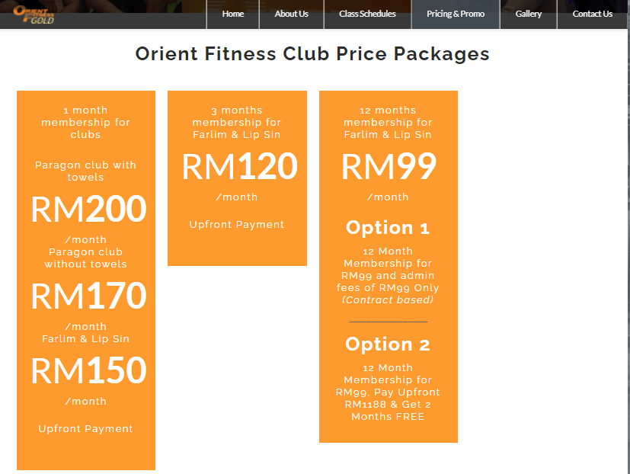

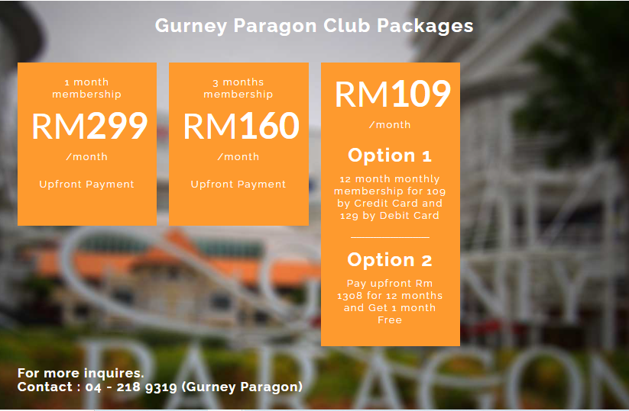

Figure . Pricing & Promo Page

Figure 2.3.9 lets the users understand the information and price of the packages provided by the gym. The page used the method of promotion price which providing discounts to the payment method of the users. The page shows the different packages and prices provided in the different gyms; it also attached the contact number below of each of the gyms.

#### Gallery Page

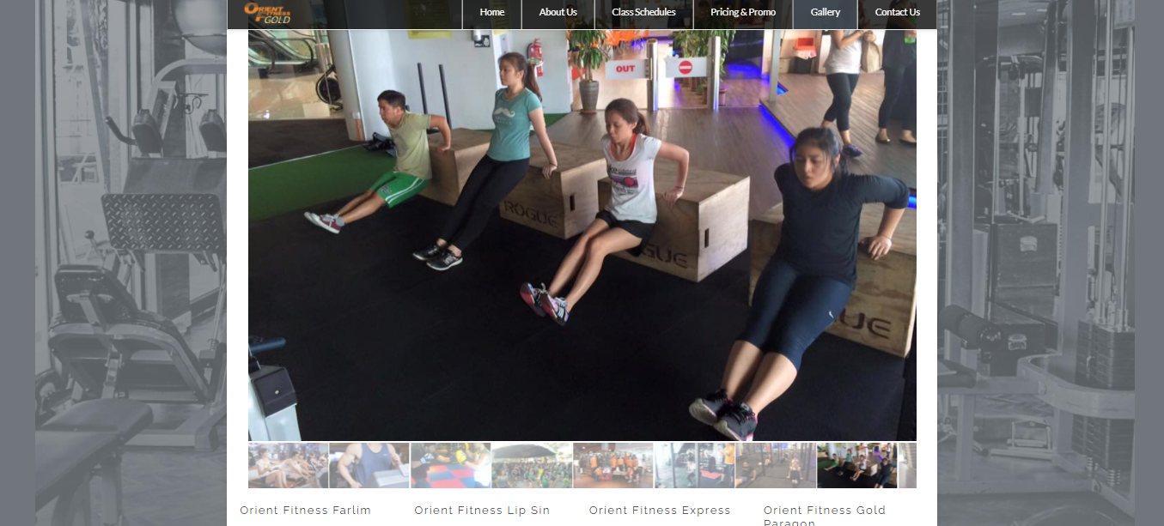

Figure . Gallery Page

Figure 2.3.10 showed some pictures of activities and interactions between the members and the trainers on the gallery page to attract the users to join the gym because motivated by the collaboration and hype from the pictures.

#### Contact Us Page



Figure . Dropdown list of contact us

Figure 2.3.11 showed that there is a dropdown list which is Free Trial that can enable the users to click into it to get the free trial.

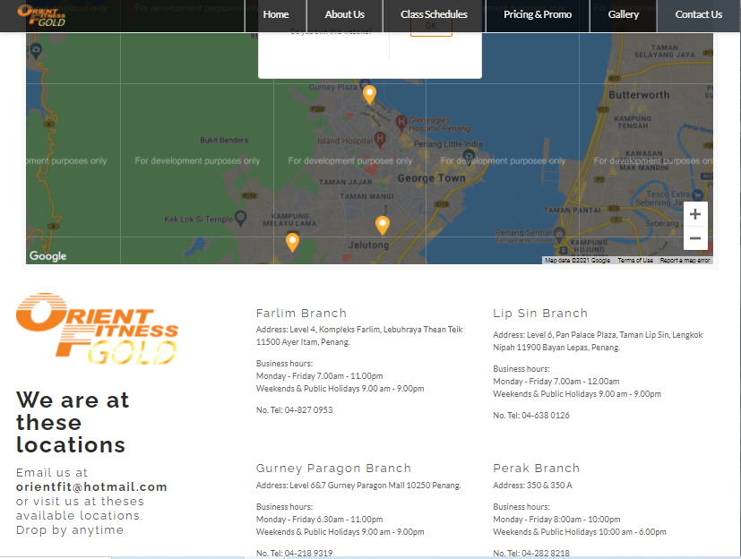

Figure . Contact Us Page

Figure 2.3.12 shows the users a map that is the available gyms nearby them. It will show the users every gym’s contact number for any inquires and it will show the operation hours of every gym. The page provides the users the gym’s email for the users to let them inquiry anything they wished to know.

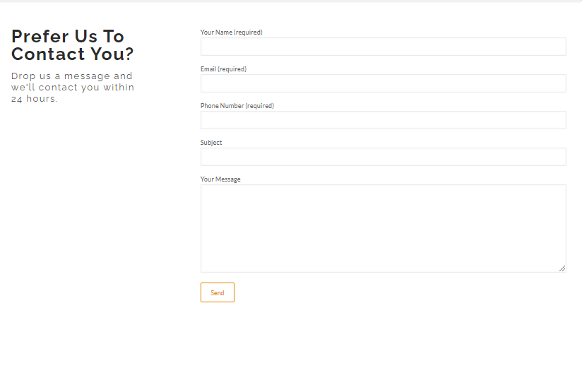

Figure . Fill in contact information on the contact page

Figure 2.3.13 lets the users fill in their information and the questions they wished to know and send to the gym online through the webpage. The staff in the gym will contact the users with email or phone numbers to assist the users in 24 hours.

## Critical Analysis of Windy City Fitness, CHI-Fitness, and Orient Fitness

In this section, the three (3) existing web-based gym system is critically analyzed, compared, and contrasted against each other. Windy City Fitness, CHI-Fitness, and Orient Fitness have their pros and cons. The table below displays all the features provided by the websites.

|  |  |  |  |
| --- | --- | --- | --- |
|  | Windy City Fitness | CHI-Fitness | Orient Fitness |
| Homepage | Simple and interactive UI design, the layout is aligned when zooming in or out, it specifies the layers of different categories with different colors when scrolling down. | Interactive UI design, it specifies the layers of different categories with different color when scrolling down. The layout of the pictures not aligned when zooming out. | Simple UI design, the layout is aligned when zooming in or out. The layers of different categories are not specified clearly because it only used one color on them. |
| Classes | Display the information and price of the class clearly, it can let the users book the class online on the website. | Display all the information of the classes clearly with categorized. It shows the timetable of the classes based on the location of the users. It cannot let the users book the class through the website of the gym but only with the mobile app of the gym. | Display all the classes provided in different locations of the gym., it shows the timetable of the classes and trainers. The information about the classes is not detailed enough and it cannot let the users book the class online on the website. |
| Membership | Display all the packages and the prices. It shows the benefits and promotions provided by the packages to attract the user to join as a member of the gym. It can let the members pay for the fees online on the website. | Display all the packages and prices. It shows the benefits and promotions provided by the packages to attract the user to join as a member of the gym. It also provides the members to have privileges of discounts in outlet stores or restaurants. It can let the members pay for the fees online on the website. | Display the packages and the prices, it shows the benefits and promotions provided by the packages to attract the user to join as a member of the gym. It cannot let the members pay for the fees online on the website. It also may confuse the users because the prices provided in different gyms are ambiguous. |
| Location and Hours | The website provides the location for the users but does not show the working hours of the gym. | The website provides the location and the working hours of the gym based on the different locations. | The website provides the location and the working hours of the gym based on the different locations. |
| Trainer Information | The website shows the bios of the trainers clearly. | The website doesn’t have the feature of showing the bios of the trainer. | The website shows the bios of the trainers clearly. |
| Blog | The website shows the success stories of the members in the gym. | The website shows the recipe’s tips to the members and a BMI calculator for the members to check their BMI. | The website does not have the feature of a blog. |

Table Comparison between Windy City Fitness, CHI-Fitness, and Orient Fitness

According to the Table 1 above, it shows the comparison between three existing web-based gym system. In terms of the Homepage, it showed that Windy City Fitness is better than CHI-Fitness and Orient Fitness. It is because the design of the interface is very attractive, it used the short clip showing an athlete working out on the top of the homepage. Besides that, the fonts and the images are aligned even though it is zoomed in or out, but the images of the CHI-Fitness is not aligned when it is zoomed out, a misaligned text and imagery may cause the users to think that the website is broken and they may leave or feel negatively about the company based on the research (MANCHESTER, 2021). In the field of layer on the homepage, the Windy City Fitness is better than Orient Fitness because it used different background colors to specify the different categories to make the users see it comfortable, but the Orient Fitness used one background color to specify different categories which may gain a bad reaction from the users because colors can stir the user's emotions or respond to a call-to-action on the website (studio1design, 2021).

In terms of the Classes, it showed that Windy City Fitness is better than the others two because it shows the users the detailed information of classes and the prices of the classes. Besides that, it lets the users choose the date and time to book the classes online. In the CHI-Fitness, the classes page is showing detailed information of classes with categorized to let the users filter the categories of the classes they desired to know. However, the classes page of CHI-Fitness does not provide online booking on the website except booking with the mobile app of the gym, it will better if the website also can let the users book for the classes online. In Orient Fitness, the classes page is showing the classes and the timetable of the classes and trainers. However, the information about the classes is not detailed and the website of the gym cannot let the users book the classes online.

In terms of the memberships, it showed that Windy City Fitness is better than the others two because the design of the showing membership’s promotion is very simple for the users to understand. It showed the promotions provided by the gym in different packages with the prices for the users. The membership page red highlighted the most recommended package for the users about the best value promotion provided by the gym, the simple highlight may highly attract the users to join the gym. The membership page in Windy City Fitness can let users log in to make payment for the membership fee online easily. The CHI-Fitness showed the membership price and the promotion based on the different locations of the gym for the users. However, there is a lot type of the membership plans provided by the gym may confuse the users who are browsing for the plans. In Orient Fitness, the membership page showed the users the membership price and the promotion based on the month or the payment method. However, the information of membership prices in different areas may confuse the users because it combined all the areas of the gyms with the prices and the promotions, but it showed again the area mentioned at the upside with different prices and promotions on the downside. It may let the users confused about which is the prices and promotions provided in that gym, it is suggested to show the prices and promotions of different areas separately like CHI-Fitness.

In terms of location and hours, the users need to know the working hours and the location of the gym in case a prospective user is looking around for options. In the comparison of the three gyms, it showed that Orient Fitness is better than the others two in showing information of location and hours. It showed the working hours and the location in the different areas of the gyms simply for the users to understand, it also showed the contact number of the gyms to the users. In Windy City Fitness, it only showed the users the location of the gym and does not show the working hours of the gym. It may let the users not joining the gym because they don’t know the working hours of the gym can suitable with their times. In CHI- Fitness, it showed the working hours and the location in different areas of the gyms for the users. However, the users need to click one by one of the areas of the gyms to check the location and hours to know which area of the gym is suitable for them. It is suggested that to show all of the locations and hours in different gyms in one webpage like Orient Fitness.

In terms of trainer information, the users need to know the information of the trainers in the gym on the website because it can attract the users to join the gym. In the comparison of the three gyms, it showed that Orient Fitness is better than the others two in showing the trainers’ information. In Windy City Fitness, it has a trainer page which is showing the information of the trainers in that gym. However, it only showed the classes provided by them and the courage words given by them, it is not showing the working experiences or qualifications of the trainers which may not give detailed information for the users. In CHI-Fitness, it does not have a webpage which is showing the information of the trainers which is important for a website of the gym. In Orient Fitness, it showed the users about the qualifications and the working experiences of the trainers clearly to let them understand and choose the trainer they desired through the information provided through the webpage.

In terms of the blog, it showed that the CHI-Fitness is better than the Windy City Fitness and the Orient Fitness because it provided the functions of recipes and BMI calculator which are not having in the others two. The webpage showed the recipes that need to be consumed by the members before or after the training, it will very good for the beginner who is new to the gym and does not have any knowledge about the food and beverages to be taken in the workout. Besides that, CHI-Fitness also provided a BMI calculator to let the users check for their BMI. It may be suggested that to have a community blog to let the members share their workout tips and knowledge in the blog webpage of the gym because a blog can make the gym more of a brand than merely a place for the people to lift weights.

## Facial Recognition

It was mentioned above that the objective of this project is to implement the facial recognition feature into the gym system to let the members in the gym can clock in and clock out by scanning their faces only. In this section, facial recognition will be introduced to deeply understand the high-tech facial recognition nowadays. Besides that, the application using in facial recognition, the operation of facial recognition, and the algorithms using in facial recognition will be discussed for research purposes during this section.

### Introduction to Facial Recognition

In nowadays high-tech world, there are a lot of crimes happened such as credit card fraud, hackers in breaking computers, security breaches, and others, the criminals will steal, duplicate, or acquires this identity such as ID cards, keys, passwords, PINs, or mother’s maiden name to access at the person’s personal property anytime they want because none of these means are to define the person but these means are to authenticate the person (Lin, 2000). Recently, biometric-based techniques have emerged as the most promising option for recognizing individuals comparing to ID cards, keys, passwords, PINs, and others. Besides that, biometric-based techniques cannot be stealing, duplicated, or forgotten (Parmar, 2014). There are two methods in biometric which are physiological methods and behavioral methods, physiological method is such as fingerprint, face, iris pattern, and others; the behavioral method is such as keystroke and voiceprint (Anon., 2019).

Among the methods of biometric, the physiological is stable than the behavior because the behavior method may fluctuate due to stress, fatigue, or illness but the physiological method is not changed except by injury (Lin, 2000). Among all the physiological methods in biometric, face recognition is one of the few biometric methods that provide high accuracy of physiological and low intrusiveness (Abdullah, 2017). Face recognition is known as the biometric technology to detect objects and recognize the objects in images or videos, the first facial recognition algorithms were developed in early of the seventies (Saez-Trigueros, 2018). The formal method of classifying faces which is multi-modal was proposed that collecting the facial profiles as the curves, finding their norm, then classifying other profiles by their deviations from the norm (Orman, 2011).

Face recognition has pros of being passive with low intrusiveness to identify the person in a friendly way like the people can do the identification by standing in front of the camera, unlike the other physiological method such as fingerprint, the people need to their fingerprints the identify them by pressing their fingers on the machine (Tolba, 2005).

### Application of Face Recognition

Nowadays, face recognition is one of the biometric-based security applications which providing accurate and perfect security for the people (Kak, 2018). In this section, there are many applications where face recognition is successfully performed in various tasks.

The first application using in face recognition is the access control. In terms of access control, they are a lot of the access control applications such as office access or computer logon, the size of the group that needs to be recognized is relatively small (Parmar, 2014). Access will allow the user groups who are getting authorized to access their accounts through their email accounts to log on and then using the computers to access their bank accounts or through ATMs to do anything they wished (Lal, 2018). However, using face recognition in access control is relatively natural, the face pictures are caught in natural conditions, such as frontal faces and indoor illumination (Parmar, 2014). The face recognition using in this application requires less intervention from the users with high accuracy (Parmar, 2014). From the example of accessing the bank accounts, the face recognition systems are used to monitor and control the user’s activity on PC or ATM automatically, the system will automatic to log out when the users leave the PC without proper closing their files and folders for a predetermined time, but the system will work again until the users logon and they are getting recognized (Lal, 2018). Any other users who try to log on without getting authorized will get declined (Parmar, 2014). Besides that, there is face recognition using access control is using in our daily lives which is the face recognition from the smartphone. According to the research (Tillman, 2021), Apple’s Face ID used the “TrueDepth camera system” which consists of sensors, cameras, and a dot projector at the top of the iPhone display to create a detailed 3D map of the user’s face to get access control on unlocking the device or making payment. Along with the examples, facial recognition used for the access control is also very useful and important in the pandemic of Covid-19 because it can perform touchless access which may prevent the spreading of the virus based on the research (Bajaj, 2020).

In the attendance system, the implementation of face recognition in the attendance system has been used for access control solutions is better than the traditional systems (Lal, 2018). The camera will capture the specific features from the people’s face and record it in the form of a mathematical template, the facial image will be normalized as to line-up eyes and mouth to recognize the face, it will make the matching with the mathematical vectors from the database and it will verify the face of the people to allow for the marking attendance or access transaction in the last stage (Lal, 2018).

Besides that, face recognition also plays a big role in the application of surveillance. The origin of the word surveillance is from a French phrase which is “watching over”, which is a combination of the sur means from above and the veiller means to watch in surveillance (Lal, 2018). The function of the surveillance is used to view the people’s behavior and activities to ensure their safety, the surveillance is done by electronic equipment such as closed-circuit television (CCTV) or interception of electronically transmitted information (Lal, 2018). The government used the system to monitor people, crowds, or inquiries of crime (Lal, 2018). Face recognition can be integrated into the CCTV to look for the lost children or tracking the suspected criminals (Wójcik, 2016). Besides that, CCTV can be used in the airplane-boarding gate for random checks merely to monitor the passengers for further investigation and CCTV also can be used in the casino where the CCTV is on the height with good lighting to scan the people’s faces for identification purposes and also to build a comprehensive gallery for future identification and authentication tasks (Wójcik, 2016).

According to the research (Desk, 2019), China is the biggest country where has installed 200 million cameras and the United States has 50 million cameras too for surveillance purposes. In London, the city council claims that the crime rate had dropped by 34% since it has installed 300 cameras linked to the CCTV controller room (Parmar, 2014). Besides that, some crimes were solved because of the surveillance cameras. There was a case which was happened in the Boston Marathon Terror Attack on April 15 in 2013, there were double bombings that killed three people and more than 200 of the people injured which planted during the marathon event based on the research (Research, 2021). However, the bombing perpetrators were identified after the hours of the bombing because of the surveillance cameras in Boston, the perpetrators were identified on the footage of the camera that mounted on the Lord & Taylor department store pointed onto Boylston Street based on the research (Nolan, 2021). There was also a case which was happened in Philadelphia, a girl was kidnapped during the night on a sidewalk, the kidnapper was located and apprehended because the surveillance cameras in Germantown showed the whole progress of the girl got kidnapped and forced into a Ford Taurus car based on the research (Nolan, 2021).

In the application of face recognition, security is also important in many areas. There is the primary concern at airports to secure the staff and the passengers by using the face recognition system (Parmar, 2014). The implementation of face recognition in the airport is to scan the people to recognize who is them, there is an example that is the Fresno Yosemite International (FYI) airport in California installed Viisage’s face recognition technology to protect the security of the staff and passengers in the airport (Parmar, 2014). The Viisage’s face recognition technology will scan the people and recognize who is them when they are entering the airport’s security checkpoint, the airport will be alerted when there is matching to the appearance of a criminal suspect, the people who are recognized will have further investigate the process by the public safety officers (Parmar, 2014). Besides that, computer security is being carried out with the use of face recognition applications (Lal, 2018). The users are required to be continuously authenticated to prevent someone to edit the files or transacting with others when the authorized users are away from the terminal computer for a short time (Parmar, 2014). It can protect the confidential information of the users by implementing face recognition into the computer.

### Operation of the face recognition

In this section, the operation of face recognition will be discussed to understand the basic steps to develop accurate and low intrusiveness. There are three basic steps which are face detection, feature extraction, and face recognition to develop a perfect face recognition system based on Figure 2.5.1 below (Kortli, 2019).

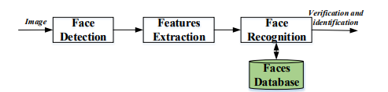

Figure . Basic face recognition building blocks

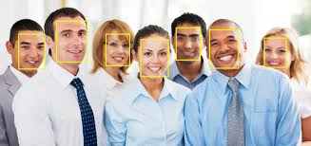

Figure . Bounding boxes found by the face detector

Face Detection - The first step of face recognition begins with the face detection of the human faces, the face detection is to determine that there is the input image that has human faces inside (Kortli, 2019). It will take the images as the input and locates face areas within the images and it will process and separate the human faces with the non-face background (AL-Allaf, 2014). After it detected the faces in the image, it will return the coordinates of a bounding box for the human faces in the image based on Figure 2.5.2 above (Saez-Trigueros, 2018). After that, the face images will be cropped to fix the locations of the image as a set of reference points, it will use the landmark detector to find a set of facial landmarks such as simple 2D or 3D alignment to fix the locations of the image as the reference points (Saez-Trigueros, 2018).

Feature Extraction – In this step, the function of the feature extraction is to extract the features of the face images collected and detected in the face detection step (Kortli, 2019). It will transform the pixel of the face images into a useful vector representation (Lin, 2000). It will show the face with a set of features vector called a “signature” that describes the special features of the human’s face in the image such as eyes, nose, and the mouth with their geometry distribution because every human’s face is evaluated by its structure, size, and shape to get verified or identified (Kortli, 2019).

Face Recognition – Face recognition is the last step to complete the whole face recognition system. This step will be based on the normalized face image and facial feature locations derived from the feature extraction step (AL-Allaf, 2014), it will search the database to find the best match to the incoming face image input (Lin, 2000). The algorithm will return the related identity after the close match is found (AL-Allaf, 2014). In face recognition, there are two general applications which are face identification and face verification based on the research (Idiap, 2021). Face identification is more on identify a human based on the image of a face and the human image will be compared with the database to identify the person. Besides that, face verification is more on validating a claimed identity based on the image of a face, it will either accepting or rejecting the identity claim.

### Algorithms of face detection and face recognition

- **Haar cascades**

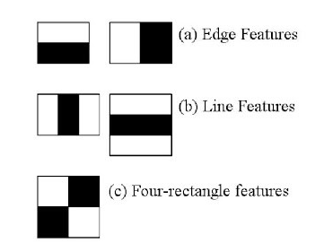

Figure . Types of Haar-like features

In this section, the haar cascades algorithm will be introduced. Haar cascades classifier is an algorithm where a cascade function is trained and detects the human’s face in the images, it will use the edge, line, and four rectangles in the algorithm (Chinimilli, 2020). According to Figure 2.5.3 above, it showed the haar features are the first step of face detection, it can easily find out the edges of the lines in the image and pick out the area where there is a sudden change in the intensities of the pixels (Behera, 2020).

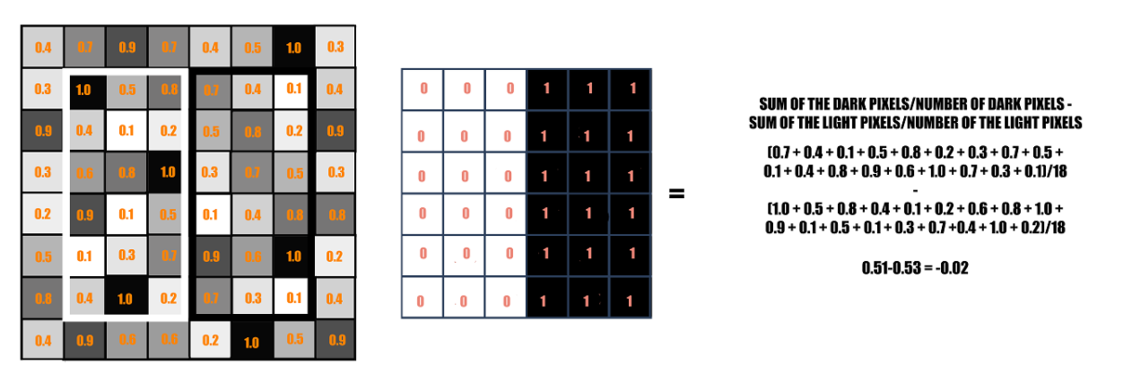

Figure . Calculation of haar value

According to Figure 2.5.4, the rectangle on the left side is the image’s representation with the values from 0.0 to 1.0, the center is the kernel which consisting of light pixels on the left and the dark pixels on the right. The values of the light areas will be 0 and the values of the dark values will be 1. The calculation of the haar value will be summing up both light and dark values together and find other their difference (Behera, 2020). The final calculation which is close to 1 will consider there is an edge detected by the haar feature. 24 x 24 windows results in over 160,000 features and each of the features is needed to find the sum of the pixels under the white and black rectangle. To solve the problem, the integral image and AdaBoost algorithm will be used to reduce the 160,000 features to 60,000 features (Selvi.R, 2019). According to the research (Alto, 2019), an integral image is a data structure and algorithm which generating the sum of values in a rectangle subset of a grid, the sums of pixel intensities in the window will be obtained after the reduction number of calculations based on the Figure 2.5.5 below. The figure showed that the haar value 0.54 is closer to 1 compared to Figure 2.5.4 above.

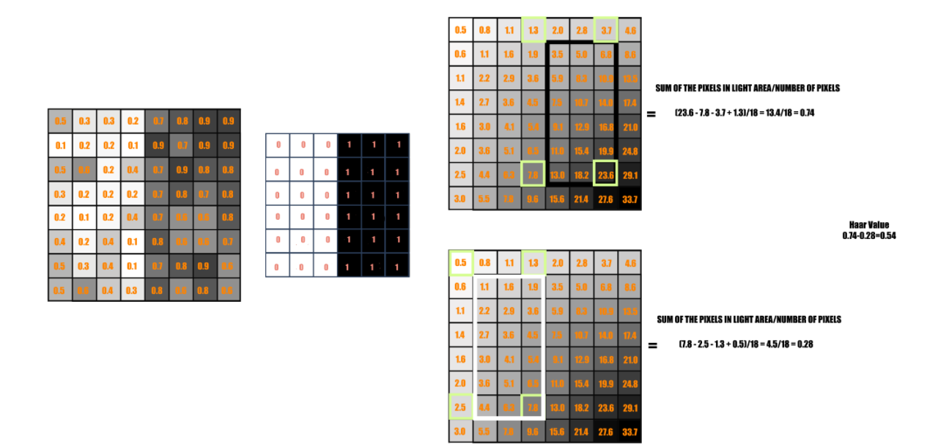

Figure . Calculation in Integral Image

The next step is using the Adaboost which are 160000 features were applied in the images separately to create a Weak Learner to decide which ones are good, the weak learners can make the final set of features reduced to 6000 of them because they produced low error rates as the positive images are separated from the negative images (Behera, 2020). The last step will be introduced as a final element of optimization, it is known that the 16000 features are reduced but the latter is still high and waste times to apply all features in all windows (Alto, 2019). The Cascade of classifiers will be used to group the features into different stages of classifiers and apply them one by one. For example, it will not consider remaining features if the window falls on the first stage, it only enters the second after the first stage is passed.

* **Eigenfaces**

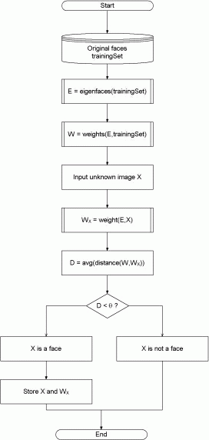

Figure . The flow of the eigenfaces algorithm

Eigenfaces were developed in 1987 by Sirovich and Kirby, the algorithm is used by Matthew Turk and Alex Pentland for face recognition (Jangir, 2018). The eigenfaces algorithm is used in the human face recognition with a set of eigenvectors, the approach covers face recognition into a two-dimensional recognition problem (Parmar, 2014). Figure 2.5.6, it showed that the flow of the eigenfaces algorithm for face recognition purposes. The first step is inserting a set of the original images as the training set into the database and it will transform into a set of eigenfaces E to compare the images (Parmar, 2014). To transform into the Eigenfaces, it will extract the characteristics features from the faces such as eyes and mouths to make sure the images are normalized to line up and resized to the same size to create the eigenfaces. After the eigenfaces are created, a mathematical tool called Principal Component Analysis will be used to extract the image of the eigenfaces. In the third step, the images in the training set will be represented into the vector of weights, and the weights are calculated and stored into the set W (PISSARENKO, 2002). After the vector of weights in the training set is calculated, it will accept the incoming image, which is set as X, the weight of the incoming image will be calculated as well and stored in the vector Wx. After that, it will compare the weights of the Wx with the weights of the training set W by calculating the average distance D between the weight vectors from the Wx which is the unknown image and the weight vectors from the training set W with the Euclidean distance. After the average distance calculated, it will be considered as not a face or unidentified when the weight vector of Wx is over the threshold, it will be considered as a face or identified when the weight vector of the Wx is closest to the weights in the database (Parmar, 2014).

* **Fisherfaces**

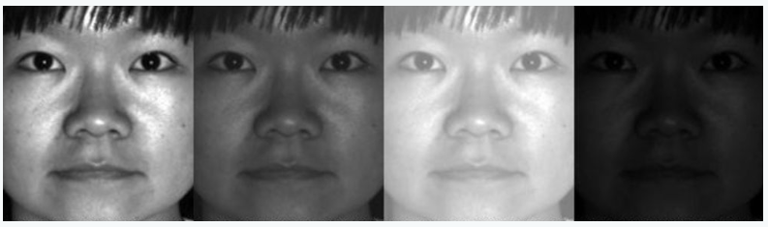

Figure . Face recognition using Fisherfaces algorithm

There is another algorithm using in face recognition which is Fisherfaces. Fisherfaces is the modified version of the Eigenfaces algorithm (Li, 2021), the Eigenfaces is considered that the illumination is very important to represent the features such as eyes, nose, or lips of the human face, but this is not the main factor why Fisherfaces is the modified version of the Eigenfaces algorithm (Yashwant, 2021). The main reason why the Fisherfaces is the modified version of the Eigenfaces is that the Fisherfaces can separate one human from another to avoid the human’s features dominating the other human’s features.

The first step of the Fisherfaces algorithm is the retrieve data process. The process will collect the data in the form of face images and it can be done with the photograph, the face the human will be asked to face toward the front and upright position and not blocked by other objects (Anggo, 2018). After the data retrieval process, it will go into the image processing process. The image processing process will be divided into two stages which are preprocessing stage and the processing stage. The image preprocessing will proceed before the image processing stage. In the image preprocessing stage, the human images will be converse from the RBG image to the grayscale. After that, the face data will be divided into two parts which are one part of the image will be used for training image purposes and one part of the image will be used for test image purposes (Yashwant, 2021). In the image processing stage, the Fisherfaces method will be implemented to generate the vector of the image data and match the vector characteristic of the training image and the vector characteristic of the test image using the PCA method which is calculating the average distance using the Euclidean distance formula to reduce the face space dimensions and the LDA method to obtain the characteristic features of the images. After the image training process, the last step is the image recognition process. The image recognition process is to determine how the system can recognize the test image properly. Two scenarios will happen in the image recognition process, the first of the scenario is it will identify the test image with 100% if the training image is the same as the testing image. The second scenario is it will identify the test image above 90% if the training image is not the same as the testing image, whether the image’s condition or the human’s expression will cause it, but the human’s face still is the same as the test image and training image (Anggo, 2018).

.

* **Local Binary Pattern Histogram (LBPH)**

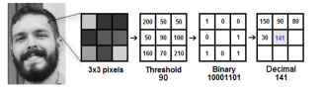

Figure . The process of Local Binary Pattern (LBP)

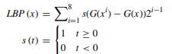

Figure . Mathematical formulation of LBP operator

The last face recognition algorithm that will be introduced is the Local Binary Pattern Histogram Algorithm. Local Binary Pattern Histogram is the combination of the Local Binary Pattern and the Histograms of Oriented Gradients descriptor, LBP is very simple and it can extract and label the pixels of an image efficiently (Deeba, 2019). LBP is to shorten the local special arrangement of the face image, the operator of LBP which was introduced by Ojala et al, is the number of binary ratios of pixel intensity in the center pixel which is approximately 8 pixels (Ahmed, 2018). The LBPH algorithm can be used to reduce the image dimension, it can extract the texture of the feature of the image by dividing the image into local regions and extract the binary pattern for each local region (ABUZNEID, 2018).

According to Figure 2.5.8, the first step of the LBPH is to convert the colored image into a grayscale image (Ahmed, 2018), the next step is creating a 3x3 pixels window in the grayscale image. Each pixel in the window will be compared with each of its eight neighbors and the center pixel in the window will be set as the threshold value (ABUZNEID, 2018). It will keep the center pixel value as the reference and compare the pixel to the other eight neighbor pixels, it will set as 1 if the neighbor pixels are higher than the value in the center pixel, otherwise, it will set as 0 if the neighbor pixels are lower than the value in the center pixel and the formula is stated at the Figure 2.5.9 above, then the output will be binary number and it will be converted into a 256-dimensional decimal number. (Ahmed, 2018).

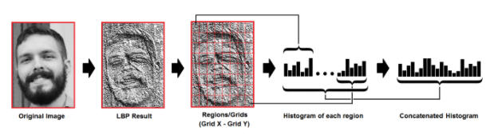

Figure . Calculation of total histograms

After getting the LBP result, a histogram for the image and formed a data vector to describe the patterns of the original image, will show the frequency of LBP results for each pixel in the histogram in 256 positions (Ahmed, 2018). It will calculate the values of 256 positions in each pixel of the image with the Nx and Ny, it will form a more significant histogram after all the histograms of the image pixels have been concatenated. For example, the Nx is set as 5 and Ny as 5, then it will use the formula 5 x 5 x 256 to get the total histograms which are 6400 positions to get the one data vector. The last step is the classification after calculating the total histograms. This step will use the Euclidean distance classifier to calculate the distance of the test image features and the image features stored in the database, the minimum distance value of both images will state the recognition rate after the calculation of the Euclidean distance (L, 2018).

## Project Development Tools

- **PyCharm Community Edition**



Figure . Logo of PyCharm Community Edition

In this project, the objective of the project is to develop a web-based gym system with biometric identification on the website. To develop a perfect website, PyCharm Community Edition will be used to develop the web-based gym system. Microsoft Visual Studio is an integrated development environment (IDE) from Microsoft which used to develop computer programs such as websites, web apps, web services, and mobile apps (Incredibuild, 2021).

In PyCharm Community Edition, there is a built-in feature which saves times while the application will take care of the routine, it will focus on the bigger things and embrace the keyboard-centric to get the productivity features. PyCharm knows everything of the code using the intelligent code completion, can find the errors easily based on the research (PyCharm, 2021) . The PyCharm Community Edition is an open-source development platform to let the students free to use platform. Microsoft Visual Studio supports programming languages such as HTML, CSS, and JavaScript which are used to develop a basic website. Besides that, it also supports downloading external plugins available through PyCharm Community Edition which will be used for the implementation of the face recognition system.

* **Flask**



Figure . Logo of Flask

According to the research (Sareen, 2018), Flask is as known as a micro-framework and the language using in the Flask is Python. Flask is a lightweight WSGI web application framework that can make getting started quick and easy to scale up with complex applications, it is a very popular Python web application framework based on the research (palletsprojects, 2021). The license of Flask is under a three clause BSD which is open-source that enables the users to do what they desired as long as the copyright sticks around based on the research (flask, 2021). It is a web framework which is a software framework used to develop web applications and deploy them. The reason why Flask is classified as a micro-framework is it does not require any tools or libraries in this application.

Besides that, the Flask does not have any database abstraction later or form validation, so that it will not care about the decision of database used in the Flask, and decision also can be easy to change based on the research (Sareen, 2018). To build the web-based gym system, the Flask will be the best choice in developing the website. The flask will be imported into the Microsoft Visual Studio as the object because the web-based gym system will implement the face recognition feature which is using the OpenCV to implement the algorithm into the website.

* **OpenCV**



Figure . Logo of OpenCV

OpenCV as known as Open Source Computer Vision Library is a huge open-source library for computer vision, machine learning, and image processing because they played a major role in real-time operation which is very important based on the research (GeeksforGeeks, 2021 ). To achieve the objective of face recognition in the gym system, OpenCV can process images and videos to identify human faces. The OpenCV is released under a BSD license which is an open-source license and it is enabled for academic and commercial use. OpenCV supports programming interfaces like C++ and Python, and the OpenCV will be used in the Python language in this project.

In applications of the OpenCV, there are a lot of the applications are using OpenCV which are face recognition, automated surveillance, medical image analysis, and others based on the research (GeeksforGeeks, 2021 ). To use OpenCV in Python, all the OpenCV array structures are converted to and from the Numpy arrays which are a highly optimized library for numeric operations with a MATLAB-style syntax based on the research (docs-opencv, 2021). It is very simple to read to code because of the simplicity of the Python language which enables the programmer to express ideas in fewer codes without reducing readability.

* **phpMyAdmin**



Figure . Logo of phpMyAdmin

In this project, the database is very important for the gym’s website because it needs to store a lot of important information such as the credential of the gym users, the equipment of the gym, the inquiry information from the users, and others. In this project, the database that will be used on the gym’s website is phpMyAdmin. PhpMyAdmin is an open-source and free software tool to be used for managing the databases, the phpMyAdmin is one of the most popular applications for MySQL database management based on the research (SiteGround, 2021). According to the research (phpMyAdmin, 2021), the software tool can be used to perform operations such as managing the databases, tables, columns, and others, it also can directly execute the statement of SQL.

According to the research (SiteGround, 2021), there are several features in the phpMyAdmin, there is an intuitive web interface, supports most of the MySQL features such as browse and drop databases, create, and copy the databases, manage stored procedures, and others. Besides that, it also can import data from the CSV and the SQL.

# 

# Research Methodology

## Methodology

As mentioned in chapter 1 about the primary research plan used in this project, the methodology used in this whole project is the waterfall methodology. In this chapter, every phase of the methodology will be discussed in detail with the diagrams and the code implemented in the project.

### Requirement Analysis

In the first stage of the project development, the most important part is to analyze the project requirements to understand what the needs of the project are. In this project, it proposed that to develop image processing in the gym system, the objectives are stated in the proposal to determine the range of requirement gatherings.

The first objective proposed is *to develop a system that able to capture the clock in and out of the member through facial recognition.* The system will be required to have the image of the member's face and store it into the face training folder, it only can let the members perform the clock in and clock out through face recognition.

The second objective proposed is *to develop a system that allows admin to generate reports such as sales reports and member reports.* The system will be required to retrieve the total sales and the total members of the gym from the database, the retrieved data will be converted into PDF format and downloaded to view it.

The last objective proposed is *to develop a web-based gym management system that allows the automation of gym management instead of paper-based.* The system will be required to let the users or members of the gym join the membership and make payment of the membership through the website of the gym instead of paper-based which will waste a lot of paper and save the environment.

#### Development Requirement

The proposed project idea is to develop a face recognition system that required image training with the image of the member's face. To perform the feature, it needs to understand the knowledge of Artificial Intelligence and Image Processing. Besides that, it also needs the knowledge of website development because the face recognition feature will deploy on the webpage. After gathering the requirements of the project, the diagram shown below is the Requirement Breakdown Structure to show the modules that will be developed in the design phase.

FaceGym-Web based gym system with face recognition (User)

Membership Checkout

Facilities

Register

Sign Up with credential 

Display checkout detail

Display the facilities of the gym

Email

Display the description of the gym

About Us

Package Name

Username

Password

Login

Package Price

Login with credential 

Email

Password

Package Duration

Button to let the users to join as members

Display the packages of the gym

Membership

Display the real-time clock in members in the gym

Real-time

Display the classes of the gym

Classes

Card Number

Display card payment form

Homepage

Exp Month

Display the gallery of the gym

Display the benefits of the gym

Display poster of the gym

Exp Year

CVV

Cancel

Checkout

Display the membership information

Require face image for training

Face Image

Display the profile detail of the logged user

Profile

Face Image

Require face image for training

Checkout

Cancel

Name

Display wallet payment form

Membership Checkout with wallet

Package Duration

Package Price

Package Name

Display checkout detail

Password

Amount

Top up with credential 

Top Up

FaceGym-Web based gym system with face recognition (User)

View Members

Display table of all view members

Generate report in PDF format

Payment Status

Generate report in PDF format

Display table of all payment status

Login

Password

Name

Login with credential 

Clock out

Display webcam

Display webcam

Clock in

Generate report in PDF format

Display table of all comments

Comments

Display total comments

Display total sales

Display total members joined

Dashboard

Allow members clock in

Allow members clock out

Display real time members

Homepage

FaceGym-Web based gym system with face recognition (Admin)

Figure . RBS Diagrams of user and admin

According to Figure 3.1.1 above, the RBS diagrams are the module to be developed in the design phase and it will proceed to the implementation phase as well. There are user interfaces and admin interfaces in this project, the different interfaces will display different functions. Besides that, the priority level is also very important for the modules to understand the priority level during the development phase.

|  |  |
| --- | --- |
| **Modules** | **Priority Level** |
| **Register** | **High** |
| **Login** | **High** |
| **Homepage** | **Medium** |
| **Facilities** | **Low** |
| **Classes** | **Low** |
| **About Us** | **Low** |
| **Real-Time** | **High** |
| **Membership** | **Medium** |
| **Top up** | **Medium** |
| **Profile** | **Medium** |
| **Payment Status** | **Medium** |
| **Membership checkout** | **High** |

Table Priority Level (User Interface)

|  |  |
| --- | --- |
| **Modules** | **Priority Level** |
| **Login** | **High** |
| **Homepage** | **Medium** |
| **Dashboard** | **Low** |
| **Comments** | **Low** |
| **View Member** | **High** |
| **Payment Status** | **High** |
| **Clock In** | **High** |
| **Clock Out** | **High** |

Table Priority Level (Admin Interface)

According to the Table 2 and Table 3above, clearly showed all the priority levels in the modules. According to the table in the User Interface, the Register, Login, Real-Time, and the Membership Checkout are labeled as High because the members need to register and login as the logged users on the website to join as the member, then the membership checkout page will require the face image of the members to store in face training to run the clock in and clock out through face recognition successfully. According to the priority level table in the Admin Interface, the Login, View Member, Payment Status, Clock in, and Clock out are labeled as High because the admin is required to login before using any feature in the Admin Interface, the view member and payment status are the second objectives of the project which is “*To develop a system that allows the admin to generate the reports such as sales report and members report*”, the view member will show the members of the gym and the payment status is the payment status of the members in the gym. The Clock in and Clock out are to be used to capture the face of the members to let them clock in and clock out the gym easily and touchless. The medium and low priority level modules will be developed after the high priority level modules are developed. Besides that, there is the Gantt Chart to be conducted to let the developer make sure the timeline of the project to ensure the progress is on track. Figure 3.1.2 below showed the Gantt Chart of the overview planning.

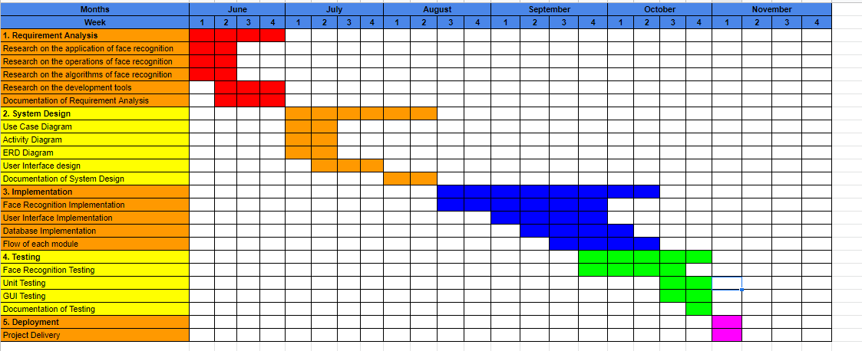

Figure . Gantt Chart of the project

According to the Figure above, it showed the tasks are scheduled through the Gantt Chart. All the phases will be completed phase by phase due to the waterfall model except the implementation and the testing will be overlapped because it will test and find the bugs, it will then code again. The process is repetitive until all the testing and the coding are completed.

|  |  |
| --- | --- |
| Hardware Specifications | CPU: Intel Core i5-6200U, 2.8GHz x64  RAM: 4GB  Storage: 1TB HDD |
| Software and Tools Specifications | PyCharm Community Edition  Python IDLE  XAMPP  PhpMyAdmin  Microsoft Excel |
| Operating System | Window 10 |

Figure . Development Requirement

According to the Figure 3.1.3 above, it showed the hardware, software, and operating system requirements. In this project development, the laptop is using the processor of Intel i5 and the RAM is 4GB. In the software requirement, the PyCharm Community Edition was used to develop the application, and the Python IDLE is used as a backup to change some little changes because it required time to open PyCharm since the laptop is using HDD only. On the database side, the XAMPP is used as the connector to connect the code in the PyCharm with the PhpMyAdmin which is the MySQL database that will be used in the development. Microsoft Excel is used to open the CSV file to check the clock in and clock out data of the members. The operating system used in the project development is Window 10.

It stated that the backend will use the PhpMyAdmin which is MySQL as the database to store the important data from the users such as the user credentials, user payment, user comments, and others. Besides that, the CSV file mentioned above is to store the time and name of the members when they clock in or clock out in the gym, the data will be passed in and out the CSV files. It will also display the real-time members in the gym by retrieving the data in the clock in a CSV file.

### System Design

After the basic concept, the functionality, and the hardware & software requirement stated on the project requirement, the next step will be going into the system design. This system design phase will state the flow of each module and the backend database design as well.

The first step in the system design phase is to show out the module’s activity flow, it is very important because the developer can develop the product based on the activity flow provided. The use case diagrams, activity diagrams, and entity-relationship diagrams are planned and illustrated. The Figures below showed the use case, activity, and entity-relationship diagram.

#### Use Case Diagrams

In this section, the use case diagrams will illustrate the modules of the user and the admin.

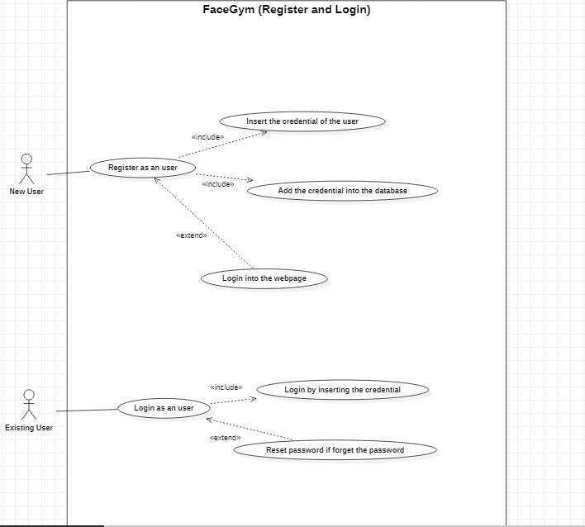

Figure . Use Case Diagram for register and login module

According to the Figure 3.1.4 above, the Figure showed that the new user of the gym website can register as a user of the gym through the website, the existing user can log in to use the function of the gym on the website, they can also reset the password when they forget the password.

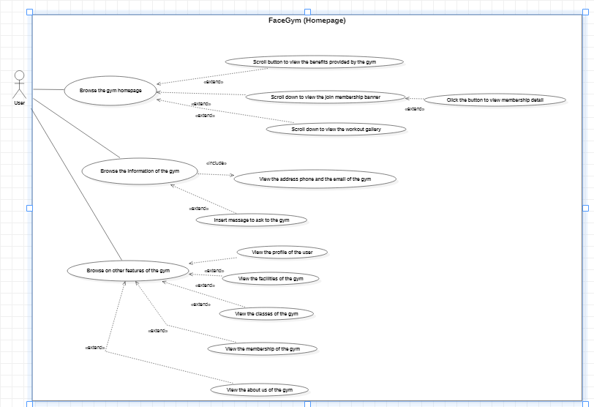

Figure . Use Case Diagram for user homepage

According to the Figure 3.1.5 above, the Figure showed that the user can browse the gym homepage to see all the information about the gym, it also has a side navigation bar to let the users browse other modules.

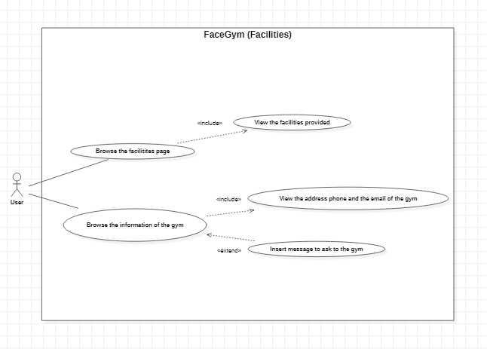

Figure . Use Case Diagram for user facilities

According to the Figure 3.1.6 above, the Figure showed that the user can browse the gym facilities page to view all the facilities in the gym.

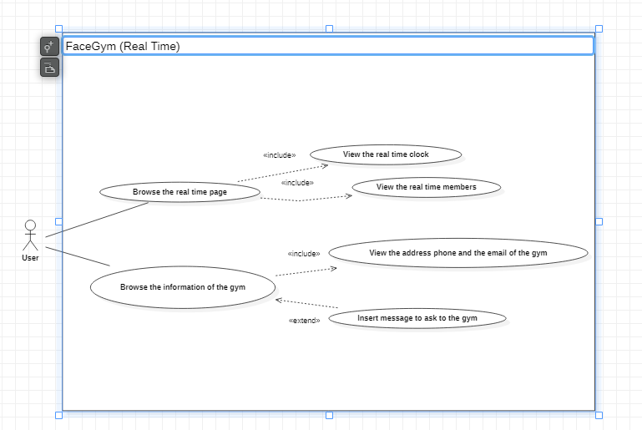

Figure . Use Case Diagram for using real-time

According to the Figure 3.1.7 above, the Figure showed that the user can browse the real-time page to view the real-time clock and the real-time members in the gym.

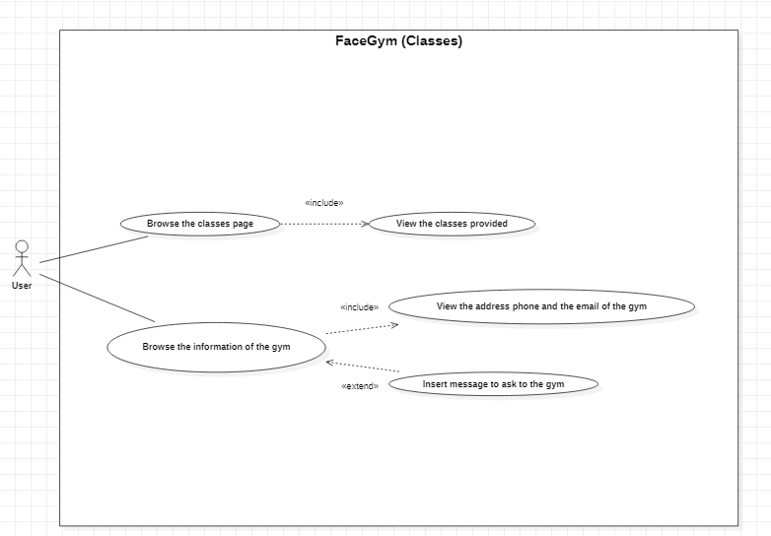

Figure . Use Case Diagram for user classes

According to the Figure 3.1.8 above, the Figure showed that the user can browse the gym classes page to view all the classes provided in the gym.

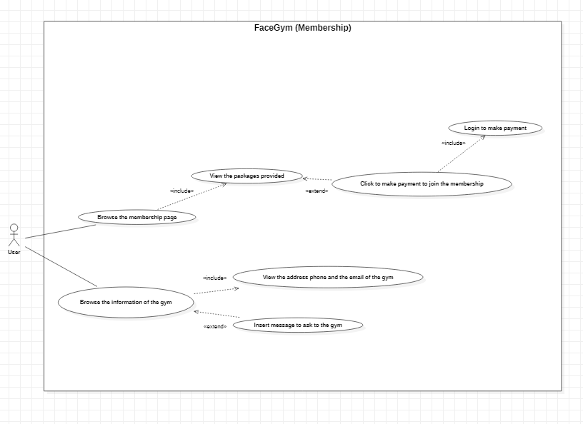

Figure . Use Case Diagram for user memberships

According to the Figure 3.1.9 above, the Figure showed that the user can browse the gym membership page to view the packages provided by the gym. The user also can join as a member of the gym through the website after logging in.

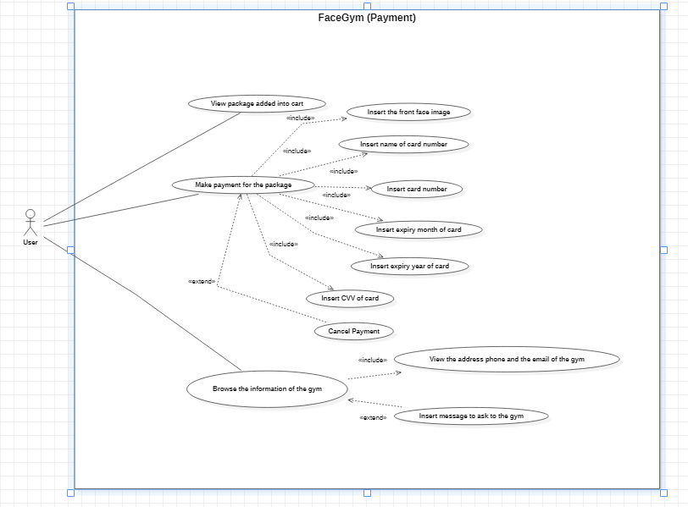

Figure . Use Case Diagram for user payment

According to the Figure 3.1.10 above, the Figure showed that the user can browse the gym payment page to make payment to join as a member of the gym. The user is required to log in and choose the package they desired and make payment through the method they wanted easily.

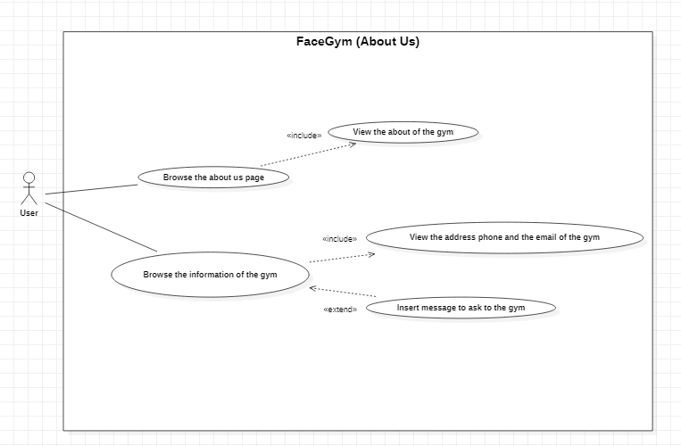

Figure . Use Case Diagram for user about-us

According to the Figure 3.1.11 above, the Figure showed that the user can browse the about us page to view the description about the gym through the website.

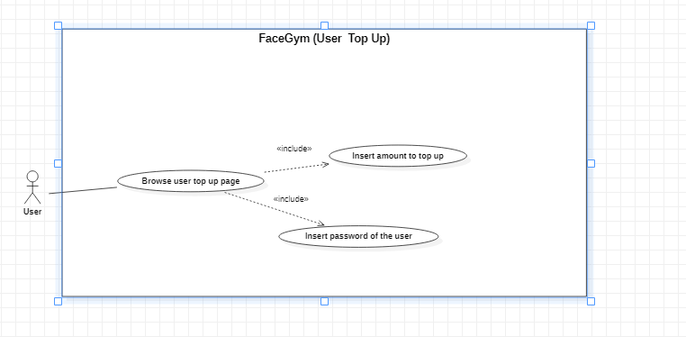

Figure . Use Case Diagram for user top-up

According to the Figure 3.1.12 above, the Figure showed that users can browse the top-up page to top up the wallet amount through the website.

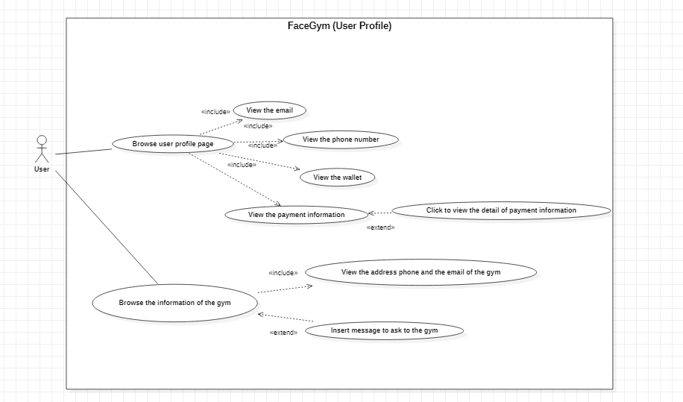

Figure . Use Case Diagram for user profile

According to the Figure 3.1.13 above, the Figure showed that the user can browse the profile to view the user’s information through the website.

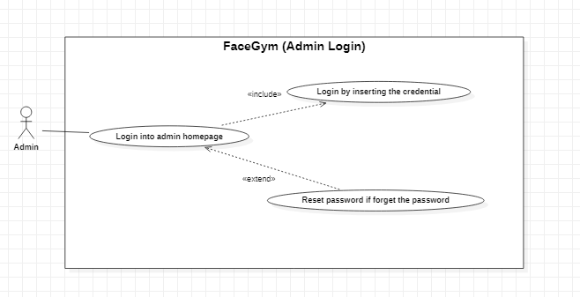

Figure . Use Case Diagram for the admin login

According to the Figure 3.1.14 above, the Figure showed that the admin needs to login into the admin homepage to use the functions, they can reset the password if they forget the password.

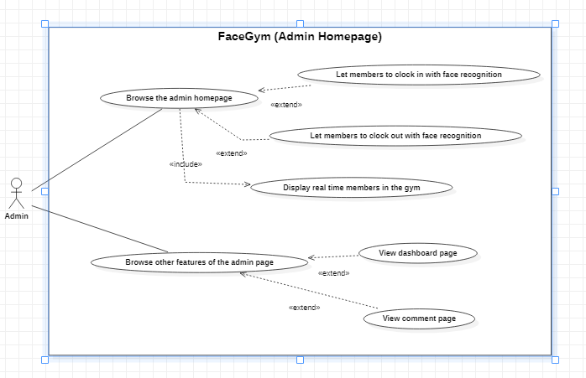

Figure . Use Case Diagram for the admin homepage

According to the Figure 3.1.15 above, it showed that the admin can browse the admin homepage. The homepage allows the members in the gym to clock in or clock out with face recognition, it also can let the members know the real-time members in the gym. Besides that, the admin can browse other features in the other web pages such as dashboard or comment pages.

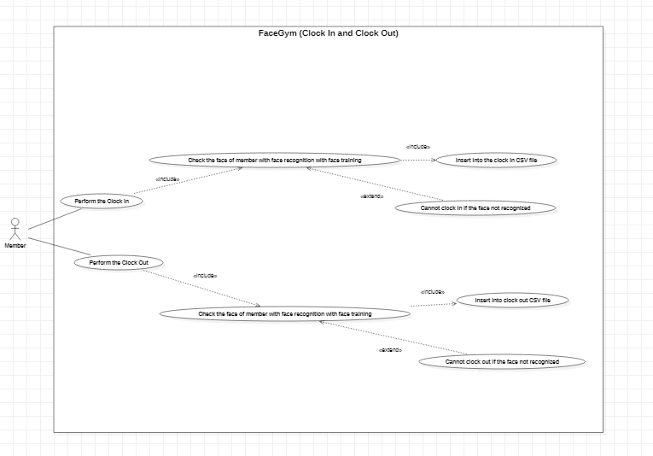

Figure . Use Case Diagram for the member clock in and clock out

According to the Figure 3.1.16 above, it showed that the members can clock in or clock out after pressing the button on the admin homepage. After entering the webpage of the clock in or clock out, it will recognize the face of the members to check the faces are exist, it cannot clock in or clock out if the faces are not recognized. After the members clock in or clock out, it will record the time into the CSV file.

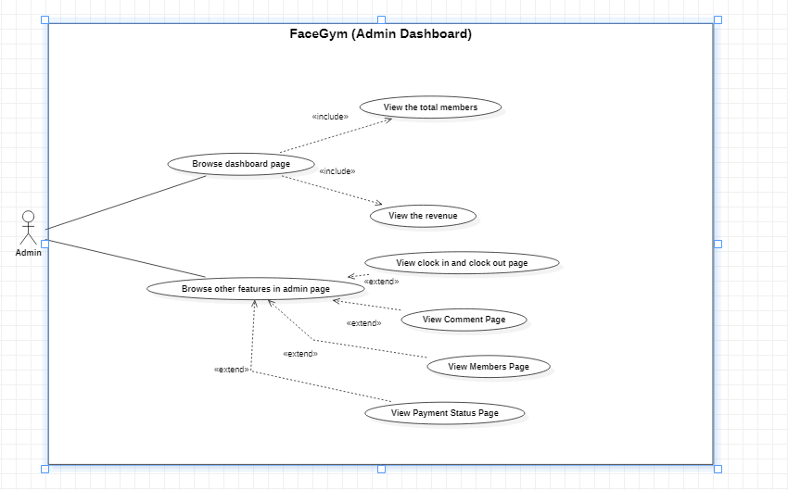

Figure . Use Case Diagram for the admin dashboard

According to the Figure 3.1.17 above, it showed that the admin can browse the dashboard page to view the total members in the gym and view the total revenue in the gym easily through the data retrieved from the database. Besides, the admin also can browse other features on the admin page.

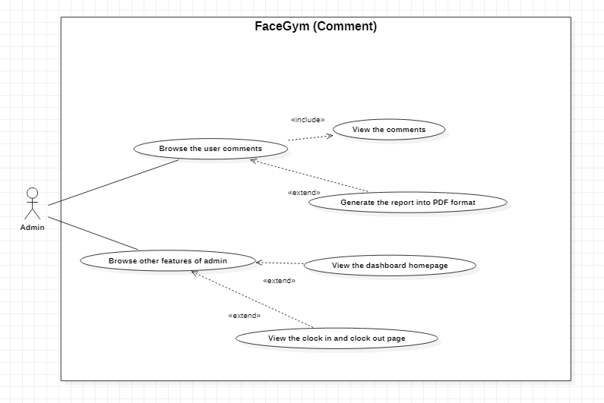

Figure . Use Case Diagram for the admin comment

According to the Figure 3.1.18 above, it showed that the admin can browse the comment page to view the comments left by the users to know their questions them. It also can generate the report into PDF format.

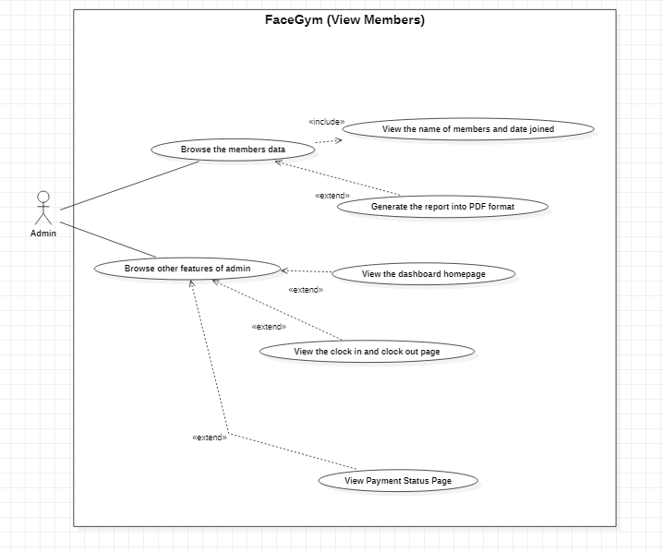

Figure . Use Case Diagram for the admin view members

According to the Figure 3.1.19 above, it showed that the admin can browse the view members page to view the information of the members in the gym to know the packages and the date they joined. It also can generate the report into PDF format.

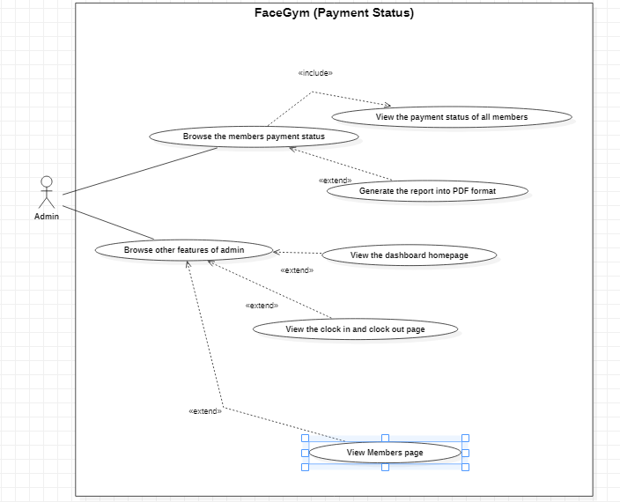

Figure . Use Case Diagram for the admin payment status

According to the Figure 3.1.20 above, it showed that the admin can browse to view the payment status of the members in the gym. It will show the name of members, amount, date expired, and the status on the webpage. It also can generate the report into PDF format.

#### Activity Diagram

In this section, the activity diagram will be conducted and discussed. The activity diagrams included the user sign up, user login, user clock in & clock out, user checkout, admin dashboard, admin view member status, and admin view payment status.

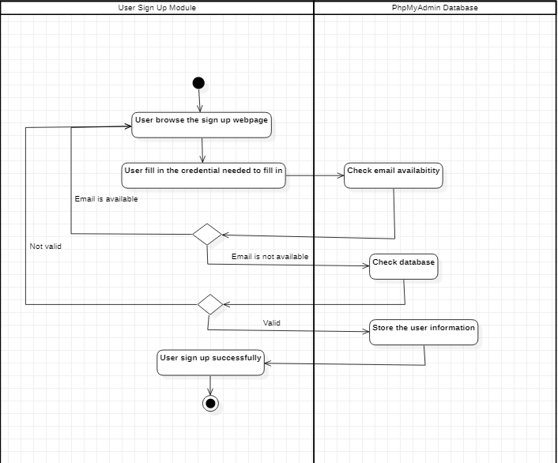

Figure . Activity Diagram of user sign up

According to the Figure 3.1.21 above, it showed the whole flow of the user sign-up when the user performs the registration procedure on the user gym website.

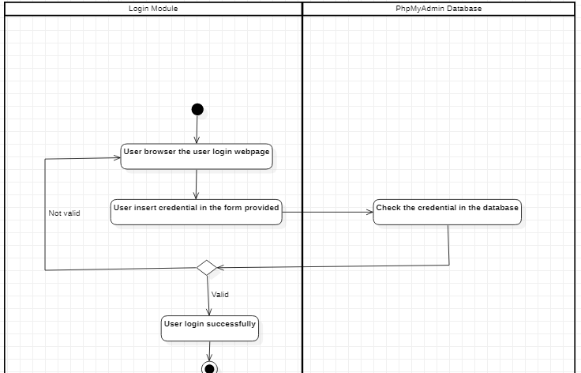

Figure . Activity Diagram of user login

According to the Figure 3.1.22 above, it showed the whole flow of the user login when the user performs the login procedure on the user gym website.

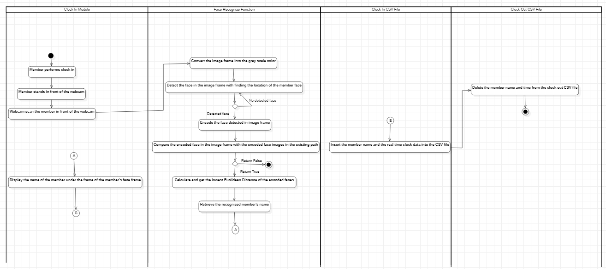

Figure . Activity Diagram of member clock in

According to the Figure 3.1.23 above, it showed the whole flow of the member clock in when the member performing the clock in the gym center.

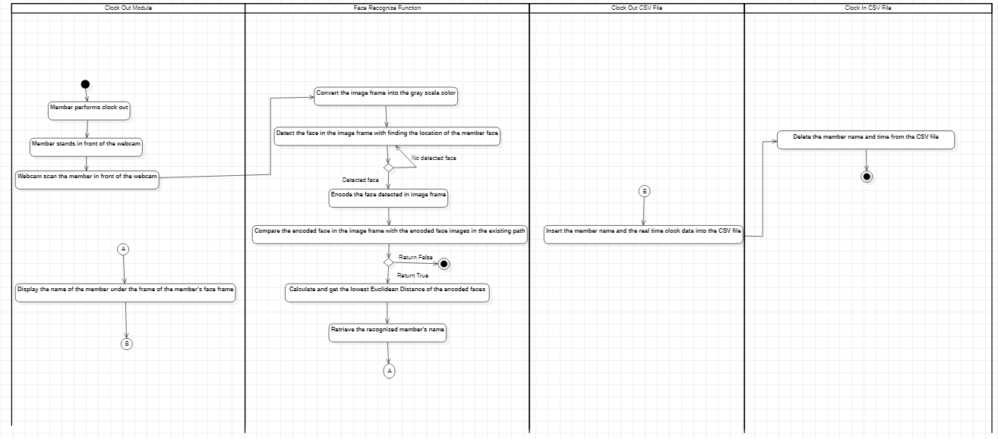

Figure . Activity Diagram of member clock out

According to the Figure 3.1.24 above, it showed the whole flow of the member's clock out when the member performing the clock out in the gym center.

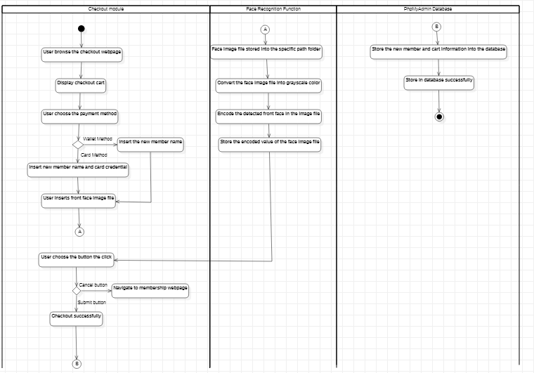

Figure . Activity Diagram of user checkout

According to the Figure 3.1.25 above, it showed the whole flow of the user checkout when the user performs the checkout procedure on the user gym website.

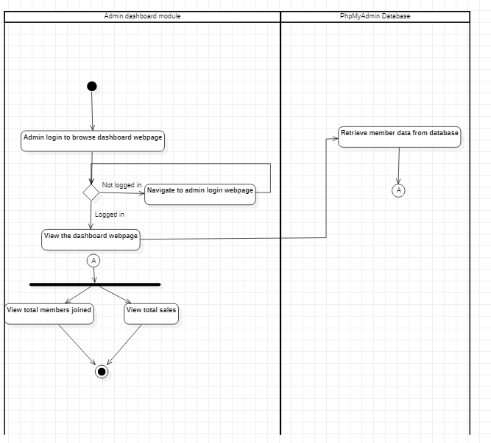

Figure . Activity Diagram of the admin dashboard

According to the Figure 3.1.26 above, it showed the whole flow of the admin dashboard when the admin performs the admin dashboard browsing in the admin gym website.

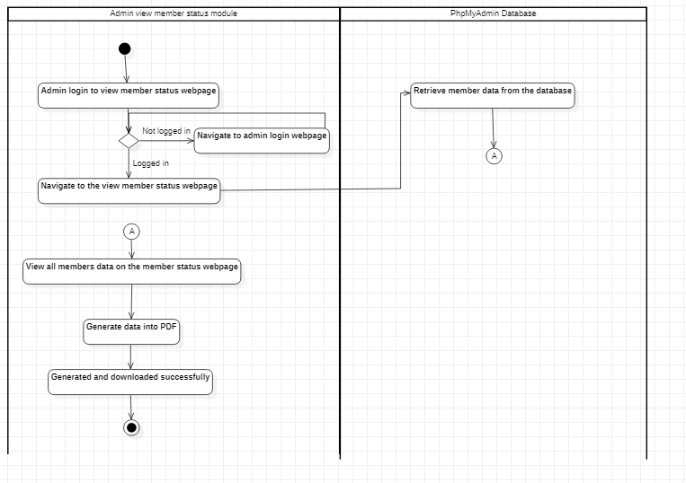

Figure . Activity Diagram of admin view member status

According to the Figure 3.1.27 above, it showed the whole flow of the admin view member status when the admin performs the admin view member status in the admin gym website.

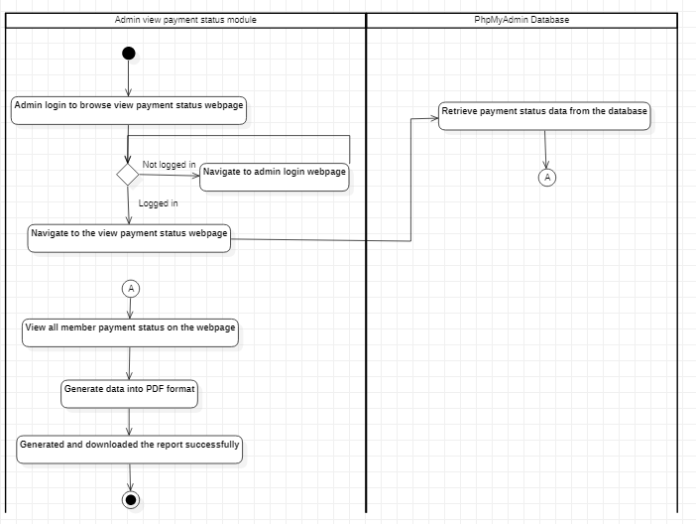

Figure . Activity Diagram of admin view payment status

According to the Figure 3.1.28 above, it showed the whole flow of the admin view payment status when the admin performs the admin view payment status in the admin gym website.

#### Database Design

In this section, the database structure will be conducted in table form. In the database, there are several tables which are consisting of the field of the record, the type of the record, the null value, and the description of the record. All the actions will be performed in the MySQL database named PhpMyAdmin.

##### Table : users

|  |  |  |  |
| --- | --- | --- | --- |
| Field | Type | Nullable | Description |
| **id** | integer | no | User’s unique ID auto-incremented by database |
| **email** | string | no | User’s email address |
| **phone** | string | no | User’s phone number |
| **wallet** | integer | no | User’s wallet amount |
| **token** | string | no | User’s token when forgot password |
| **name** | string | no | User’s name |
| **password** | string | no | User’s password |

##### Table : admin

|  |  |  |  |
| --- | --- | --- | --- |
| Field | Type | Nullable | Description |
| **id** | integer | no | Admin’s unique ID auto-incremented by database |
| **name** | string | no | Admin’s name |
| **password** | string | no | Admin’s password |

##### Table : members_joined

|  |  |  |  |
| --- | --- | --- | --- |
| Field | Type | Nullable | Description |
| user | string | no | Member’s name |
| package | string | no | Member’s package name |
| price | string | no | Member’s package price |
| date | date | no | Member’s date joined |
| expired_date | string | no | Member’s date expired |

##### Table : payment_status

|  |  |  |  |
| --- | --- | --- | --- |
| Field | Type | Nullable | Description |
| id | integer | no | Member’s unique ID auto-incremented by database |
| email | string | no | Member’s email address |
| user | string | no | Member’s name |
| amount | integer | no | Member’s payment price |
| date_started | string | no | Member’s payment’s date started |
| date_expired | string | no | Member’s payment’s date ended |
| status | string | no | Member’s payment status |

##### Table : comments

|  |  |  |  |
| --- | --- | --- | --- |
| Field | Type | Nullable | Description |
| id | integer | no | Commenter’s unique ID auto-incremented by database |
| name | string | no | Commenter’s name |
| email | string | no | Commenter’s email address |
| mobile | string | no | Commenter’s phone number |
| message | string | no | Commenter’s message detail |

#### Entity Relationship Diagram

#### In this section, the entity-relationship diagram will be conducted and discussed below.

#### 

Figure . Entity Relationship Diagram (ERD)

#### According to the Figure 3.1.29 above, it showed the ERD diagram which will be stored as the structure of the tables in the PhpMyAdmin database. In the diagram, the users, admin, and the comments tables are standalone as the tables are not connected and communicate with any other tables. The only table connection is the tables of the members_joined and the payment_status. The members_joined contains the payment_status with the one-to-many relation.

### System Implementation

In this section, the phase in the development will be entered to the implementation phase which is after the design of the project was planned and convinced. In this phase, it will combine the requirements needed and the designs needed in the project to develop a functional website. In this project, the main purpose is to develop the clock in and clock out with face recognition for the members. To achieve it, it is required to learn the OpenCV library which is in Python language, and also needs to take some time to the progress of image processing, it will allocate more time compared to the other features. It mentioned that it will combine all of the requirements which are the functions in the project and the design which are the interfaces in the project. In terms of the functionalities, the functionality will be written in Python, whereas the user interface will be written in HTML, CSS, and JavaScript, both of them are using the PyCharm Community Edition application to develop. In this FaceGym website project, all the modules will be implemented and discussed in the down sections.

#### PhpMyAdmin Usage in project development

#### The first step of the project development in the FaceGym is the usage of the database in the PhpMyAdmin. The reason why it is the first step of the project development is that the users are required to register and login into their account if they wanted to join the membership of the gym and only can insert the front face of the users when they are making the payment of the membership after they are logged in. Besides that, the register and login are also defined as a high priority in Table 2 shown above.

#### 

Figure . Table of the registered users in the gym

#### According to the Figure 3.1.30 above, it showed that the table is storing the credential of all the registered users on the gym website. In the table of the users, it will obtain the credential of the users through Python in the register progress. Before obtaining the credential of the users, it needs to connect the database with the code implemented in Python to make sure they are connected, and they can pass or retrieve the data successfully.

#### 

Figure . Database configuration in the PyCharm

#### According to the Figure 3.1.31 above, it showed that the configuration of the PhpMyAdmin in the PyCharm. It showed that it imported the library of MySQL from the flask. After that, it configures the database with the MYSQL_HOST, MYSQL_USER, MYSQL_PASSWORD, and the MYSQL_DB to make sure the database is in the PhpMyAdmin is synced. After the configuration of the database, it will go to the register and the login progress mentioned above.

#### 

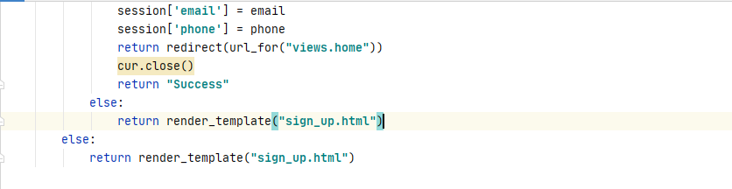

Figure . Code snippet of method “userRegistration” for user registration

According to the Figure 3.1.32 above, the code snippet is obtaining the data such as email, name, phone, and password inserted by the new user in the gym from the user sign-up page through the POST method, the password obtained from the user will be encrypted to secure the privacy of the user. After getting the credential information from the user, it will connect with the database and insert the credential information into the users table. After inserting the information into the users table successfully, it will redirect the user to the user homepage. According to the Figure 3.1.30 mentioned above, it showed that the id, wallet, and token are automatically inserted after new users are registered. The id will auto be incremented when a new user is registering on the website. The wallet will be defined as RM 0 and the users can top up their wallet to make payment for the membership easily, the token will be defined as none and the function of the token is to help the user who forgets the password and they will get the token to reset the password.

#### 

#### 

Figure . Code snippet of method “userLogin” for user login

#### According to the Figure 3.1.33 above, the code snippet is obtaining the data such as email and the password inserted by the existing users in the gym from the user login page through the POST method, the password obtained from the user will be encrypted to secure the privacy of the user. After getting the credential information from the user, it will connect with the database and retrieve the data from the tables which is the email of the user is matched with the email in the database. After that, it will verify the user’s password is matched with the password stored in the database in the encrypted method. It would redirect to the user homepage if the password inserted by the user is correct, but it will show an error message and it will redirect back to the user login page when the user’s password is not correct. It will flash other error messages when the users didn’t insert anything in the user login page, it will also redirect the user to the user homepage if the user already logged in.

#### 

Figure . Code snippet of method “userLogout” for user logout

According to the Figure 3.1.34 above, the code snippet is letting the users to log out from their account after they wanted to exit the FaceGym website. It will clear the session of the user and it will redirect the user to the user's homepage.

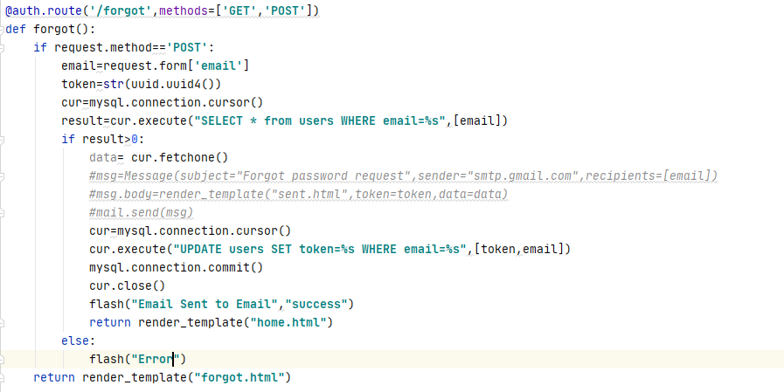

Figure . Code Snippet of forgetting password function

According to the Figure 3.1.35 above, the code showed that the function of forget() will send the token to the users when they forgot their password and the function will let the users change to a new password through the token. In the function of the forgot(), it will retrieve the email inserted by the user, there is a variable named token to store the random 128 bits objects with the uuid.uuid4() method. After that, it will query the user data from the database through the email retrieved. It will update the user's table by inserting the token generated into the token column through the email retrieved.



Figure . Email of users inserted in the webpage

According to the Figure 3.1.36 above, it showed that the users inserted the email address to get the token to create a new password.



Figure . Output of token inserted into the database

According to the Figure 3.1.37 above, it showed that the user's table had been updated and the token generated had been inserted into the token column with the email inserted by the users. After the token is inserted into the database, the next step is changing the password through the token.

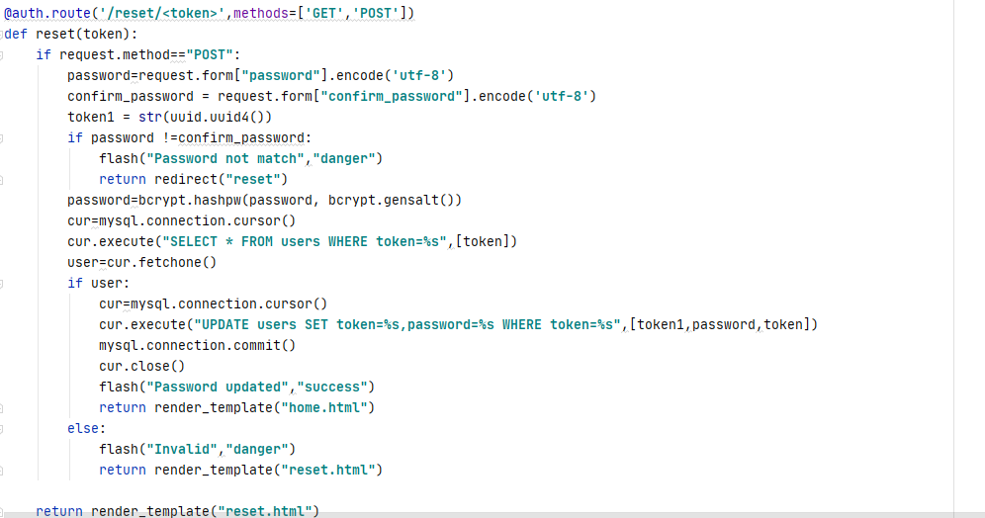

Figure . Code Snippet of the reset password function

According to the Figure 3.1.38 above, the code showed that the function of reset(token) will define the token as the parameter, it will retrieve the new password inserted by the user and there is a new variable named token1 which will store new 128 bits object into the database. After the new password gets encrypted, the database will retrieve the users table based on the token parameter passing in, it will update the users table and change the previously encrypted password into the new encrypted password. It will return to user homepage after the password had been updated.

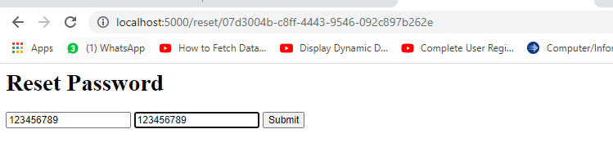

Figure . User inserting the new password in the reset webpage

According to the Figure 3.1.39 above, it showed that the users inserted the new password by entering the URL with the token provided. The password shown out on the webpage is for testing purposes, the format will be changed after the testing is done.



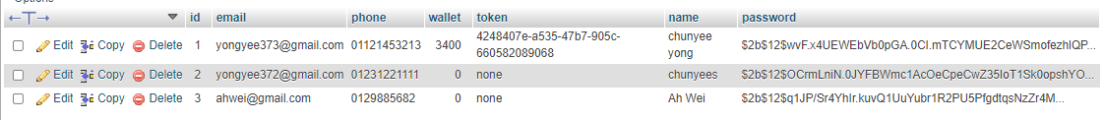

Figure . Output of the password reset successfully

According to the Figure 3.1.40 above, it showed that it navigated the users to the homepage when the users reset their password successfully. The password column in the users table also changed compared to the Figure 3.1.37, the new token was also updated in the token column as well.

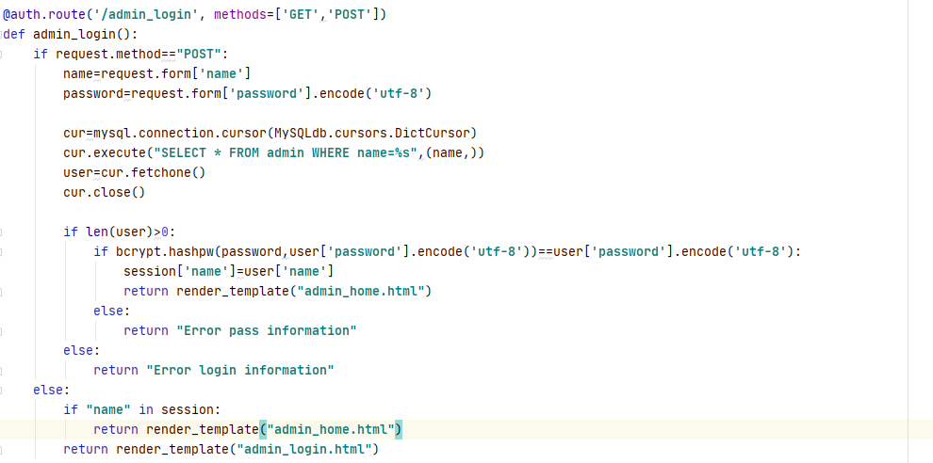

Figure . Code Snippet of method “adminLogin: for admin login

According to the Figure 3.1.41 above, the code snippet is obtaining the data such as email and the password inserted by the admin in the gym from the admin login page through the POST method, the password obtained from the admin will be encrypted to secure the privacy of the admin. After getting the credential information from the admin, it will connect with the database and retrieve the data from the tables named admin which is the email of the user is matched with the email in the database. After that, it will verify the admin’s password is matched with the password stored in the database in the encrypted method. It would redirect to the admin homepage if the password inserted by the admin is correct, but it will show an error message and it will redirect back to the admin login page when the admin’s password is not correct. The admin does not have the function of register because the credential of the admin is given to the employees with setup successfully. It also does not have the forgot password function, they need to email to seek assistance when they are facing the forgot password issue.

#### Implementation of Face Detection and Face Recognition

In this section, the face detection and face recognition implementation will be implemented in the project, and the feature is the first objective of the project, and it is stated as the high in the priority table. The face detection and face recognition will reside in the clock in and clock out module to allow the members of the gym to clock in or clock out easily with the face recognition. In this implementation of face detection and face recognition, some libraries are importing into the PyCharm Community Edition as the setup. The libraries importing the setup are the OpenCV, numpy, face recognition, os, and the datetime.

The OpenCV library is a huge open-source library for computer vision, machine learning, and image processing and it also can play important role in real-time operation, the version of the OpenCV used in this project is 4.5.3.56. The numpy library is used for working with arrays, it can work in the domain of linear algebra, and matrices. The version of the numpy used in this project is 1.21.1. The face recognition library is used for recognizing and manipulating people's faces from Python or the command line, it is the simplest face recognition library in the world using the dlib’s state-of-the-art face recognition and with deep learning. The version of the face recognition used in this project is 1.3.0. The os library is used to create and remove a folder, fetch the contents, images and changing the location of the folder. The datetime library is fetching the real-time date and time. The Figure 3.1.42 below showed the libraries and the version in the project.

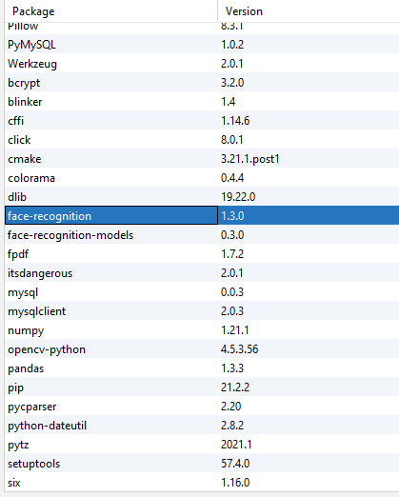

Figure . Libraries installed in the PyCharm

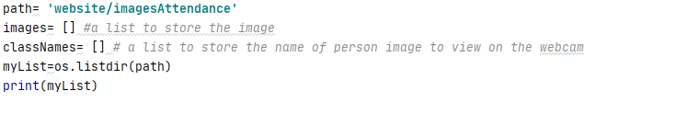

Figure . Code snippet of storing and retrieving the face images

After the libraries are setup in the PyCharm Community Edition installed, it will start implementing face detection and face recognition. According to the Figure 3.1.43 above, the first step in the implementation is to setup the path to read or store the images. After setup the path of the face images, it needs a list to store all the images and a list to store the name of the members through the images stored in the path. Before getting the file in the path, the image folders in the path need to be converted into the list, so it defined a new variable name called myList to store the image folders in the list which are converted using os.listdir() method.





Figure . Output of the myList after converted

According to the Figure 3.1.44 above, it showed that the folder is the path of storing four face images, and the output showed that it the four image folders are stored into the myList variable with the os.listdir method. The myList is used to count how many elements in the list in order to read the images in path.

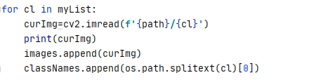

Figure . Code snippet of load images from path file

According to the Figure 3.1.45 above, the variable of myList is defined as in for loop, in each loop of the myList, the variable curImg will load the image from the path file through the index of the myList. After loading the image from the path, it will append the curImg into the list of images, the classNames list will append the image folder name in the path by splitting the text with the format of the folder such as jpg and png.



Figure . Output of the data in the classNames

According to the Figure 3.1.46 above, the output showed the name of the members stored in the list of classNames. It showed that the member names are without the picture format.

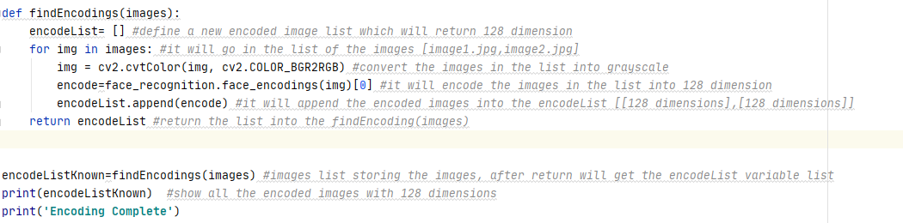

Figure . Code snippet of encoding the images in path

According to the Figure 3.1.47 above, it showed that the function to encode the face images into the 128 dimensions. To encode into the 128 dimensions, it needs to create a list called encodeList to store all the encoded images into the list. In the function of the findEncodings, the variable images will be a parameter in the function to pass into the function. It will convert the color of all face images into the grayscale color with for loop. After converting the images into the grayscale, it will encode the face images through the library of face recognition to encode them into 128 dimensions. After encoding the images, it will append the encoded values into the encodeList and return the encodeList. After encoding the images in the path, it will go into the showing webcam to detect the face of the people in front of the webcam.

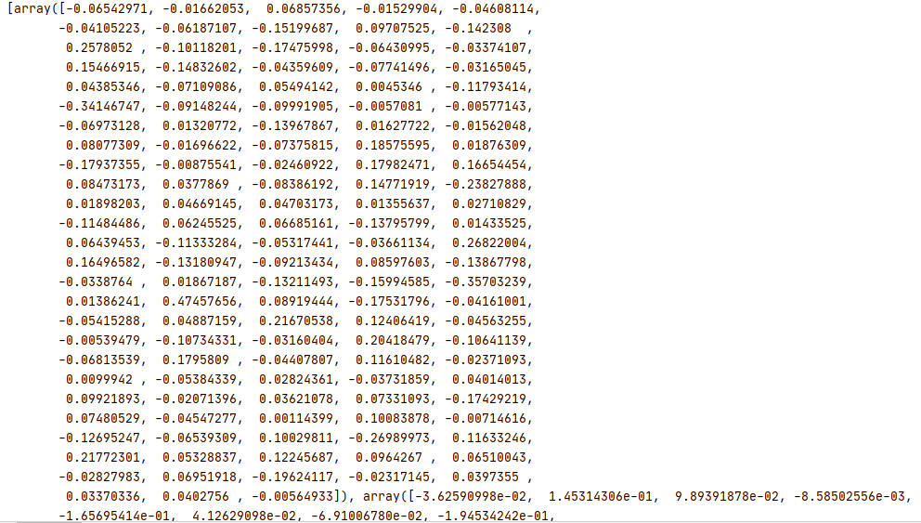

Figure . Output of one of the encoded face image

According to the Figure 3.1.48 above, the return value from the function findEncodings in 128 dimensions. The figure above showed one of the encoded face images only, the encoded images will be used to compare with the members who are in front of the webcam to check the matchings.

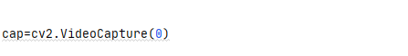

Figure . Code Snippet of video capture

According to the Figure 3.1.49 above, the cv2.VideoCapture is returning the video on the first webcam of the computer, it will set into 1 if the first webcam is used for recording purposes, and it will return the second video on the second webcam.

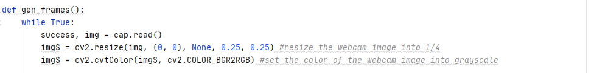

Figure . Code Snippet of the image frame

According to the Figure 3.1.50, in the function of gen_frames, there is success and img defined as cap.read(). The success is a Boolean to indicate that there is a return the frame, it will return None if there is no frame returning. After that, the new variable imgS will resize the picture in the webcam into ¼ with the cv2.resize() method. After resizing the imgS, it will convert the imgS into the grayscale color with the cv2.cvtColor().



Figure . Code Snippet of detecting face and encoding face in webcam

According to the Figure 3.1.51 above, the new variable facesCurFrame is detecting the location of the people's face in front of the webcam using the face_recognition.face_locations() method. In this method, it will return the 2d array of bounding boxes of the people's faces using the cnn face detector. It will find the location of the people's face in the resized image. The found face location in front of the webcam will return the value in (top, right, bottom, left) order. There is a new variable encodesCurFrame is encoding the people faces into 128 dimensions. In this variable, it will encode the resized images of people's faces in front of the webcam and also with the location faces founded in the variable facesCurFrame to encode the values accurately.

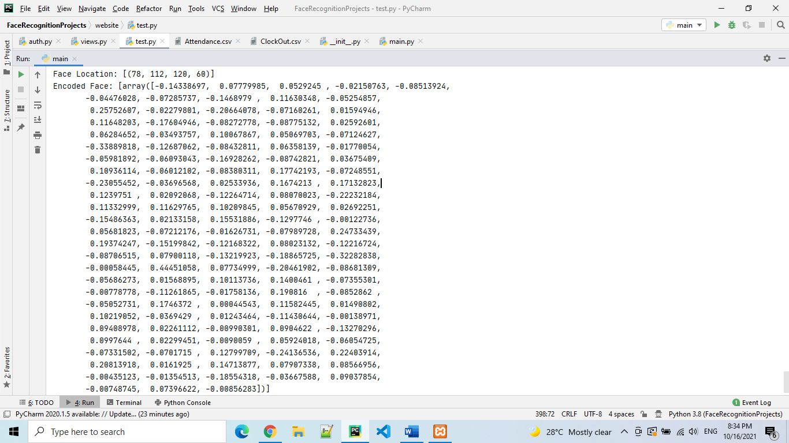

Figure . Output of face location and encoded face in webcam

According to the Figure 3.1.52 above, the output showed that the face location detected in front of the webcam and return the value of 78,112,120,60 which indicates top, right, bottom, and left. After the location of the face founded, it will encode the resized face image with the founded location value in front of the webcam in the array of 128 dimensions. After encoding the face in front of the webcam, it will enter the face recognition phase.

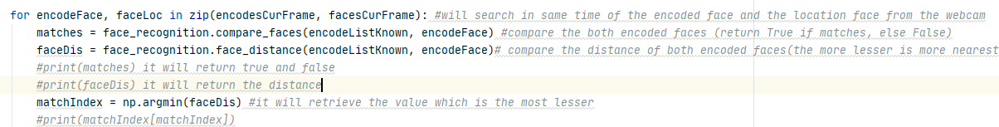

Figure . Code Snippet of comparing the encoded faces

According to the Figure 3.1.53 above, it showed the code is doing the face recognition phase which is comparing the face of the encoded face in front of a webcam and the encoded face images in the path. It iterates the variable encodesCurFrame and facesCurFrame with for loop. In each loop of the for loop, there are the matches and faceDis variables, the matches variable is comparing the encoded webcam face and the encoded face images in the path with the face_recognition.compare_faces() method. The faceDis variable is calculating the Euclidean distance between the faces of the encoded webcam face and the encoded face images in the path with the face_recogntion.face_distance() method. The variable of matches will return true or false with the array, the true indicates that it recognized the face of the people and the false indicates that it failed to recognize the face of the people. The variable of faceDis will return the distance between the similarities of the comparing faces, the value with the least will consider as the face of the people is recognized.



Figure . : Output of the matches and the face distance

According to the Figure 3.1.54 above, it showed that the output of the matches and the face distance. The output showed that it compared the four faces in the folder, it returned True in the first index of the list, it indicated that it matched the encoding, and the others returned False and it indicated the encodings are not matched. Besides that, the array of face distance showed the value of the faces. It showed that the first index in the array is the least value compared to the other indexes. After getting the distance value from the array, it will only retrieve the least value in the array with the np.argmin() method which will indicate the minimum element from the array based on the Figure above.

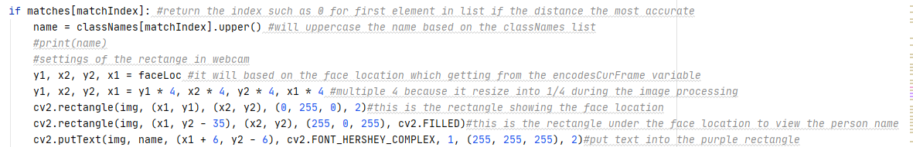

Figure . Code snippet showing the recognized faces in the webcam

According the Figure 3.1.55 above, there is a named variable to fetch the name of people which was stored inside the list of the className with the index in the matchIndex which is retrieving the minimum element from the distance list calculated above. After retrieving the name, the y1, x2, y2, and x1 are defined to retrieve the location of the face based on the faceLoc variable, it will also resize the face location with multiple of 4 because the image of the webcam resized into 1/4. After that, it will show the rectangle which the location of the people faces in front of the webcam with the cv2.rectangle() method. The (0,255,0) is defined as the green color of the rectangle, the 2 is defined as the thickness of the rectangle. There is a second rectangle that will be shown in the webcam which is to show the name of people. It will set the rectangle under the frame rectangle of showing the location of the people's faces. The color used in showing the name of the people is purple and it filled the rectangle with the cv2.filled, it will put the name of the people in the rectangle with the cv2.putText() method.

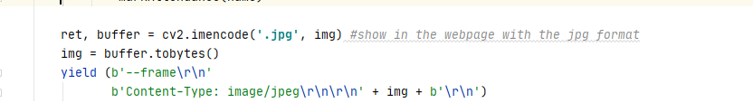

Figure . Code Snippet of showing webcam on the webpage

According to the Figure 3.1.56 above, the code showed that the setup of buffering the video of the webcam on the webpage to recognize and show the name of the people when getting recognized. The format of the image will be in the jpg format.

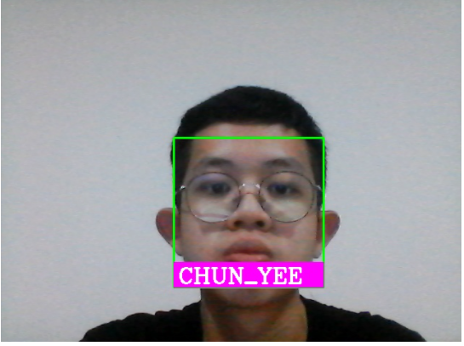

Figure . Output of the face showing in the webcam

According to the Figure 3.1.57 above, it showed that the green rectangle is showing the location of the people's faces, it showed the name of the people under the green rectangle clearly on the webcam. After the face had been recognized and shown on the webcam, the final step is to store the name and time when the webcam recognizes the face of the people when the people performing the clock in or clock out in the gym, the time will be stored into the name and time into CSV file.

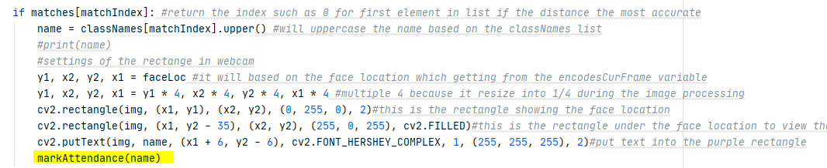

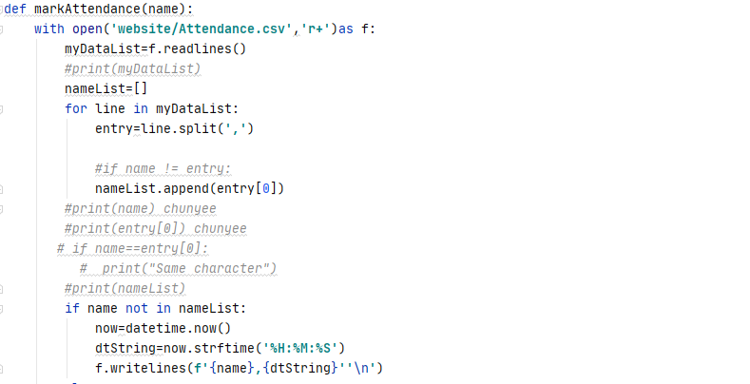

Figure . Code snippet of storing the clock in name and time

According to the Figure 3.1.58 above, it showed a function name called markAttendance() which stores the variable named name as the parameter of the markAttendance, it opened the folder named Attendance.csv and defined it as f. It will read the lines in the csv file, it will iterate the data inside the csv file with comma with the split method to split the name of the people and the time. There is a new variable named nameList to store the name getting from the recognized face into the nameList, the name stored in the nameList will be checked that there is the same name inside the nameList, it will store into the nameList if there is didn’t have the same name in the nameList, it will insert the name and the real time date which using the datetime library imported in the PyCharm into the new line, therefore it will not insert the name inside the nameList if the name already inserted inside the nameList.

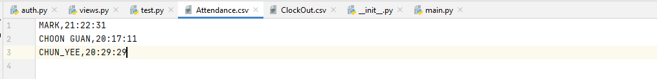

Figure . Output of name and time in Attendance.csv

According to the Figure 3.1.59 above, it showed that the name recognized just now had been inserted into the Attendance.csv file in real-time time.

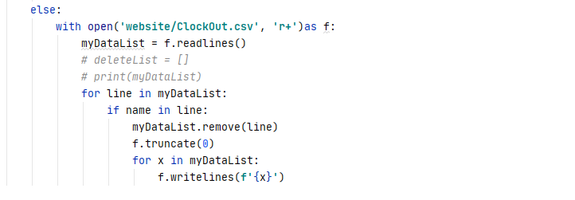

Figure . Code snippet of removing the name and time in the ClockOut.csv

According to the Figure 3.1.60 above, it showed that it will open the ClockOut.csv file when the name is already in the nameList, it will remove the name and the time in the file to avoid conflict. It will go the same with the ClockOut.csv when the people performing clock out, it will remove the name and the time in the Attendance.csv file to avoid confliction as well. The code snippet will be shown at below.

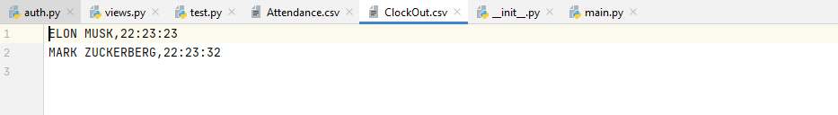

Figure . Output of ClockOut.csv

According to the Figure 3.1.61 above, it showed that there are two same names in both files.

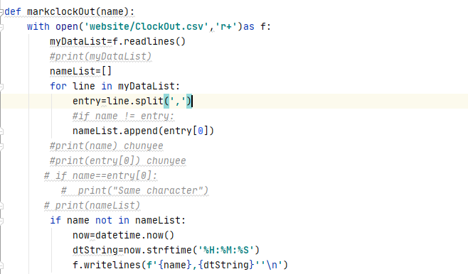

Figure . Code snippet of storing the clock out name and time

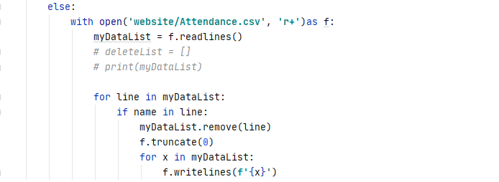

Figure . Code snippet of removing the name and time in the Attendance.csv

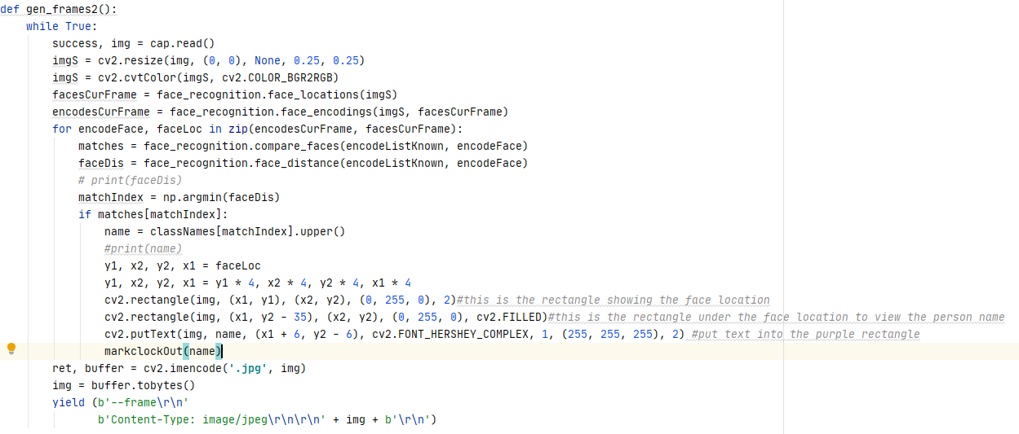’

Figure . Code snippet of function performing face recognition in clock out

|  |
| --- |
| Face Detection and Face Recognition process with code snippet |
| 1. Find the path storing the face images and creating some lists to store the face images |
| 1. Convert the face images in the path into grayscale and encode the face images |
| 1. Setting the webcam to start capturing the people face in front of |
| 1. Resize the image captured in the webcam and convert the color into grayscale |
| 1. Start detecting the location of the people faces |
| 1. Encoding the faces after detecting the people faces |
| 1. Compare and calculate the Euclidean distance to recognize the people faces |
| 1. Retrieve the least Euclidean distance after calculating in the list |
| 1. Display the location of people faces and the name after getting recognized |
| 1. Storing the name of recognized people as parameter. |
| 1. Open the csv file to store the name and real time time with validation |
| 1. Remove the line in the other csv file to avoid confliction and match the logic |

#### Implementation of real-time function

#### In this section the real-time function will be implemented in the project, the feature of the real-time is stated as high in the priority table. The real-time function will let the members know the number of current members in the gym, it provides the members of benefits knowing the members in the gym before they go to the gym center to avoid the time wasted, they may need to wait in the gym when the gym center is full capacity. It will save a lot of time when they know the real-time members in the gym center. The implementation will be discussed below.

#### 

Figure . Code Snippet of the real-time function

#### According to the Figure 3.1.65 above, it showed that in the function of real-time (), the first step is to open the file named Attendance.csv which is storing the name and time of the members when they performed the clock in the method. After retrieving and reading the data from the Attendance.csv file, there is a newList variable created to store the lines in the list in the file. It will then iterate the lines in the file, it will use the append() method to store the data into the newList variable. The userDetails variable will count the total elements in the newList to determine the total members in the gym with the len() method after the iteration is finished and the userDetails will return total amount of the members. After that, the userDetails variable will pass into the interface of the realtime.html to view the real-time members on the webpage.

#### 

Figure . Output of the real-time function

According to the Figure 3.1.66 above, it showed that the output showed that the total members of 3 in the gym and changed to 2 members after one of the members in the gym left.

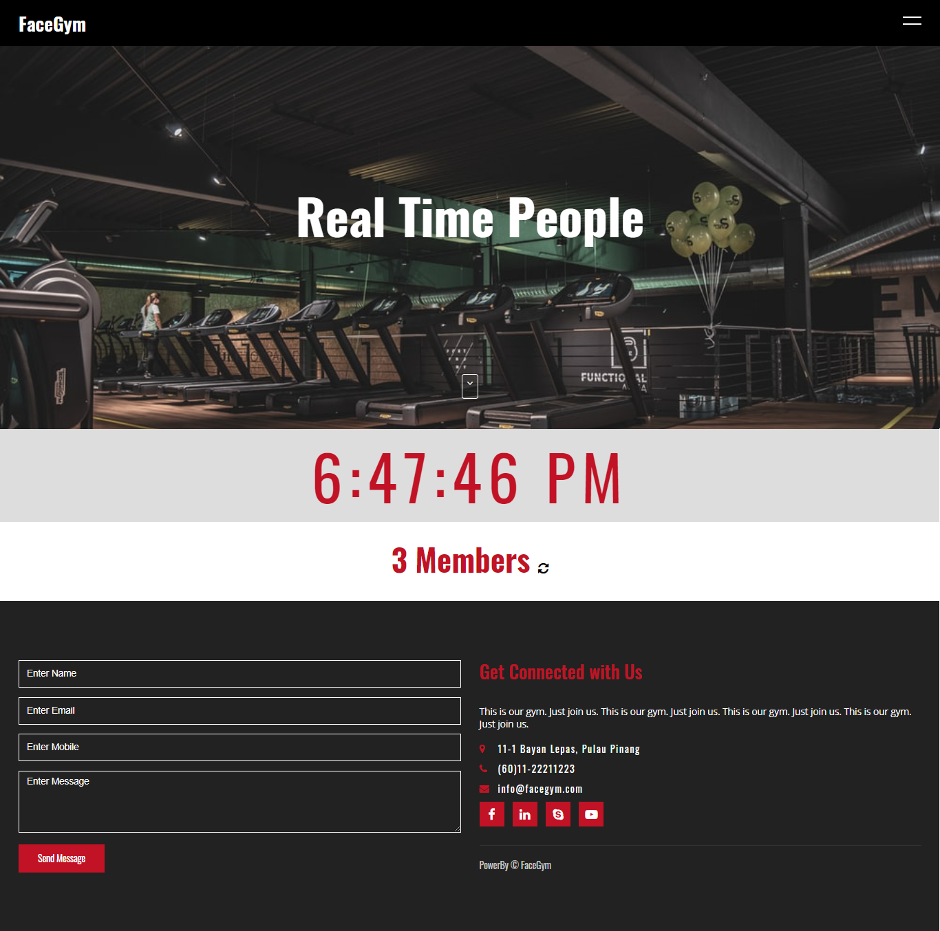

Figure . Interface of the user real time webpage

According to the Figure 3.1.67 above, it showed the interface of the user's real-time webpage after the function is implemented. The interface showed the real time clock and the real time members in the gym center when it refreshed.

|  |
| --- |
| Real-time function process with code snippet |
| 1. Retrieve the clock in data from the Attendance.csv |
| 1. Read the lines in the Attendance.csv |
| 1. Count the total members in the gym with len() |
| 1. Output of the total members in the gym in real-time |
| 1. One of the line deleted after the member clocked out |
| 1. Output of the total members in the gym after clocked out in real-time. |

#### Implementation of a membership package checkout

In this section the membership package checkout function will be implemented in the project, the feature of the membership checkout package is stated as high in the user priority table. The membership package checkout function will let the members make payment of the package they chose to become the member of the gym, it lets the members to checkout the membership package through two payment methods which are card payment and wallet payment, it can benefit the members to make payment through online easily compared to make payment in front of the counter in the gym to avoid more paperwork. Besides that, the reason why the membership package checkout function is labeled as high in the priority is because it will get the front face image of the members when they are performing their checkout method, it will store the face image of the members into the specific folder to perform the face recognition function. The implementation of the membership package checkout will be discussed below.

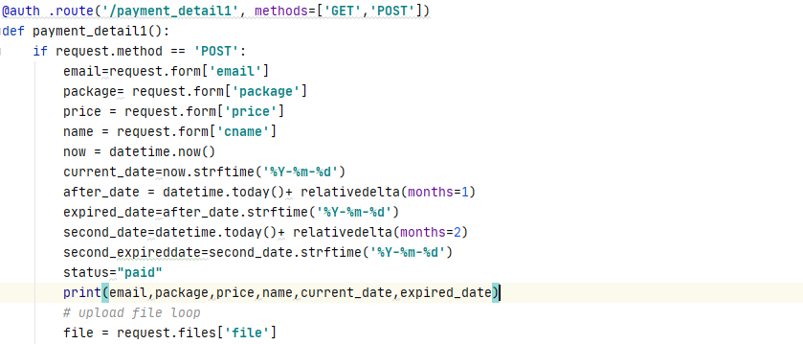

Figure . Code snippet of membership package checkout with card method function

According to the Figure 3.1.68 above, it showed that the code is performing the checkout function with the card payment method in the payment_detail1() function. In the function, it will enter the request method when the method is POST. In the if loop, it retrieved the data from the form in the package webpage. The data retrieved are the email of the user, the package name, the price of the package, the name of the new member, the real time date and time, and others. There is a variable called status which stores the string of paid to indicate the member had been paid for the package.

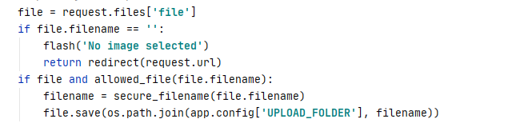

Figure . Code snippet of storing the front face image of the member

According to the Figure 3.1.69 above, it showed that it will retrieve the file inserted from the member which is the front face image into the paymentdetail1() function. It flashes an error message when there is no image file retrieved. After the image file is retrieved, it will save and upload the image file into the specific path to perform the face recognition method when the members are clock in or clock out.

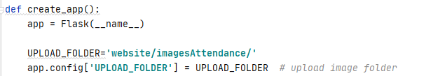

Figure . Code snippet of the path storing the image file

According to the Figure 3.1.70 above, it showed that the variable UPLOAD_FOLDER is the path to store the image file.

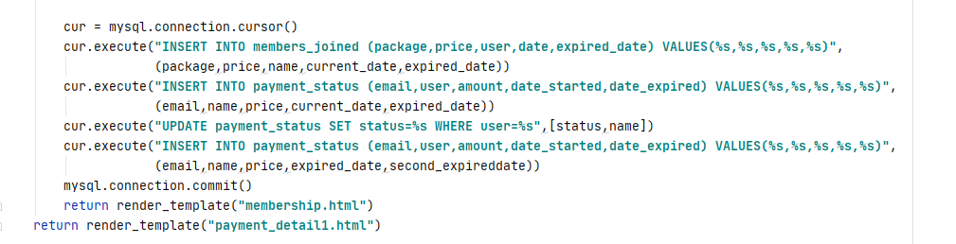

Figure . Code snippet of storing the data into the database

According to the Figure 3.1.71 above, it showed that it connects with the database which is configured, it stores the data into the table of the member_joined which is storing the new members joined in the gym, the data stored in the table are the package name, price of the package, the new member name, the date joined and the date expired. After storing into the member_joined table, it will store the data into the table of payment_status which is storing the payment status of the members. The data stored in the table are the email of the user, the new member name, the date joined and the date expired. After storing in the payment_status table, it will update the status in the payment_status table into paid based on the name of the member. The last step is to store the next expiring date of the members into the payment_status table to let the users knowing that the date to make payment of their monthly payment before that day. After all the data is inserted in the database successfully, it will return to the membership.html interface.

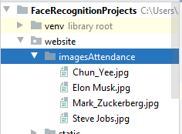

Figure . Output of image stored into the path

According to the Figure 3.1.72, it showed that the face image file of the member was stored into the path configured successfully.

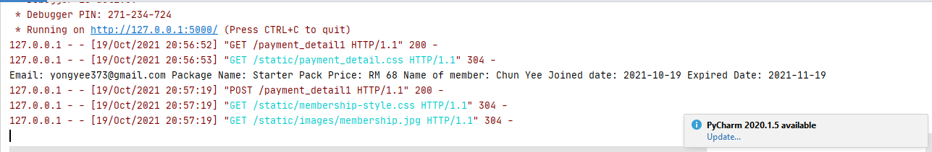

Figure . Output of the retrieved data

According to the Figure 3.1.73 above, it showed that the output is showing the data inserted by the member in the form, there are email, package name, price of the package, the name of the member, and the current date and expired date.

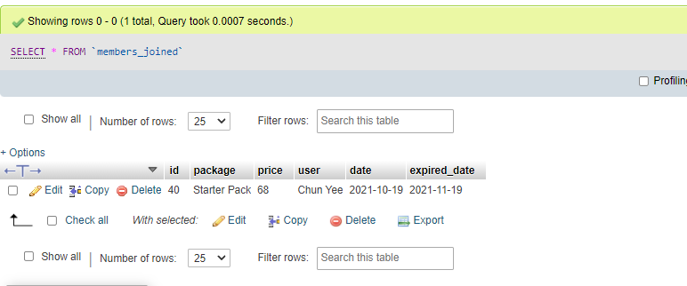

Figure . Table of member_joined in the database

According to the Figure 3.1.74 above, it showed that the table of member_joined stored the data retrieved from the member inserted successfully based on the output shown in the Figure 3.1.73 above.

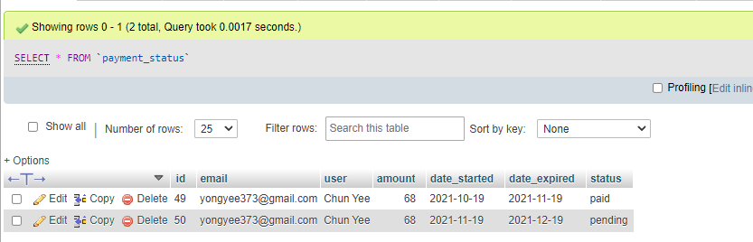

Figure . Table of payment_status in the database

According to the Figure 3.1.75 above, it showed that the table of payment_status stored the data retrieved from the member inserted successfully, the table showed that the status of the current month updated from the pending into paid, it also inserted the new expired date into the new column with the status showing pending of the member successfully.

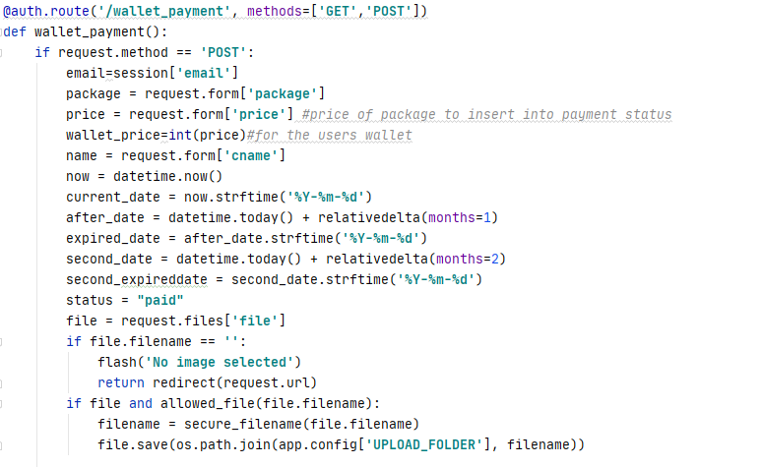

Figure . Code snippet of membership package checkout with wallet method function

According to the Figure 3.1.76 above, it showed that the code is performing the checkout function with the wallet payment method in the wallet_payment() function. In this function, it performed the same function as the payment_detail1() function based on the Figure (the coded snippet) above, the difference between them is it will convert the string format price variable into the integer which is stored in the wallet_price variable.

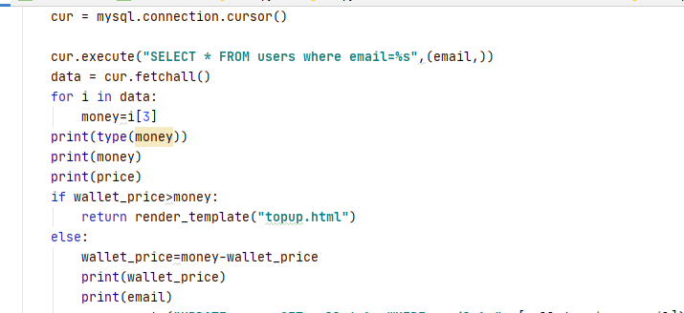

Figure . Code snippet of deducting the money in the wallet

According to the Figure 3.1.77 above, it showed that it retrieved all the data from the users table based on the email. After selecting the table of users, it retrieved and defined the wallet in column 3 of the table in the variable named money. After that, it will deduce the wallet of the user with the package price, it will redirect the member to the top-up page if the amount of the wallet is not sufficient to pay for the package.

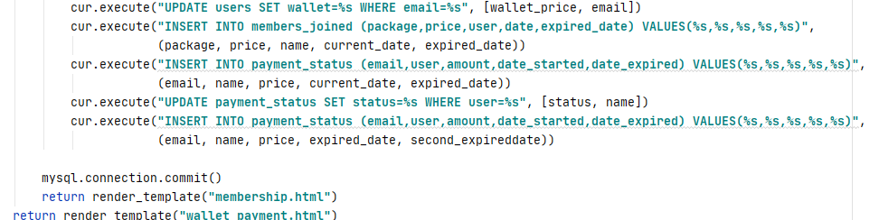

Figure . Code snippet storing data into the database

According to the Figure 3.1.78 above, it showed that the first step is updating the wallet amount of the users in the users table, then the step is the same with the method in the payment_detail1() function to store the data into the members_joined table and the payment_status table. After all the data storing successfully, it will redirect to the membership.html webpage.

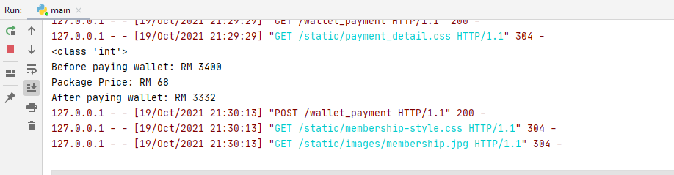

Figure . Output of the wallet deducted

According to the Figure 3.1.79 above, it showed the wallet of the user deducted after paying the package, it deducted the wallet from RM3400 into the price of RM3332 successfully.

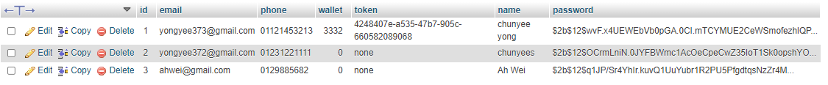

Figure . Table of users in the database

According to the Figure 3.1.80 above, it showed that the amount wallet of the user had been updated after deducting the package price.

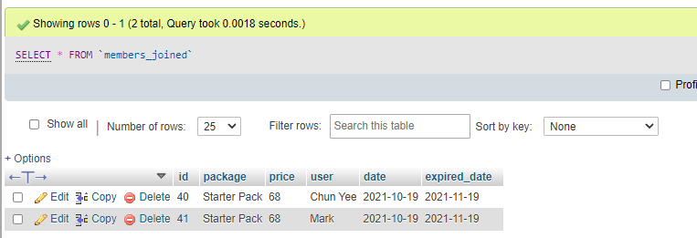

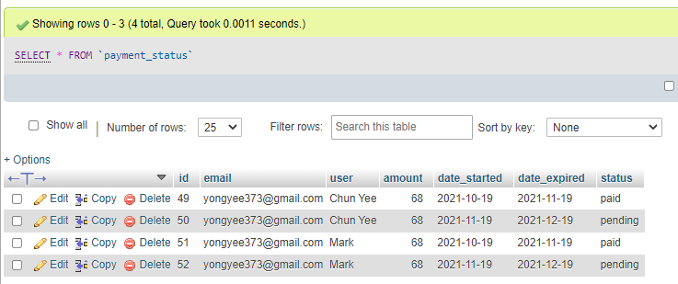

Figure . Tables of members_joined and payment_status in the database

According to the Figure 3.1.81 above, it showed that all the data had stored into the members_joined and the payment_status tables successfully.

#### Implementation of top up function

#### In this section, the top up function for the users will be implemented in the project, the feature of the top up function is stated as medium after the high priority is implemented and developed in the priority table. The top up function will let the users in the gym website able to top up their wallet to make payment of their monthly member fees through online easily. It will benefit the users to top up their wallet easily through online without cash. The implementation of the top up function will be discussed below.

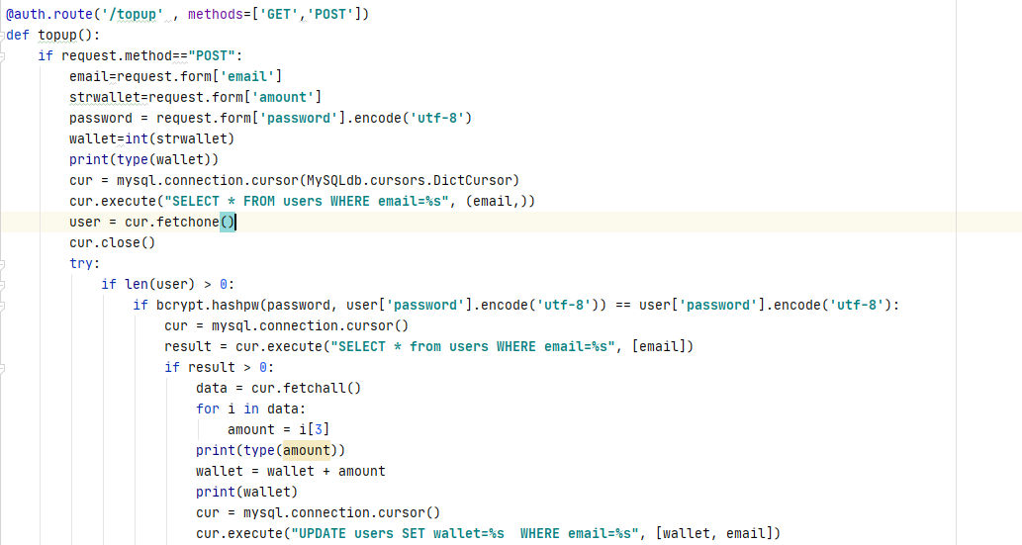

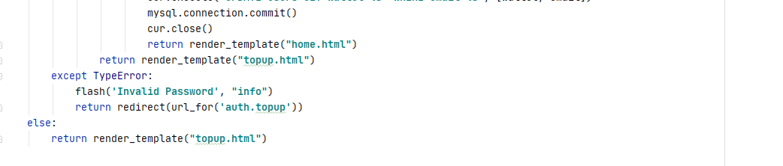

Figure . Code snippet of user top up function

According to the Figure 3.1.82 above, it showed that it will retrieve the data inserted at the top up webpage, the data retrieved are the email of the user, amount to top up and the password of the user. After that, it converts the string type amount into the integer, then it connects with the table of the users based on the email in the database to verify that the password filled in is matches with the password in the database. After the password matched, it will update the wallet in the users table to update the amount of the users based on the email of the users with the addition of the wallet of the users in the table and the amount to top up. It will redirect the users to the user homepage after the top up is successful.

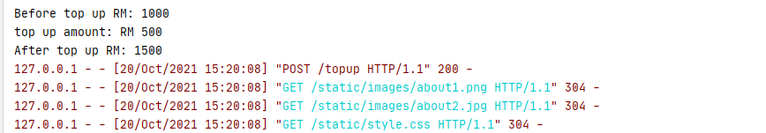

Figure . Output of the top up function

According to the Figure 3.1.83 above, it showed that the wallet of the user was RM1000, the user top up the amount of RM500 and the wallet of user become RM1500 after the top up function was performed successfully.



Figure . Users table in the database

According to the Figure 3.1.84 above, it showed the data of the users table in the database. It showed that the wallet of the user had been updated to the latest amount which is from RM1000 to RM1500 successfully.

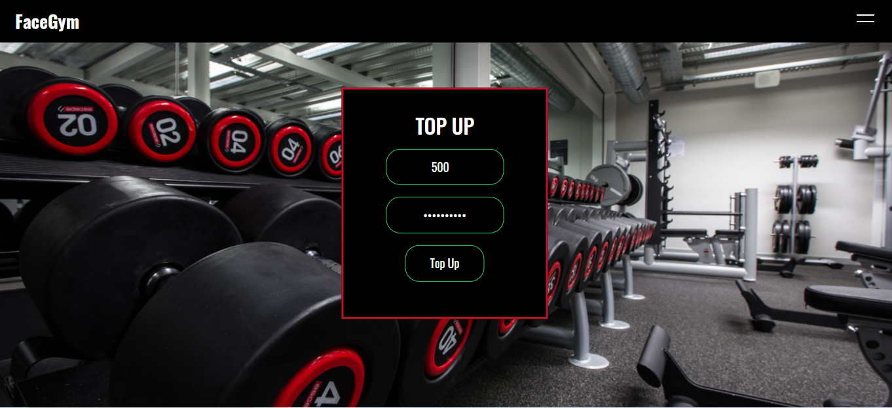

Figure . Interface of the user top up webpage

According to the Figure 3.1.85 above, it showed the interface of the user top up webpage. The top up webpage lets the user to insert the amount and the password to fill in, the top up button is pressed after the users inserted the form.

#### Implementation of the interface of the user and admin register and login page

In this section, the implementation of the interface of the user and admin register and login page will be conducted in this project. The interface is of the user register and the login page is implemented after the functionalities of the register and login are finished. The implementation of the interface will be discussed below.

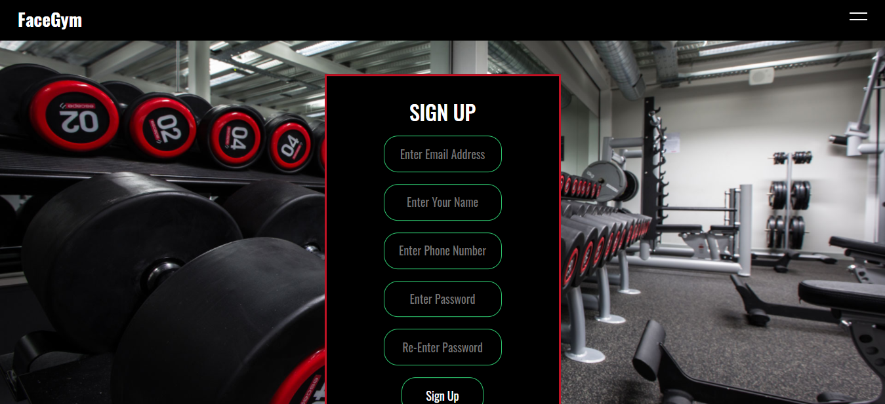

Figure . User Interface design of user register webpage

According to the Figure 3.1.86 above, the register webpage allows the user to register as the user of the gym webpage by inserting their details such as email, name, phone number and the password in the form provided. After the user inserted the form in the register webpage and pressed the sign-up button, the information inserted will be stored into the table of the users in the database when the sign-up progress is performed successfully. In the sign-up page, it will reload again in the sign-up page when the user sign-up an existing email which already signed up or the password and confirm password column are not match.

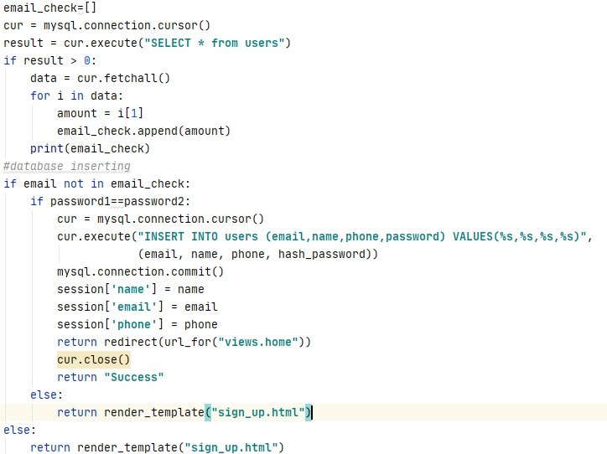

Figure . Code snippet of error checking

According to the Figure 3.1.87 above, it showed that there is a new variable named email_check to store all the email column data in the table of users in the database into a list with the append() method after the database is connected. After that, it checked whenever the email inserted by the user had existed in the list of the email_check with if loop if the email is not in the email_check, it will proceed to the password checking, else it will redirect the user into the sign-up page again. In the password checking, it checked the password and confirm password inserted by the user matches with the if loop. It will proceed to insert all the data inside the table users if the passwords are matched, else it will redirect the user into the sign-up page again.

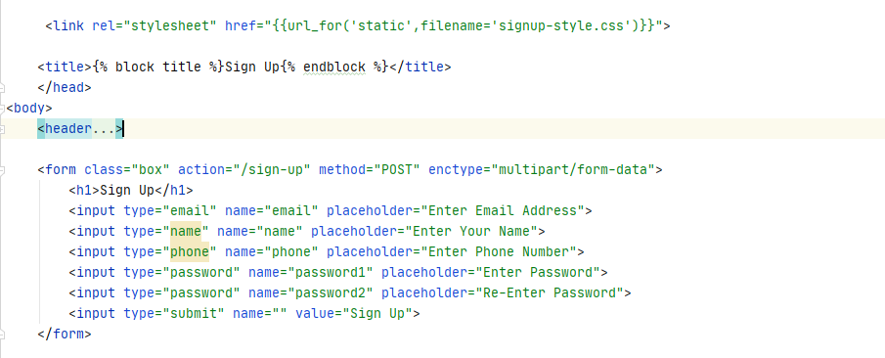

Figure . Code snippet of interface design of the user sign-up page

According to the Figure 3.1.88 above, it showed that the design of the webpage is redirected with the CSS file named signup-style.css file. In the body of the webpage, the header is the side navigation bar of the webpage which will discuss in deep in the user homepage interface section. In the form class which includes the method of POST to pass the value to the sign-up() function, there are 6 input types to let the users enter their credentials into each of the 5 inputs, the last input is letting the users press on the sign-up button after they filled their credentials.

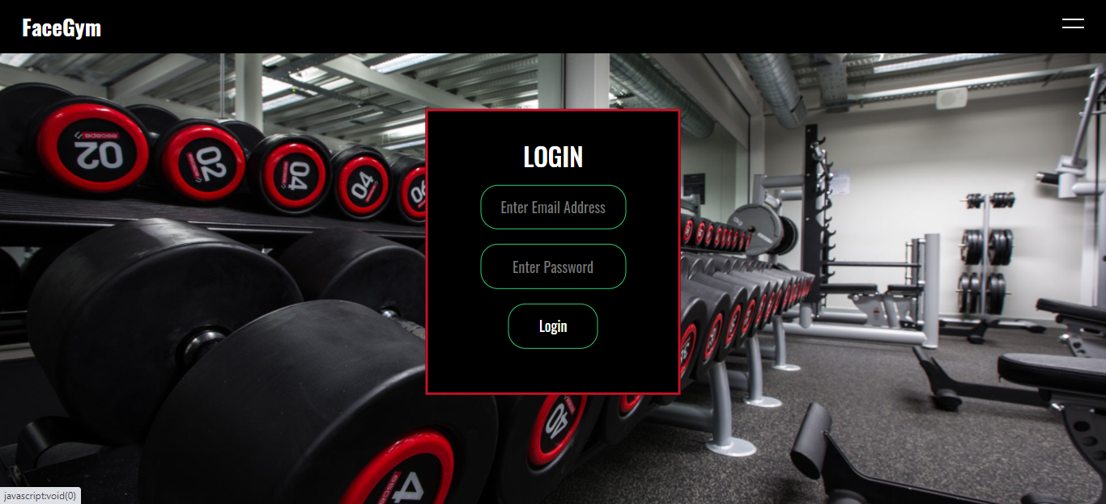

Figure . User Interface design of user register webpage

According to the Figure 3.1.89 above, the login webpage allows the user login in gym webpage by inserting their details which are the email and the password in the form provided. After the user inserted the form in the login webpage and pressed the login button, it will redirect the user to the user homepage when the user login successfully, else it will redirect the user again to the login webpage when the user login unsuccessfully.

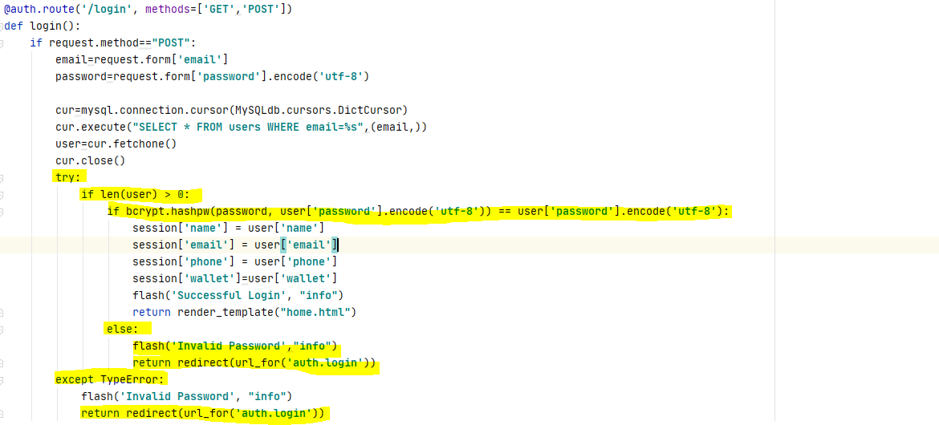

Figure . Code snippet of error checking in user login

According to the Figure 3.1.90 above, the code showed that it will use the try and except method to check whenever there is data inserted in the login page, it will appear TypeError when the users submit the form without filling anything and redirect the users in the login page again. After checking the form is being filled, it will check the password is matching with the password stored in the users table which is the password registered by the users with the if loop after the database is connected. It will redirect the users to the user homepage when the passwords are matched, else it will redirect the users to the login page again when the passwords are not matched.

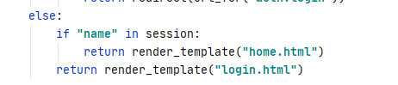

Figure . Code snippet of the user had logged in

According to the Figure 3.1.91 above, it showed that it will redirect the user to the user homepage when the user had logged in in the session with the if loop, else it will redirect the user to the user login page to ask them to insert the credential to log in.

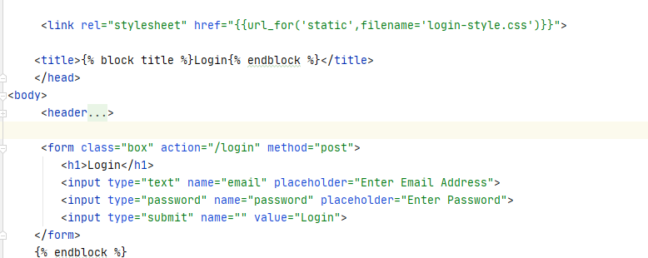

Figure . Code snippet of interface design of the user login page

According to the Figure 3.1.92 above, it showed that the design of the webpage is redirected with the CSS file named login-style.css file. In the body of the webpage, the header is the side navigation bar of the webpage. In the form class which includes the method of POST to pass the value to the login() function, there are 3 input types to let the users enter their credentials into each of the 2 inputs, the last input is letting the users press on the login button after they filled their credentials.

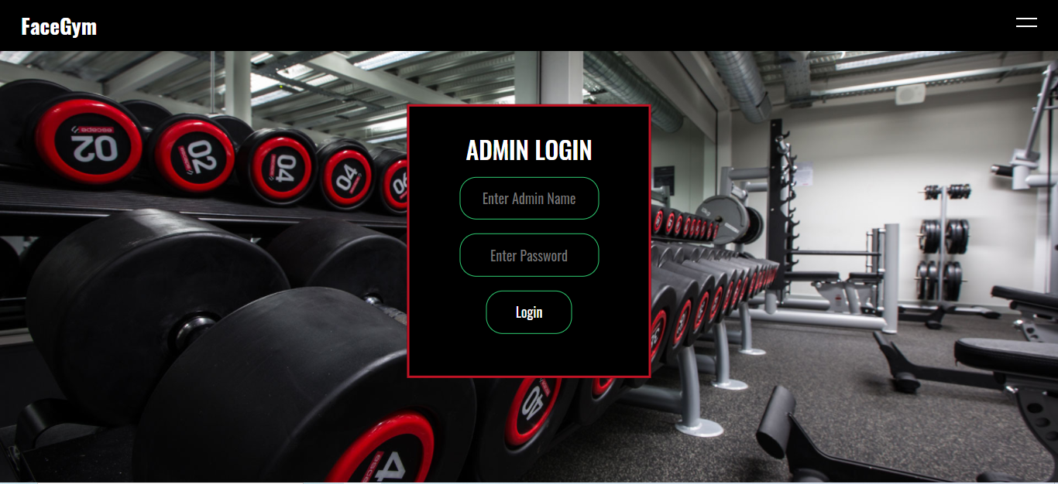

Figure . Interface of the admin login interface

According to the Figure 3.1.92 above, it showed that the design of the admin login interface is almost the same as the user login interface, the difference between them is only the header of admin is showing the word of admin login. In the admin webpage, it does not have the admin register webpage for the admin to register, the credential is given by the head of the gym.

#### Implementation of the interface of the user membership and checkout

In this section, the implementation of the interface of the user membership and checkout webpages will be conducted in this project. The interfaces of the user membership and checkout are implemented after the functionalities of the membership checkout. The implementation of the interface will be discussed below.

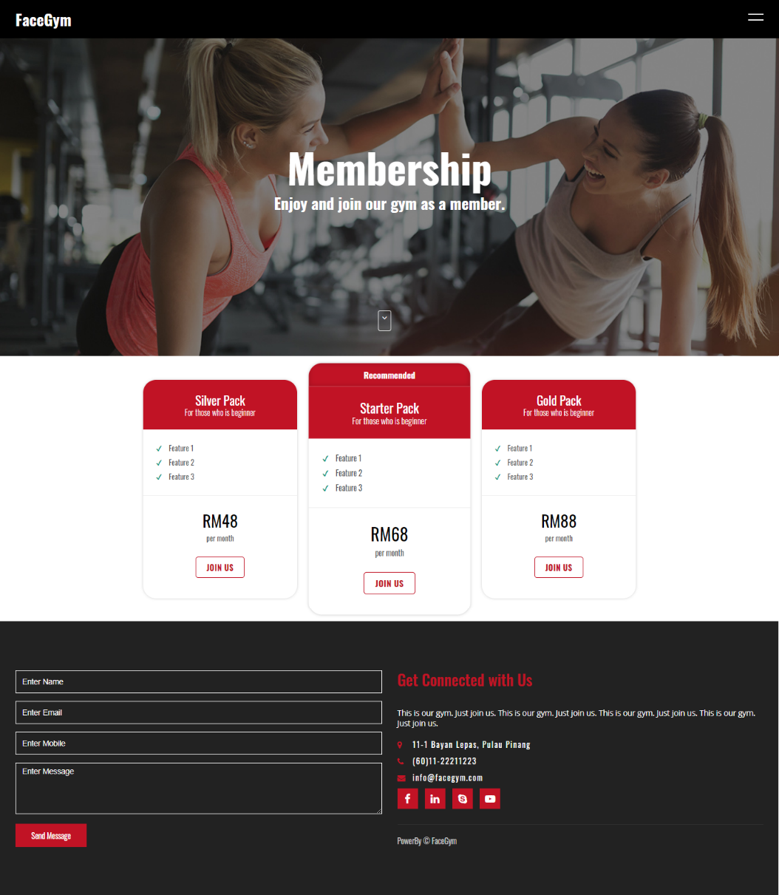

Figure . User Interface design of user membership packages webpage

According to the Figure 3.1.94 above, it showed the user interface of the membership packages. The webpage, showed the packages provided by the gym with the price of the packages. The user who desired to join as the membership can press the join us button to join the gym based on the package chosen after they logged in. There is also the footer to let the users fill in problems or comments to tell the gym.

#### 

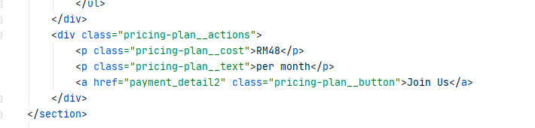

Figure . Code snippet of one package in membership package interface

According to the Figure 3.1.95 above, it showed that the design of the membership package interface is designed with the CSS file named membership-style.css. In the div class named pricing-plan-container, the container is storing all of the packages, the div of pricing-plan-description is storing all the features provided by the package in the pricing-plan-container, the div pricing-plan__actions is storing the cost of the package, and the button to redirect to the checkout page when the users pressed the button.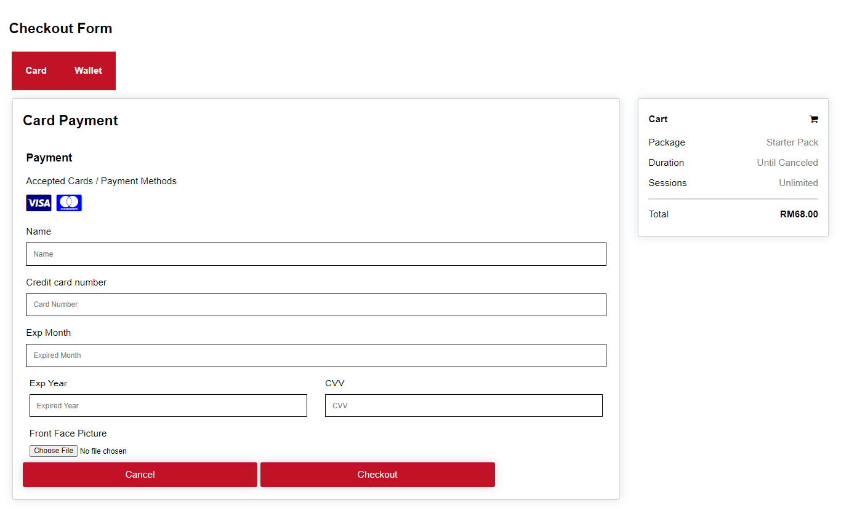

Figure . User Interface design of user checkout with card method webpage

According to the Figure 3.1.96 above, it showed the user interface design of user checkout with the card method webpage. The webpage, showed the package name, duration, session, and the total price needed to pay on the right side. Besides that, it also provides the form to let the user insert the card information in the form, it also provides the file to let the user insert the front face image file to store the file into the specific path to perform the face recognition method. The cancel button will redirect the user to the membership webpage and the checkout will indicate that the user had checked out the package and become a member of the gym successfully.

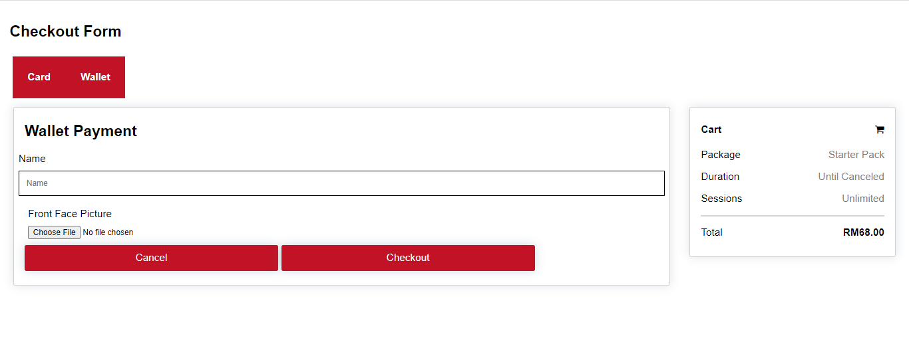

Figure . User Interface design of user checkout with wallet method webpage

According to the Figure 3.1.97 above, it showed the user interface design of user checkout with the wallet method webpage. The webpage, showed the package name, duration, session, and the total price needed to pay on the right side. Besides that, it provides a form to let the user insert the name of the user to join as the member and it provides the file to let the user insert the front face image file to store the file into the specific path to perform the face recognition method. The cancel button will redirect the user to the membership webpage and the checkout will indicate that the user had checked out the package and become a member of the gym successfully.

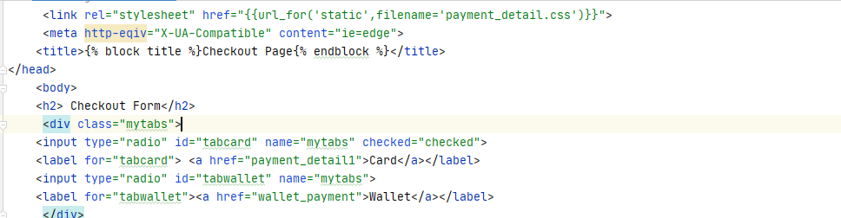

Figure . Code Snippet of tabs user checkout with card method interface

According to the Figure 3.1.98 above, it showed that the design of the webpage is using the CSS file named payment_detail.css file. In the div class named mytabs, it will store two tabs which are the card and the wallet payment methods.

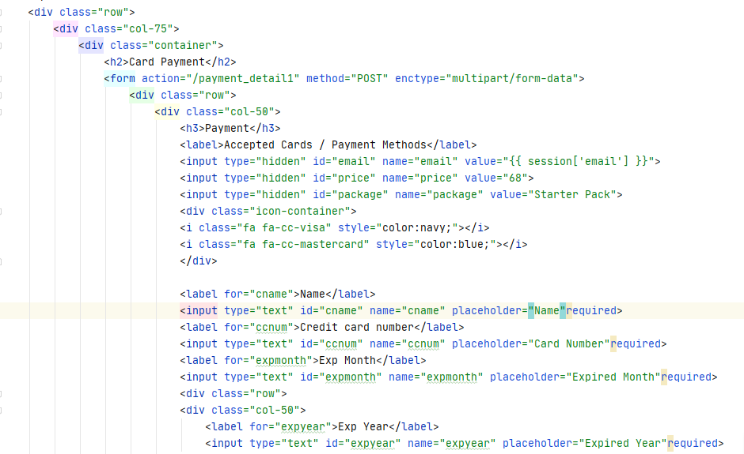 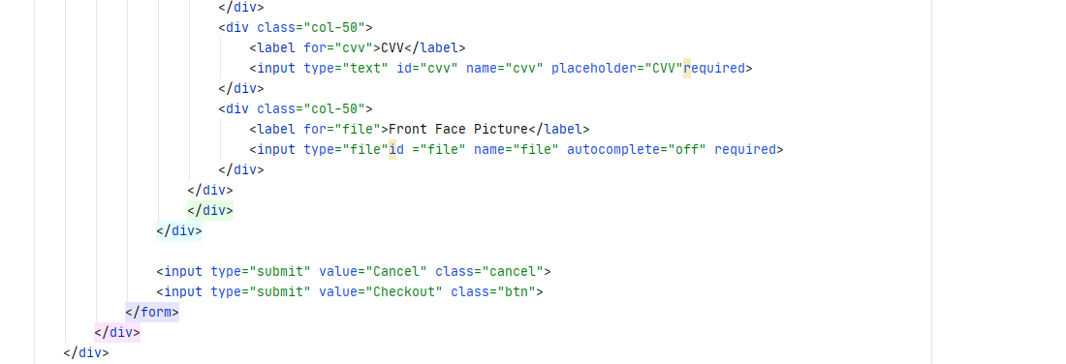

Figure . Code snippet of form in the user checkout with card method interface

According to the Figure 3.1.99 above, the code showed that the div class named col-58 is the container to store all the forms inside. There are three inputs types that are hidden which are storing the current session email, the price of the package, and the name of the package. In the div class of the icon-container, it stored the icon of the cards. After that, there are inputs which are the name of the new member, the card number, expired month, expired year, CVV, and the most important front face image file of the member to let the users insert their information. Lastly, there are two button inputs to cancel or checkout for the membership package.

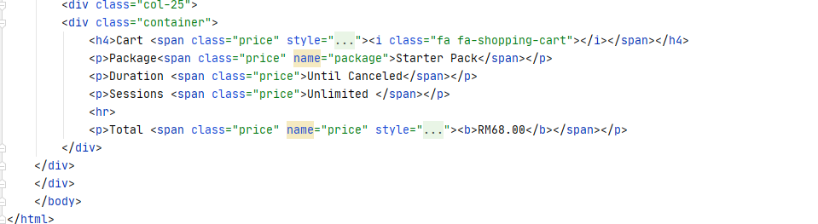

Figure . Code snippet of showing the cart information in the user checkout with card method interface

According to the Figure 3.1.100 above, it showed the cart information storing in the div class named col-25, it viewed the name of the package, the duration of the package, the sessions of the package and the price of the package.

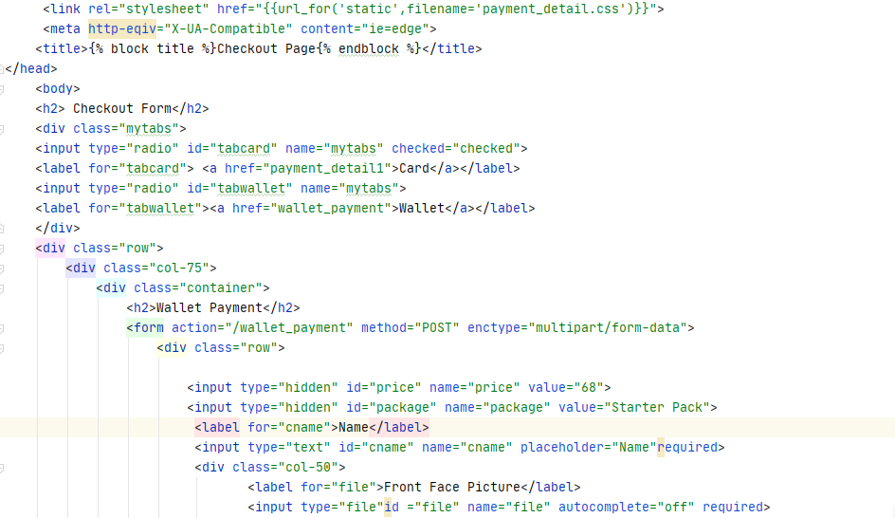 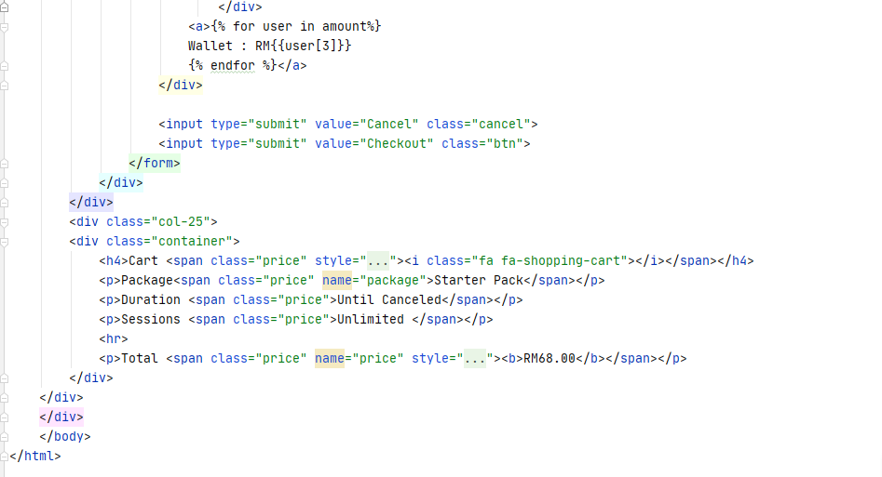

Figure . Code snippet of the user checkout with wallet method interface

According to the Figure 3.1.101 above, the code showed many similarities compared to the interface of the checkout with the card method interface. The difference between them is the inputs needed to be inserted are only the name of the new member and the front face image file of the member, the interface code showing the package is the same as the checkout with card method interface code.

#### Implementation of user homepage and admin homepage interfaces

#### In this section, the user homepage and admin homepage interfaces will be implemented in the project, the interfaces of the homepage will be implemented after the high priority functions in the priority table because it is stated as the medium. The user homepage will let the users view the homepage of the gym webpage. The homepage is considered as the image of the gym, a nice design homepage will attract the people to visit the gym website because the users will see the user homepage when they visited the gym webpage. The implementation of the user homepage interface will be discussed below.

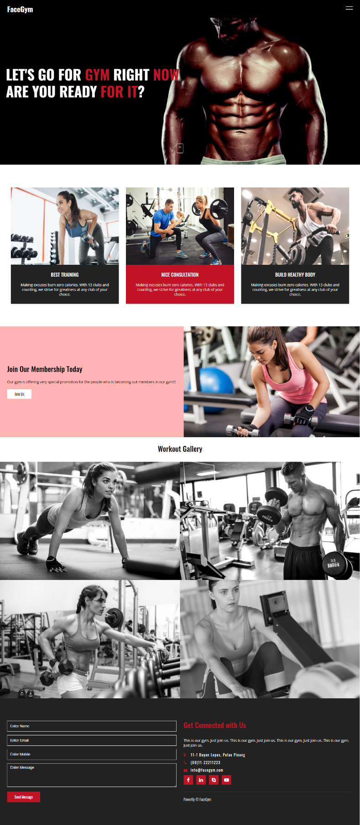

Figure . Interface of the user homepage

According to the Figure 3.1.102 above, it showed the interface of the user homepage, five sections are shown on the user homepage. The first section showed the motivation word to encourage the people to the gym at the top of the homepage. The second section showed a brief of the gym provided with three cards. The third section showed that the users can be pressed on the join us to view the membership packages provided. The fourth section showed the users the gallery of the gym, the picture will light up when the users click on the picture on gallery section. The last section is the footer of letting the logged users fill in the comments or problems to the gym.

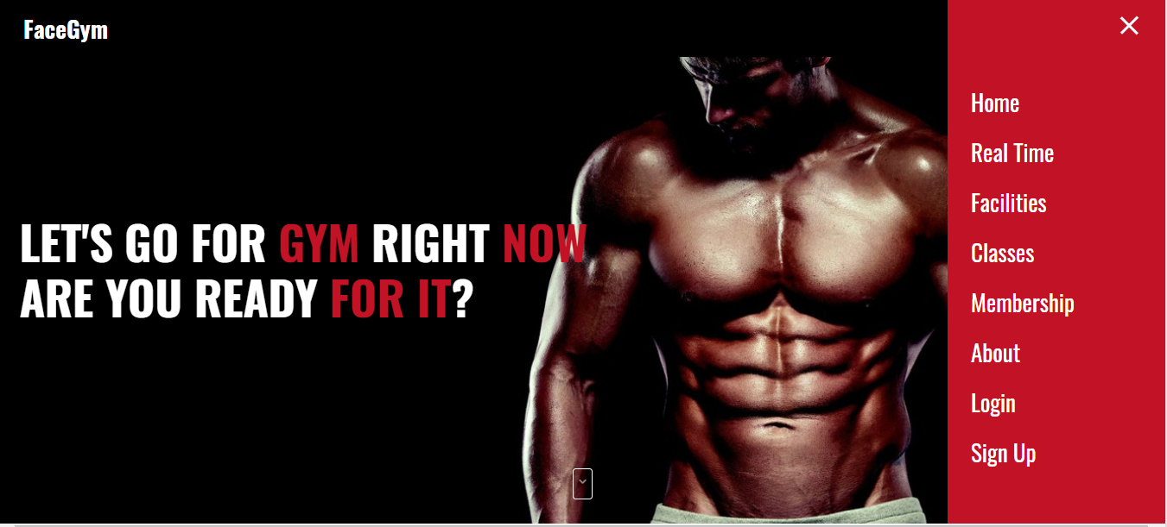

Figure . Side navigation bar of the user homepage interface

According to the Figure 3.1.103 above, it showed the side navigation bar on the user homepage. The navigation can lead the users to the other web pages to view other features of the gym. There are the facilities, the classes, the membership, and others provided by the gym to let the users more understand the gym in deep.

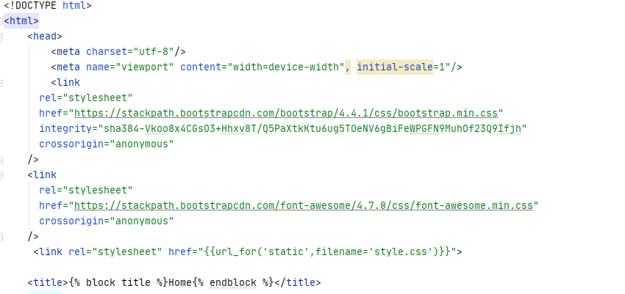

Figure . Code snippet of the interface user homepage

According the Figure 3.1.104 above, it showed the bootstrap, and the font is imported to make the design and the font nicer, the design of the user homepage is using the CSS file named style.css.

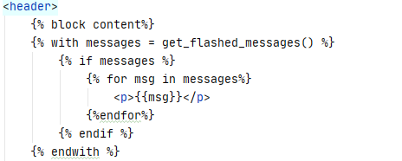

Figure . Code snippet of flash messages

According to the Figure 3.1.105 above, it showed that it will flash the messages whenever the users in the gym webpage perform some actions.

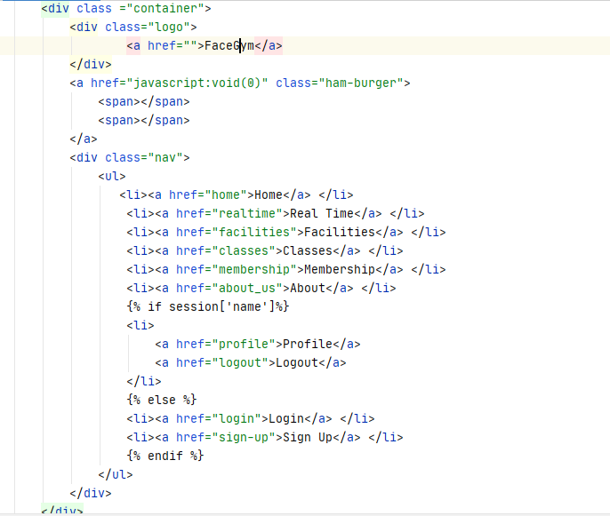

Figure . Code snippet of the navigation bar

According to the Figure 3.1.106 above, it showed the code of the navigation bar in the user homepage interface. There is if loop in the navigation bar, it will show the login and sign-up on the navigation bar when the users didn’t login into the gym webpage, else it will show the profile and logout on the navigation when the users logged in. Besides that, it showed that the home, real-time, facilities, classes, membership, and about when the users are not log in or they are login in the navigation bar.

#### 

Figure . Code snippet of the home section in user homepage interface

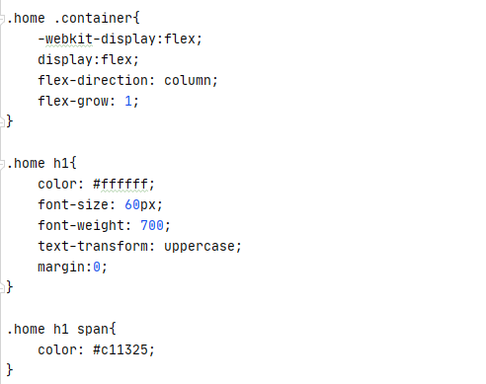

Figure . Code snippet of the style.css file

#### According to the Figure 3.1.107 above, it showed that section class named home will be showing the motivation word for the people to view at the top of the homepage and there is a button which will lead the users to the downside when they clicked it. According to the Figure above, the style.css file is decorating the design of the user homepage, it showed that the font of the h1 and span are different which are the color is white on h1 and red on span. The function of the button is using the JavaScript function based on the Figure below.

#### 

Figure . Code snippet of JavaScript function of the dropdown button

#### 

#### 

Figure . Code snippet of the about section on the user homepage interface

#### According to the Figure 3.1.110 above, the code showed there are three div classes named box to store the information of the gym into these three boxes. Each of the boxes will show the image inserted into the div and the different information of the gym the boxes.

#### 

Figure . Code snippet of the start section on the user homepage interface

#### According to the Figure 3.1.111 above, the code showed there is a div class named box text to let the users to view the header of “Join Our Membership Today”, the paragraph of the words and the button of “Join Us” to let the users viewing the packages of the gym provided. There is also a div class named box img to let the users to view the image of the jpg format on the user homepage interface.

#### 

Figure . Code snippet of the gallery section on the user homepage interface

#### According to the Figure 3.1.112 above, the code showed there is a div class named content to store three div classes named box which will store the image files with the jpg format to let the users view the gallery of the gym center.

#### 

#### 

Figure . Code snippet of the contact section on the user homepage interface

#### According to the Figure 3.1.113 above, the code showed there is a div class box form to let the users who logged in insert the comments or questions to the gym, the non-logged users will redirect them to the login page when they are not login. Besides that, there is a div class named box text to store the other div class which is the div class named info to store and view the address of the gym center, the phone number of the gym center, and the email of the gym center. It also has div class named social which provided the difference of social media icons to let the users press in to view and show the gym is active on other social media. The div class named copy is showing the copyright word of the FaceGym on the homepage interface.

#### 

Figure . Interface of the admin homepage

#### According to the Figure 3.1.114 above, it showed the interface of the admin homepage. The design of the admin homepage is very plain and only shows the welcome word to the members, real-time clock, and the clock in & clock out button for the members to press in for clock in or clock out purposes.

#### 

Figure . Side navigation bar of the admin homepage

According to the Figure 3.1.115 above, it showed the side navigation bar on the admin homepage. The navigation can lead the admin to the other web pages to use the other features. There are a selection of dashboard and the logout for the admin to choose after they logged in.

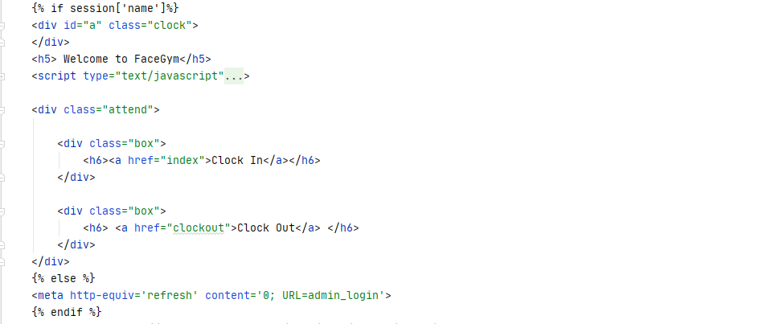

Figure . Code snippet of the admin homepage interface

According to the Figure 3.1.116 above, the only difference between the user and admin homepage is the admin homepage a div class named clock to view the real time clock on the admin homepage with the JavaScript function based on the Figure 3.1.116 and a div class named attend to store two div classes named box which viewing the clock in and clock out button to let the members to perform the clock in and clock out functions. It will redirect the admin to the admin login page when they are not logged in with the if and else loop.

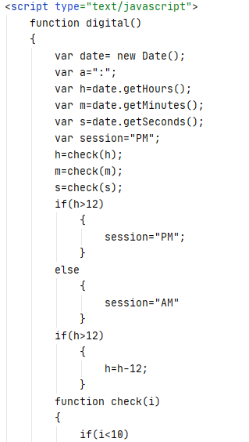 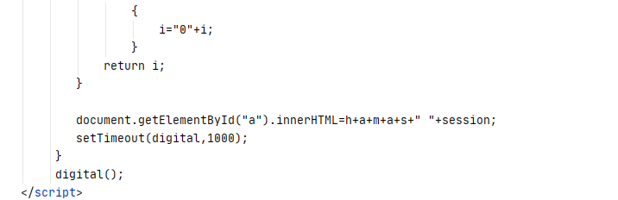

Figure . Code snippet of the real time clock function in JavaScript

#### Implementation of other user interfaces

In this section, the implementation of the other user interfaces will be implemented in the project, the other user interfaces are considered as low priority based on the priority table and they are developed after the high and medium priority. There are several interfaces which are user facilities, classes, and the about us webpages, the implementation of the user facilities interface is showing the users the facilities provided by the gym center; the implementation of classes interface is showing the classes provided by the gym center; the implementation of about us interface is showing the about of the gym center to the people. The implementation of all the user interfaces will be shown below.

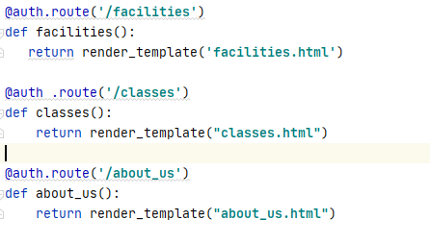

Figure . Code snippet of the routing of the interface

According to the Figure 3.1.118 above, it showed that the routing method used in these interface webpages is the same, both of them are using the render_template() method to return the HTML files to let users can route to the interfaces correctly. After routing the interfaces, the interfaces of the web pages will show at below.

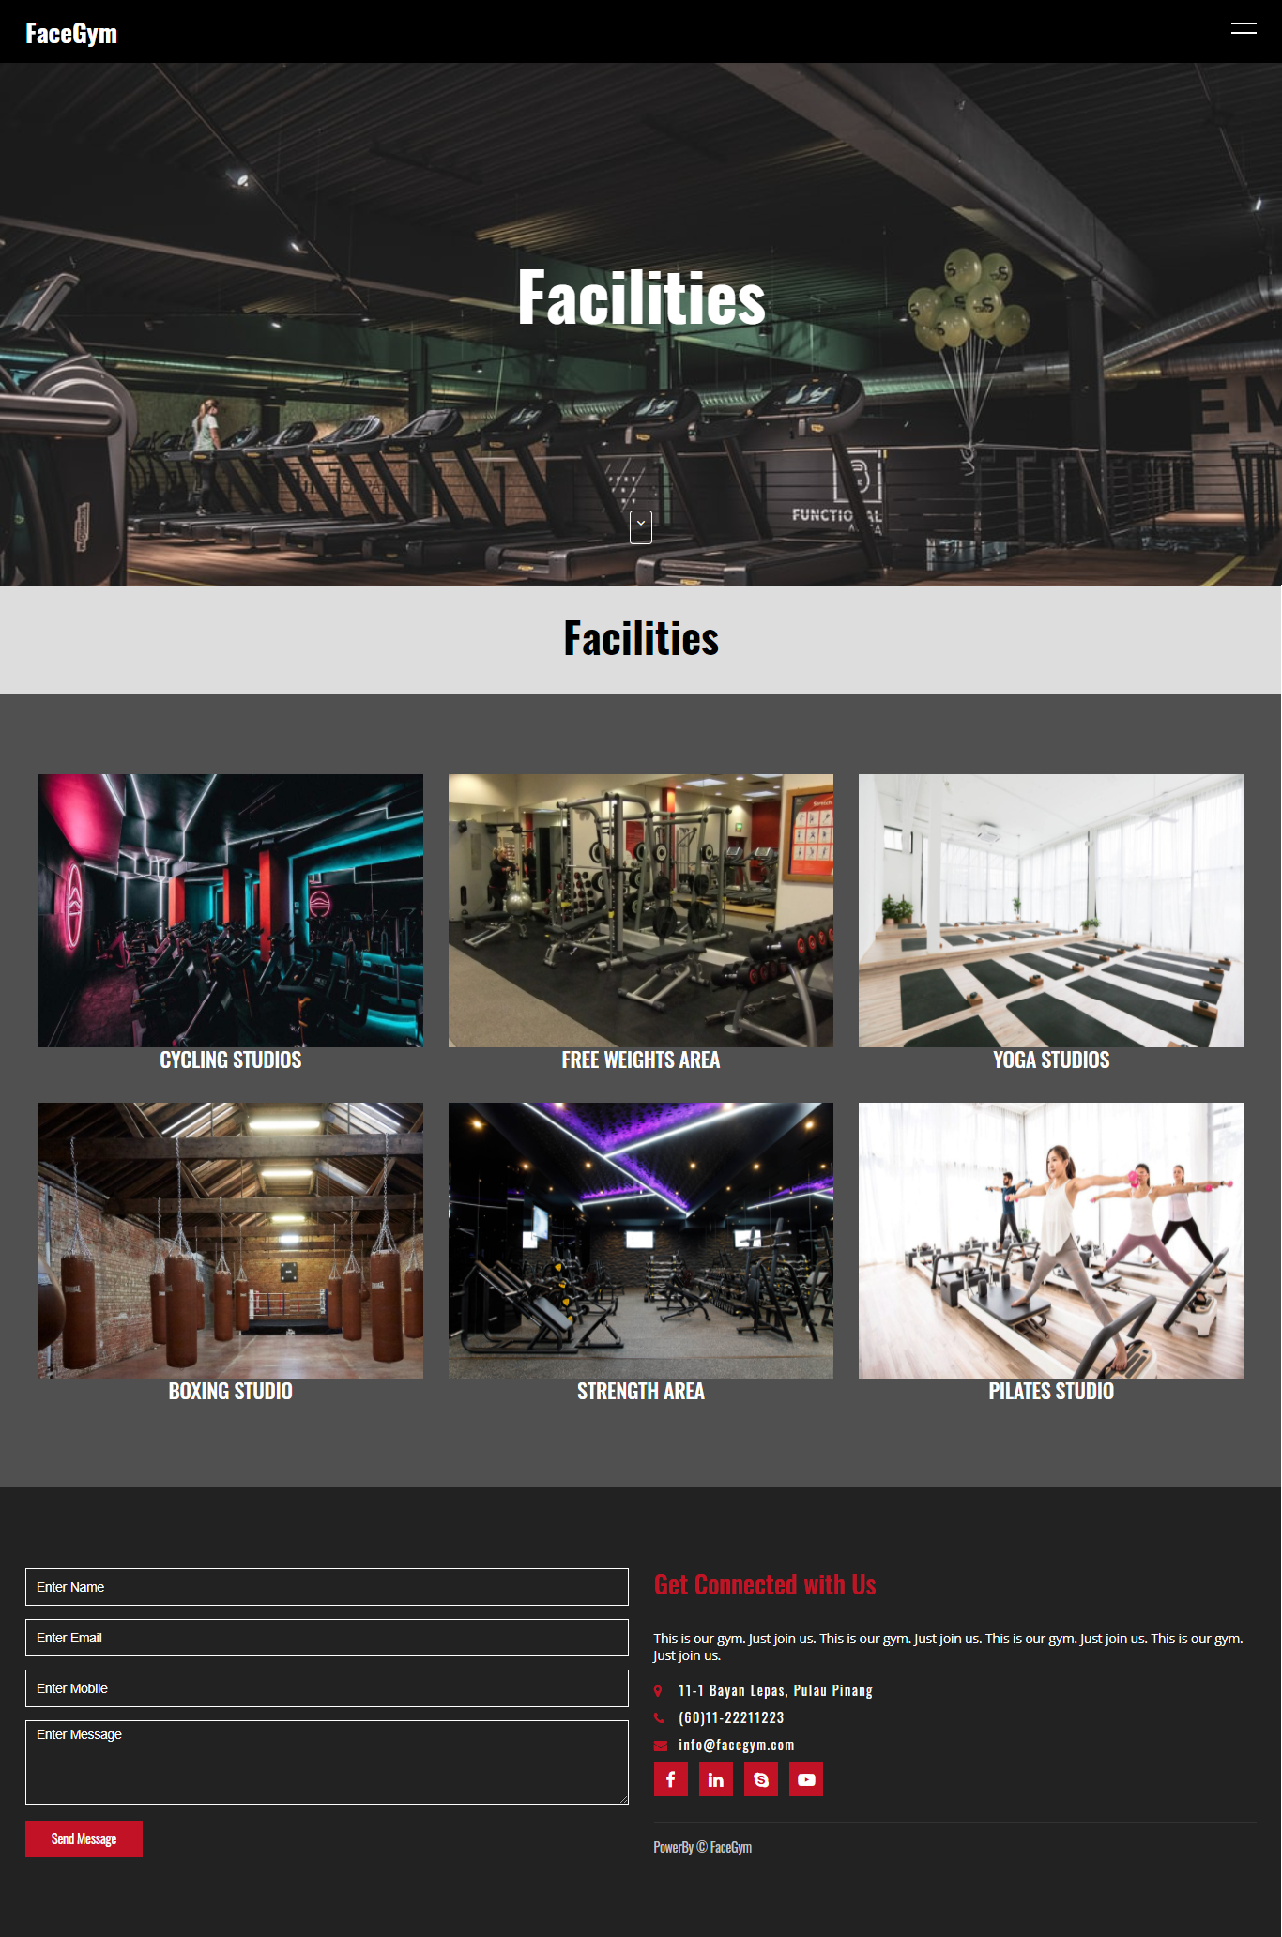

Figure . Interface of the user facilities webpage

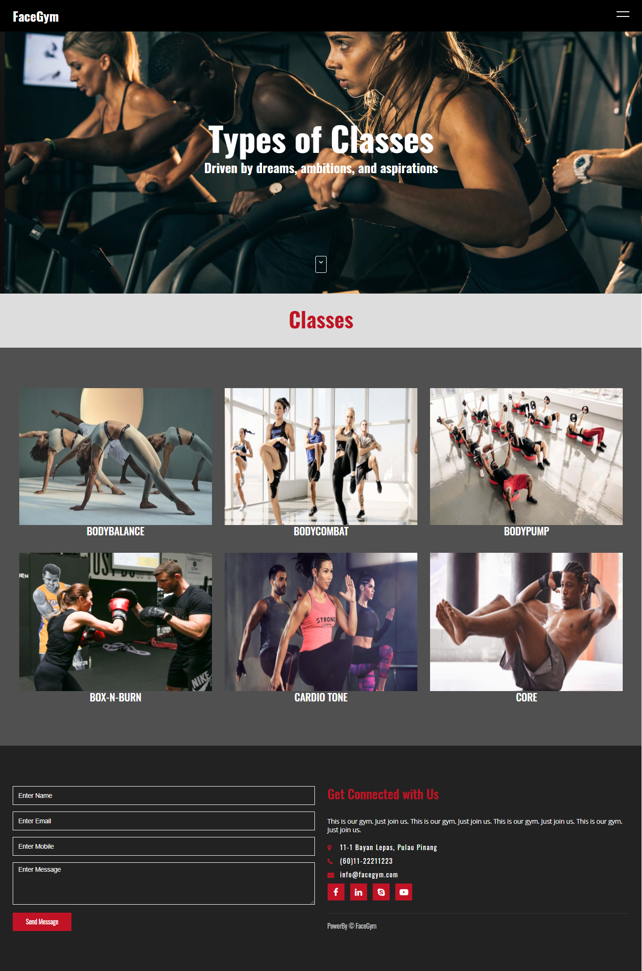

Figure . Interface of the user classes webpage

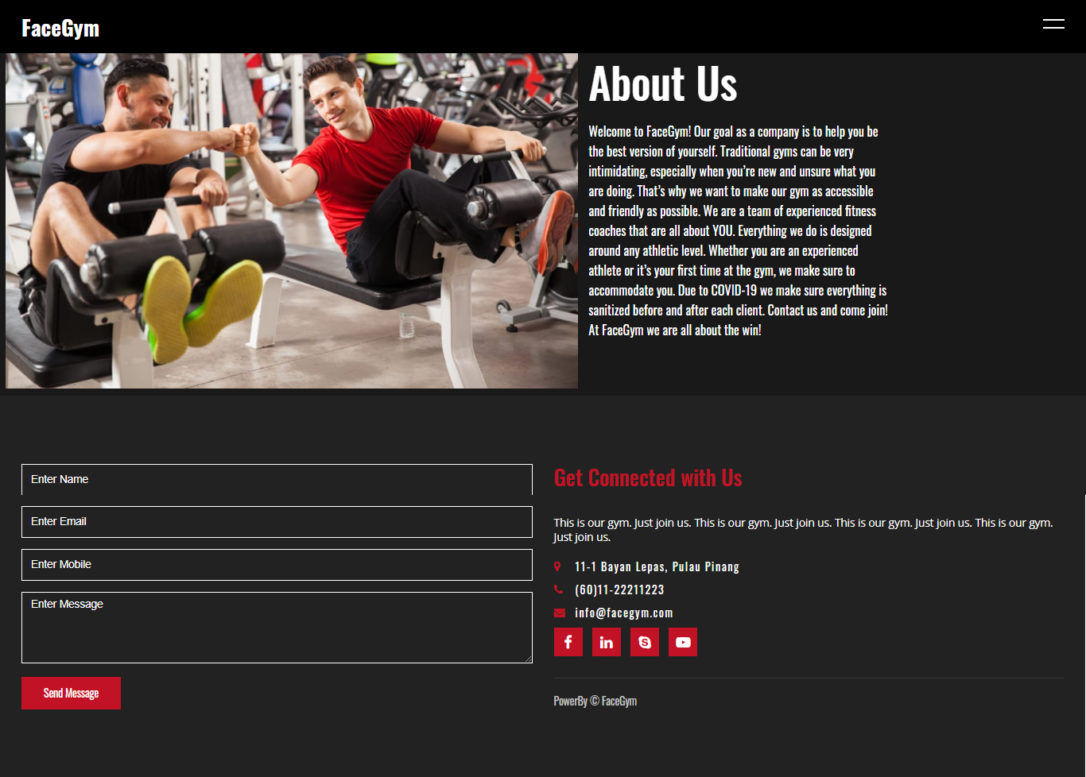

Figure . Interface of the user about us webpage

#### Implementation of user profile interface

In this section, the implementation of the user profile interface will be implemented in the project, the user profile interface will show the logged user profile name, the wallet amount, the phone number, and the payment status. The implementation of the user profile interface will be shown below.

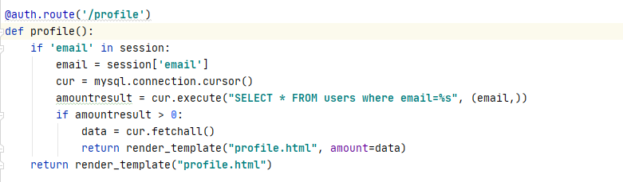

Figure . Code snippet of the profile interface routing

According to the Figure 3.1.122 above, it showed that the routing method of the profile interface. In the function of the profile(), it showed that it will retrieve the current logged in user’s email, then retrieve all the data from the users table in the database based on the email. It will fetch all the data from the table with the fetchall() method and return variable named amount into the profile.html.

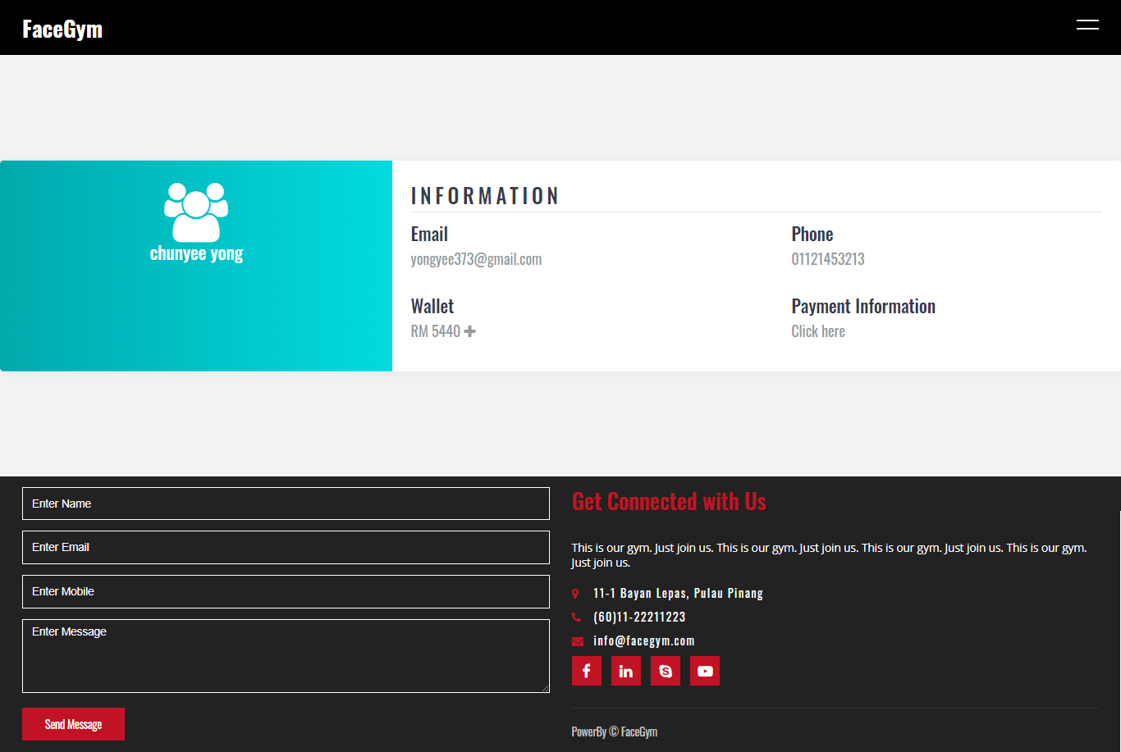

Figure . Interface of the user profile webpage

According to the Figure 3.1.123 above, it showed the interface of the user profile webpage. It showed that the information of the logged user such as email, phone number, wallet with the plus button to top up the wallet and the payment information.

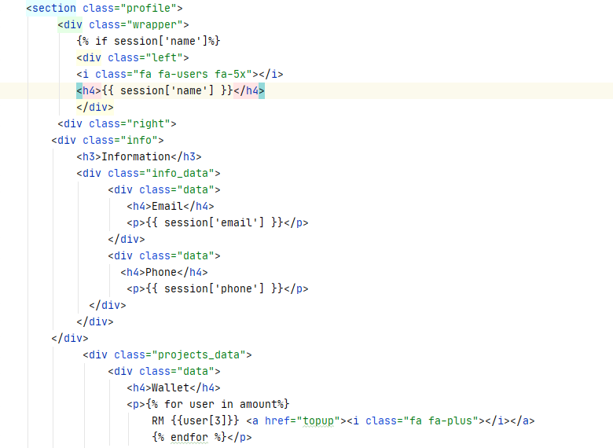 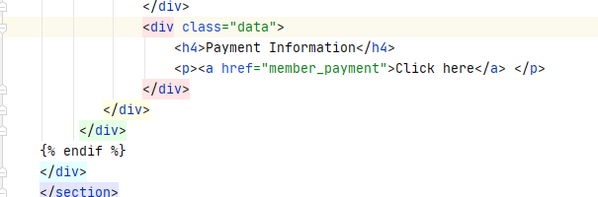

Figure . Code snippet of the user profile interface

According to the Figure 3.1.124 above, it showed the section class named profile viewing the user profile data. In the div class named info showing the current logged email and the phone number with the session. In the div class named projects_data, it showed the data of the wallet by searching the specific column in the database to show the logged user’s wallet amount and it showed the plus button to let the user top up. Besides that, it showed the user the payment information to let the user click in and redirect the user to the user’s payment information.

#### Implementation of the admin dashboard interface

#### In this section, the implementation of the admin dashboard interface will be implemented in this project. The admin dashboard will show the total members joined and the total revenue of the gym in the webpage. The implementation of the admin dashboard interface will be discussed below.

Figure . Code snippet of the routing admin dashboard

According to the Figure 3.1.125 above, it showed that the admin_dashboard() function gets the total of the members with the COUNT(id) and the total revenue of the gym with the SUM(price) from the members_joined table based on the id of the table. After getting the data from the table, it fetched the data with the fetchall() method, then it returns variable named userDetails into the admin_dashboard.html.

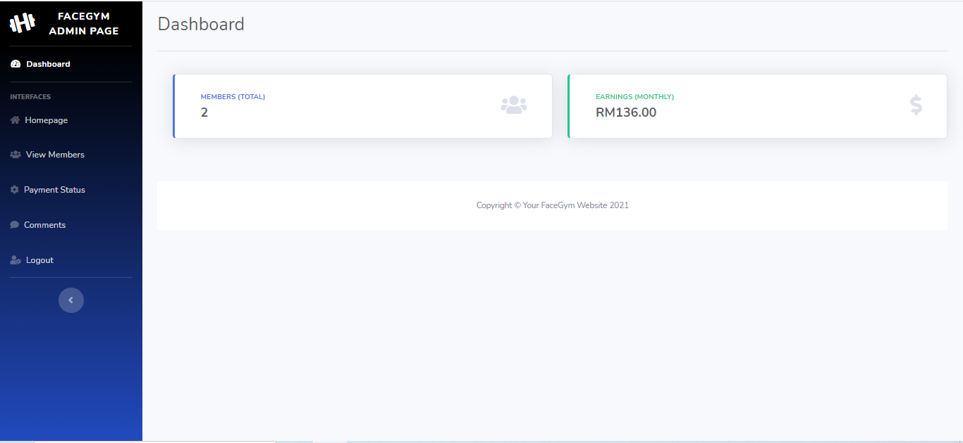

Figure . Interface of the admin dashboard interface

According to the Figure 3.1.126 above, it showed the interface of the admin dashboard interface. It showed the total members and the total revenue in the gym based on the data retrieved from the database. It also has a side navigation bar to let the admin browse other features.

#### Implementation of the admin other interfaces

In this section, the implementation of the other admin interfaces will be implemented in the project, the other admin interfaces are the view members status, view payment status, and the view comments. All the interfaces will show the data from the database to the admin and let the admin generate the data into the PDF file. The implementation of all the admin interfaces will be shown below. 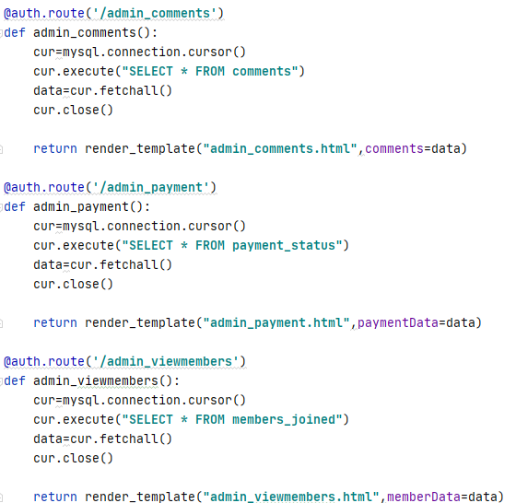

Figure . Code snippet of the routing the interfaces

According to the Figure 3.1.127 above, it showed the routing method is almost similar, the difference between them is the table retrieving from the database. The view comments are getting from the comments table, the view payment status is getting from the payment_status table, the view members status is getting from the members_joined table. After getting and fetching the data from the database, they will return into different html files.

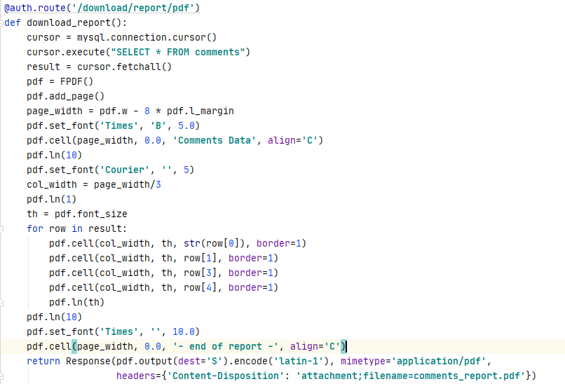 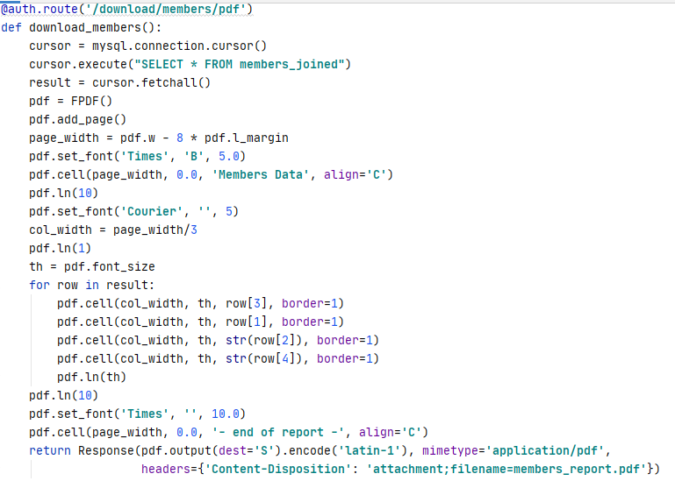

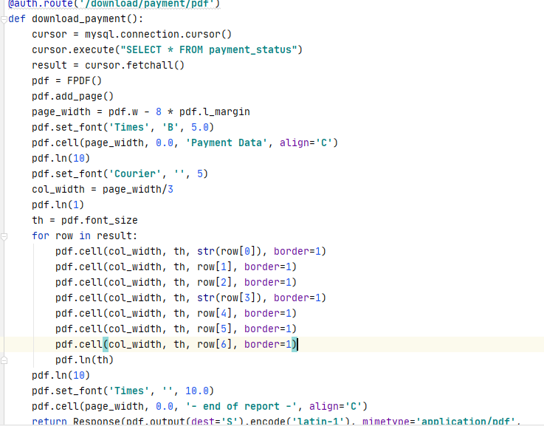

Figure . Code snippet of the generating the reports

According to the Figure 3.1.128 above, it showed that the generating the data from the view comments, view member status and the view payment status into the PDF file format. The generating methods are almost same but the difference between them is the data getting from the table respectively in the database.

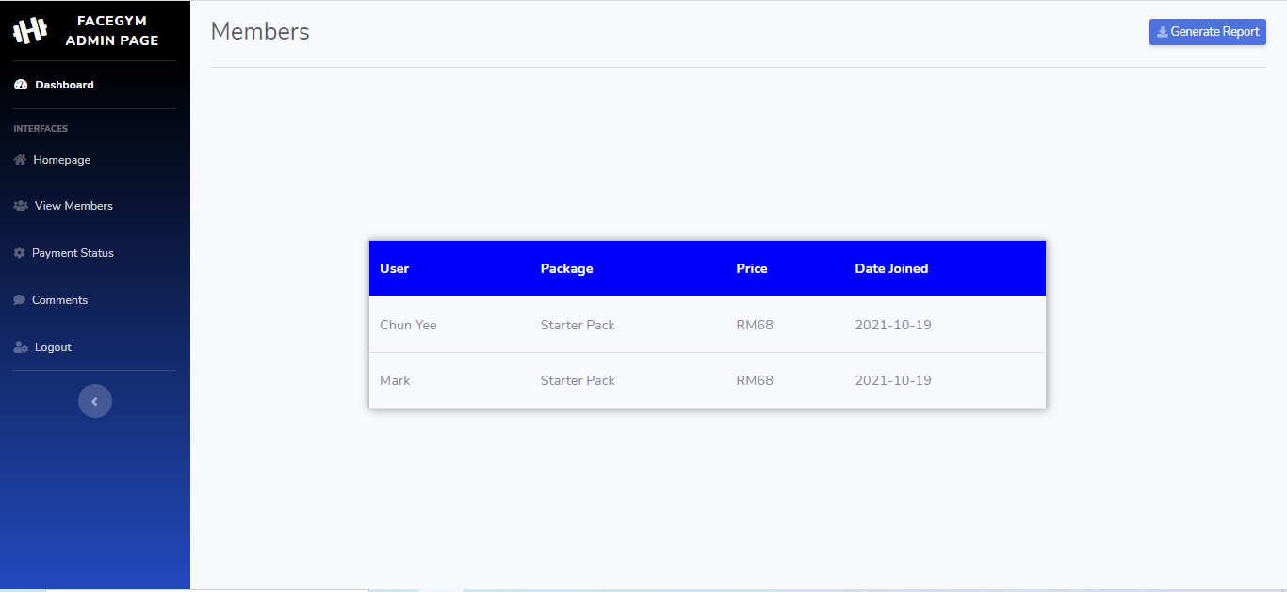

Figure . Interface of the admin view members webpage

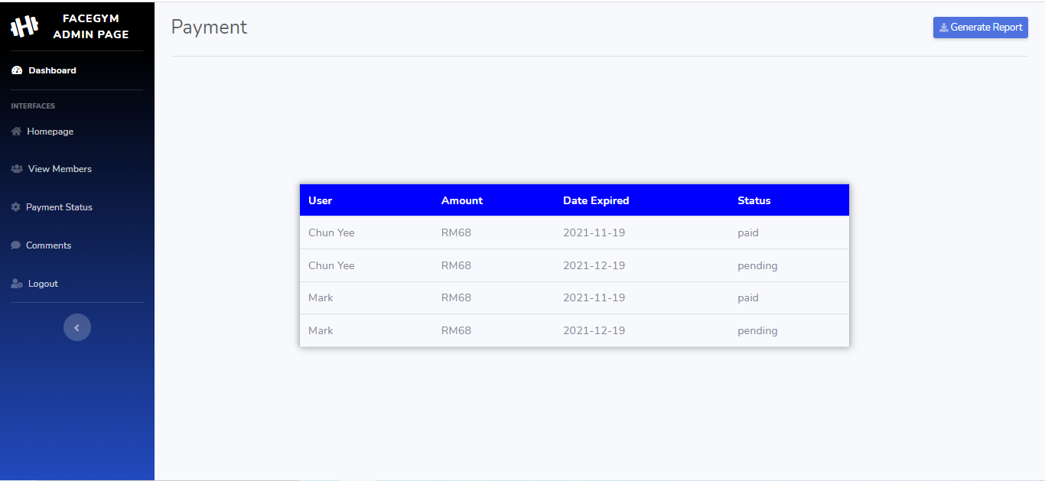

Figure . Interface of the admin view payment status webpage

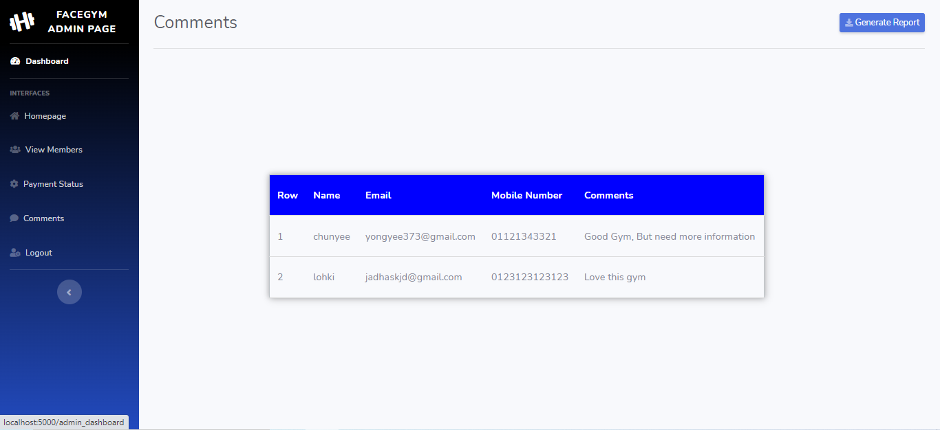

Figure . Interface of the admin view comments webpage

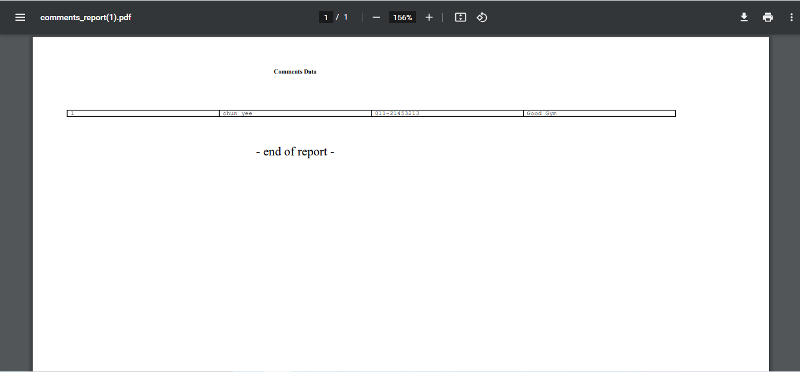

Figure . Interface of generated comments PDF file

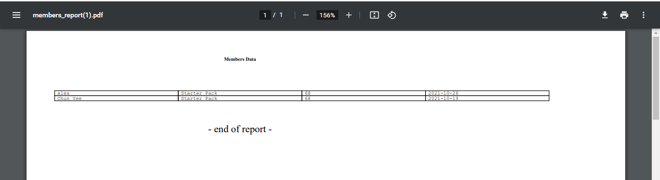

Figure . Interface of generated members status PDF file

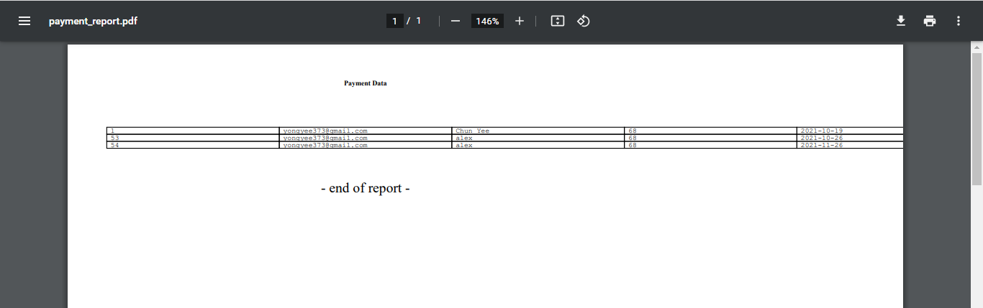

Figure . Interface of generated payment status PDF file

Figure :

# 

# Testing

In this section, the testing will be performed in this chapter to make sure the functions of all features in the project are working perfectly. The reason why testing is needed in software development is that it discovers the bugs and fixes the bugs before delivery to the client (Sharma, 2021). In this testing chapter, all the testing will be tested in manual testing. The face recognition part will be tested by calculating the distance of the faces. Besides that, there is unit testing, and GUI testing will be used as manual testing to test the features.

## Face Recognition Testing

In this section, face recognition testing will be used to test the face recognition to recognize the people in front of the webcam. The testing will be tested through the manual way, it will be tested into comparing the face with the image faces in the specific folder. Three testings are compared which are comparing with 5 image faces, 15 image faces, and 30 image faces to compare the accuracy of the face. It will also loop 5 times to calculate the face distance to ensure the accuracy of the distance. The Euclidean Distance will be used to calculate the distance between any two points in two-dimension space, it will measure the absolute distance between points in N-dimensional space. The smallest values in the face recognition are considered as the more similar faces after the distances calculated. 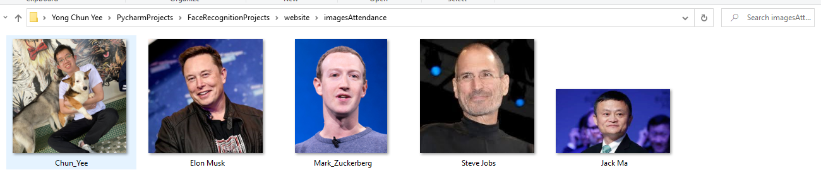

Figure . 5 image faces testing

According to the Figure 4.1.1 above, the folder stored 5 image faces to check the face recognition can recognize the people in front of the webcam. The person will be tested with the person named Chun Yee showing in front of the webcam to get recognized.

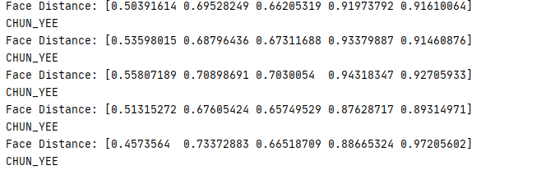

Figure . Comparison of calculated face distance of the encoded webcam face image

According to the Figure 4.1.2 above, it showed the comparison of the distance of the encoded webcam face image with the encoded 5 face images in the specific folder. It showed that the first index of the list has the smallest value of the Euclidean Distance after it was tested 5 times. The first index of the list is showing the person named Chun Yee who is getting recognized after getting the smallest value of distance which is considered as the face recognized in the comparison.

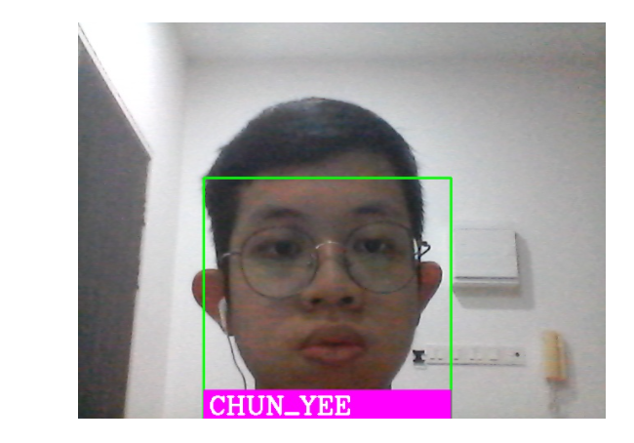

Figure . Face of the person recognized with 5 images testing with showing the name

According to the Figure 4.1.3 above, it showed that the face in front of the webcam is exactly the first image stored in the specific folder based on the Figure 4.1.1.1. After the 5 images testing is successfully tested, the next phase is testing with the 15 image faces.

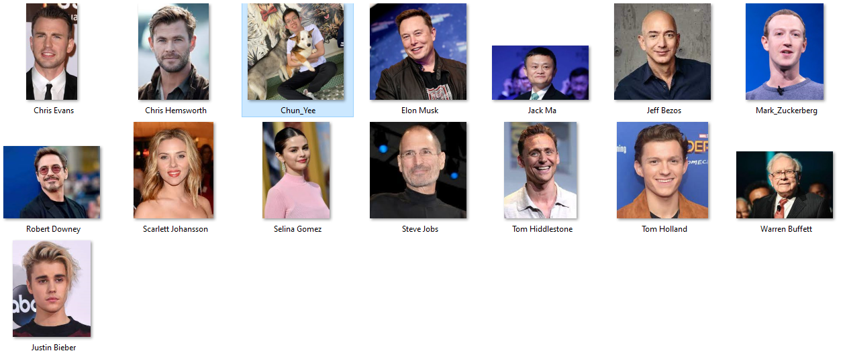

Figure . 15 image faces testing

According to the Figure 4.1.4 above, the folder stored 15 image faces to check the face recognition can recognize the people in front of the webcam. The person also will be tested with the person named Chun Yee showing in front of the webcam to get recognized.

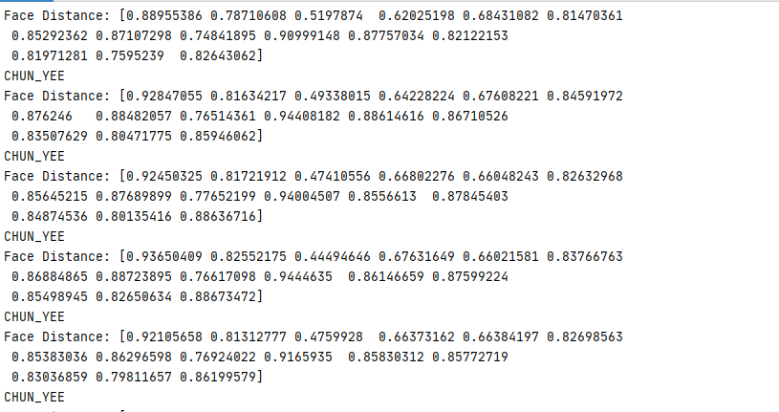

Figure . Comparison of calculated face distance of the encoded webcam face image

According to the Figure 4.1.5 above, it showed the comparison of the distance of the encoded webcam face image with the encoded 15 face images in the specific folder. It showed that the third index of the list has the smallest value of the Euclidean Distance after it was tested 5 times. The third index of the list is showing the person named Chun Yee who is getting recognized after getting the smallest value of distance which is considered as the face recognized in the comparison.

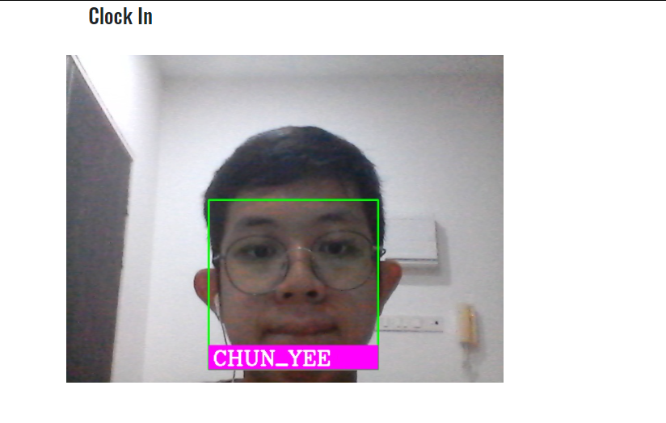

Figure . Face of the person recognized with 15 images testing with showing the name

According to the Figure 4.1.6 above, it showed that the face in front of the webcam is exactly the third image stored in the specific folder based on the Figure 4.1.1.4. After the 15 images testing is successfully tested, the next phase is testing with the 30 image faces.

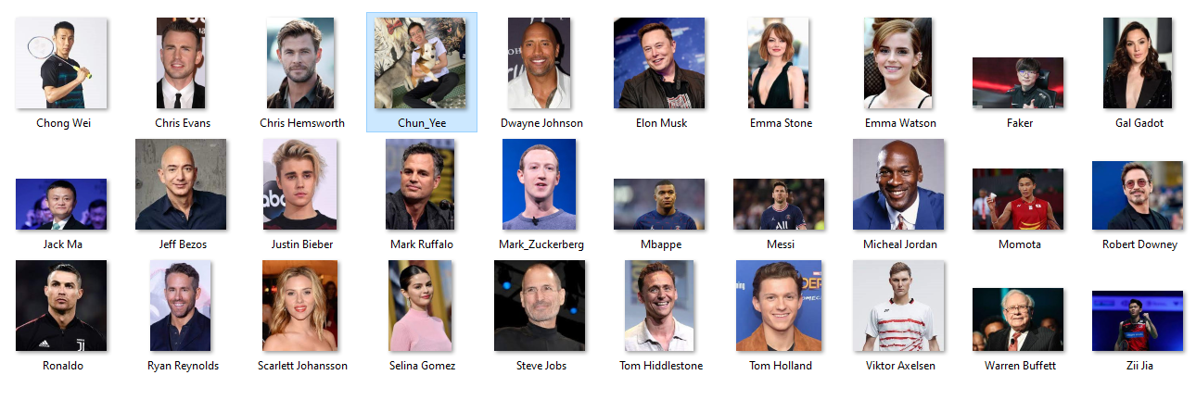

Figure . 30 image faces testing

According to the Figure 4.1.7 above, the folder stored 30 image faces to check the face recognition can recognize the people in front of the webcam. The person also will be tested with the person named Chun Yee showing in front of the webcam to get recognized.

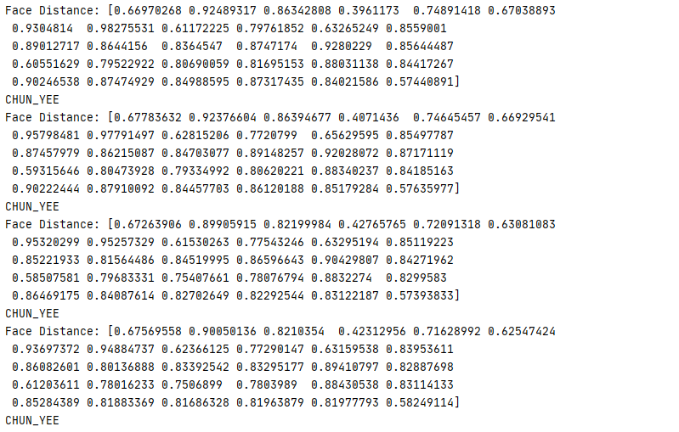

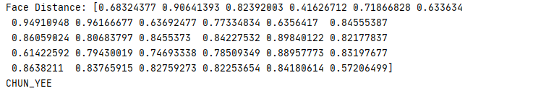

Figure . Comparison of calculated face distance of the encoded webcam face image

According to the Figure 4.1.8 above, it showed the comparison of the distance of the encoded webcam face image with the encoded 30 face images in the specific folder. It showed that the fourth index of the list has the smallest value of the Euclidean Distance after it was tested 5 times. The fourth index of the list is showing the person named Chun Yee who is getting recognized after getting the smallest value of distance which is considered as the face recognized in the comparison.

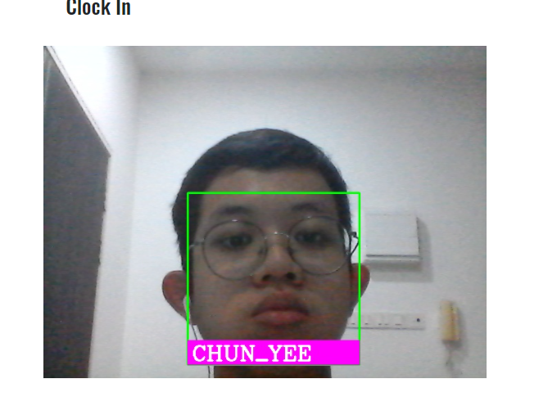

Figure . Face of the person recognized with 30 images testing with showing the name

According to the Figure 4.1.9 above, it showed that the face in front of the webcam is exactly the fourth image stored in the specific folder based on the Figure 4.1.1.7. After the 30 images testing is successfully tested, the face recognition testing is tested successfully.

## Unit Testing

In this section, the unit testing will be used to test the individual units or functions of software testing. The primary purpose of the unit testing is to test each unit or function, the unit test is the smallest part of the application and it has only a few inputs and produces one output based on the research (Gill, 2018). The PyCharm Community Edition, it has a library named unittest which will be imported into the unit testing file named projecttest.py file. It can perform the unit testing easily and successfully through the library. 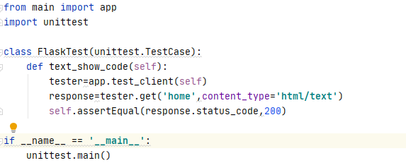

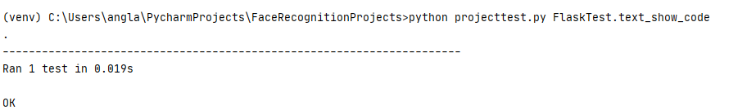

Figure . Code snippet of inputs and output of successful unit testing

According to the Figure 4.2.1 above, it showed the simple unit testing to test the server response code. The server will run on the response code of 200, the input inserted the value of the 200 to test, the output showed that the test ran successfully without any error.

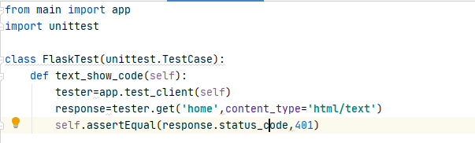

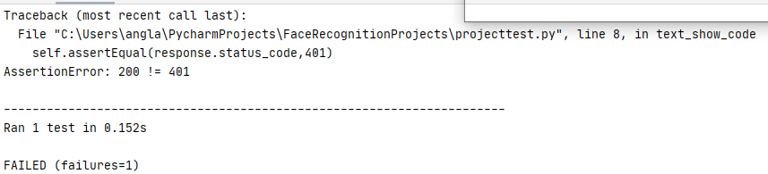

Figure . Code snippet of inputs and output of unsuccessful unit testing

According to the Figure 4.2.2 above, it showed the simple unit testing to test the server response code. The server will run on the response code of 200, the input inserted the value of the 401 to test, the output showed that the test ran unsuccessfully and the output terminal showed the assertion error which is the value of 200 is not equal to the input of the 401. After testing the code server, the other module testings will be conducted into the tables and discussed below.

|  |  |  |  |
| --- | --- | --- | --- |
| Login Module | | | |
| No | Description | Result | Remark |
| 1 | Enter into the login webpage | Pass | Input of login word obtained |
| 2 | Obtain the user’s email and password | Pass | Input email and password obtained |
| 3 | Redirect to homepage after the login successfully | Pass | Return login successfully if completed |
| 4 | Redirect to login page after the login unsuccessfully | Pass | Obtain the login word if the login is incomplete |

Table Unit Testing in user login module

|  |  |  |  |
| --- | --- | --- | --- |
| Sign Up Module | | | |
| No | Description | Result | Remark |
| 1 | Enter into sign up webpage | Pass | Input of sign up word obtained |
| 2 | Obtain the credential of the user | Pass | Input of the email, name, phone, password obtained |
| 3 | Redirect to homepage after sign up successfully | Pass | Return sign up successfully if completed |
| 4 | Redirect to sign up page after sign up unsuccessfully | Pass | Obtain the sign up word if the sign up is incomplete |

Table Unit Testing in user sign up module

|  |  |  |  |
| --- | --- | --- | --- |
| User Home Module | | | |
| No | Description | Result | Remark |
| 1 | Obtain the first section of the homepage | Pass | The “Are you ready” word obtained |
| 2 | Obtain the second section of the homepage | Pass | The “Best Training” word obtained |
| 3 | Obtain the third section of the homepage | Pass | The “Join Our Membership Today” word obtained |
| 4 | Obtain the fourth section of the homepage | Pass | The “Workout Gallery” word obtained |
| 5 | Obtain the footer section of the homepage | Pass | The “Send Message” word obtained |

Table Unit Testing in user homepage module

|  |  |  |  |
| --- | --- | --- | --- |
| User Facilities Module | | | |
| No | Description | Result | Remark |
| 1 | Enter the facilities webpage | Pass | The “Facilities” word obtained |
| 2 | Obtain the detail of the facilities of the gym | Pass | The “Cycling Studios” word obtained |
| 3 | Obtain the footer section of the facilities page | Pass | The “Send Message” word obtained |

Table Unit Testing in user facilities module

|  |  |  |
| --- | --- | --- |
| User Classes Module | | |
| Description | Result | Remark |
| Enter the classes webpage | Pass | The “Types of Classes” word obtained |
| Obtain the detail of the classes of the gym | Pass | The “Bodybalance” word obtained |
| Obtain the footer section of the classes page | Pass | The “Send Message” word obtained |

Table Unit Testing in user classes module

|  |  |  |  |
| --- | --- | --- | --- |
| User About Us Module | | | |
| No | Description | Result | Remark |
| 1 | Enter the about us webpage | Pass | The “About Us” word obtained |
| 2 | Obtain the detail of the about us of the gym | Pass | The “Welcome to FaceGym!” word obtained |
| 3 | Obtain the footer section of the about us page | Pass | The “Send Message” word obtained |

Table Unit Testing in user about us module

|  |  |  |  |
| --- | --- | --- | --- |
| User Membership Module | | | |
| No | Description | Result | Remark |
| 1 | Enter the membership webpage | Pass | The “Membership” word obtained |
| 2 | Obtain the packages of the gym | Pass | The “Silver Pack” word obtained |
| 3 | Obtain the footer section of the membership page | Pass | The “Send Message” word obtained |

Table Unit Testing in user membership module

|  |  |  |  |
| --- | --- | --- | --- |
| User Checkout with Card Module | | | |
| No | Description | Result | Remark |
| 1 | Enter the checkout with card webpage | Pass | The “Card Payment” word obtained |
| 2 | The cart showed the details | Pass | The “Starter Pack” word obtained |
| 3 | The cancel button worked successfully | Pass | The “Best Training” word in user homepage obtained |
| 4 | The checkout button worked successfully | Pass | The “Membership” word in membership webpage obtained |

Table Unit Testing in user checkout with card module

|  |  |  |  |
| --- | --- | --- | --- |
| User Checkout with Wallet Module | | | |
| No | Description | Result | Remark |
| 1 | Enter the checkout with wallet webpage | Pass | The “Wallet Payment” word obtained |
| 2 | The cart showed the details | Pass | The “Starter Pack” word obtained |
| 3 | The cancel button worked successfully | Pass | The “Best Training” word in user homepage obtained |
| 4 | The checkout button worked successfully | Pass | The “Membership” word in membership webpage obtained |

Table Unit Testing in user checkout with wallet module

|  |  |  |  |
| --- | --- | --- | --- |
| User Profile Module | | | |
| No | Description | Result | Remark |
| 1 | Enter the user profile webpage | Pass | The “My Profile” word obtained |
| 2 | Show the email of the user | Pass | The “Email” word obtained |
| 3 | Show the phone number of the user | Pass | The “Phone” word obtained |
| 4 | Show the wallet amount of the user | Pass | The “Wallet” word obtained |
| 5 | Show the payment information of the user | Pass | The “Payment Information” word obtained |
| 6 | The user can top up the wallet with the button | Pass | The “Top Up” word obtained |
| 7 | The user can view the payment status | Pass | The “Your Payment” word obtained |

Table Unit Testing in user profile

|  |  |  |  |
| --- | --- | --- | --- |
| User Top Up Module | | | |
| No | Description | Result | Remark |
| 1 | Enter the user top up webpage | Pass | The “Top Up” word obtained |
| 2 | Obtain the user’s top up amount and password | Pass | The amount and the password obtained |
| 3 | The top up done successfully | Pass | The “Best Training” word obtained in user homepage |
| 4 | The top up done unsuccessfully | Pass | The “Top up” word obtained in top up webpage |

Table Unit Testing in user top up

|  |  |  |  |
| --- | --- | --- | --- |
| Admin Homepage Module | | | |
| No | Description | Result | Remark |
| 1 | Enter the admin homepage webpage | Pass | The “Welcome to FaceGym” word obtained |
| 2 | Obtain the clock in button | Pass | The “Clock In” word obtained |
| 3 | Obtain the clock out button | Pass | The “Clock Out” word obtained |

Table Unit Testing in admin homepage module

|  |  |  |  |
| --- | --- | --- | --- |
| Admin Dashboard Module | | | |
| No | Description | Result | Remark |
| 1 | Enter the admin dashboard webpage | Pass | The “Dashboard” word obtained |
| 2 | Show total members value | Pass | The “Members” word obtained |
| 3 | Obtain total revenue value | Pass | The “Earnings” word obtained |

Table Unit Testing in admin dashboard module

|  |  |  |  |
| --- | --- | --- | --- |
| Admin View Members Module | | | |
| No | Description | Result | Remark |
| 1 | Enter the admin view members webpage | Pass | The “Members” word obtained |
| 2 | Show the table of the users | Pass | The “User” word obtained |
| 3 | Generate the report successfully | Pass | The “Generate Report” word obtained |

Table Unit Testing in admin view members module

|  |  |  |  |
| --- | --- | --- | --- |
| Admin View Payment Status Module | | | |
| No | Description | Result | Remark |
| 1 | Enter the admin view members webpage | Pass | The “Payment” word obtained |
| 2 | Show the table of the users | Pass | The “Status” word obtained |
| 3 | Generate the report successfully | Pass | The “Generate Report” word obtained |

Table Unit Testing in admin view payment status module

|  |  |  |  |
| --- | --- | --- | --- |
| Admin View Comments Module | | | |
| No | Description | Result | Remark |
| 1 | Enter the admin view comments webpage | Pass | The “Comments” word obtained |
| 2 | Show the table of the users | Pass | The “Comments” word from table obtained |
| 3 | Generate the report successfully | Pass | The “Generate Report” word obtained |

Table Unit Testing in admin view comments module

|  |  |  |
| --- | --- | --- |
| Admin Login Module | | |
| Description | Result | Remark |
| Enter into the admin login webpage | Pass | Input of admin login word obtained |
| Obtain the admin’s name and password | Pass | Input name and password obtained |
| Redirect to admin homepage after the login successfully | Pass | Return admin login successfully if completed |
| Redirect to admin login page after the login unsuccessfully | Pass | Obtain the admin login word if the login is incomplete |

Table Unit Testing in admin login module

## GUI Testing

In this section, the graphical user interface testing will be conducted and discussed to the user experience the desired outcome from their action. The GUI testing is also to ensure the project is meeting the requirements. To test the user interface, the screenshot of the modules will be discussed below. The GUI testing will be separated into two parts which are user GUI testing and admin GUI testing.

### User Homepage



Figure . Interface of the user homepage

According to the Figure 4.3.1 above, it showed the interface of the user homepage showed successfully. The first section of the user homepage showed the banner of the courage words to encourage the users to join the gym. There is an angle down button to drag the section down after the users click it.

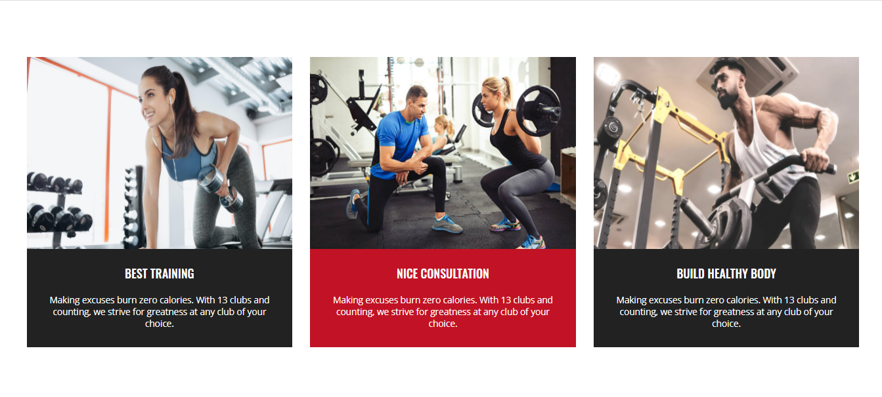

Figure . Interface of the second section of user homepage

According to the Figure 4.3.2 above, it showed the interface of the second section of the user homepage showed successfully after the users clicked the angle down button.

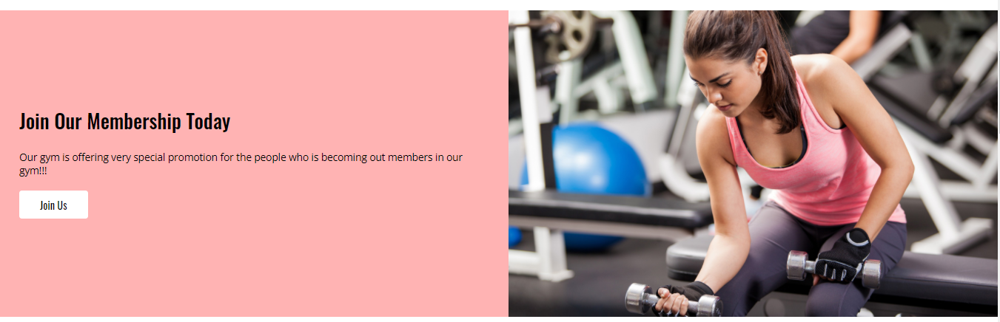

Figure . Interface of the third section of user homepage

According to the Figure 4.3.3 above, it showed the interface of the third section of the user homepage showed successfully.

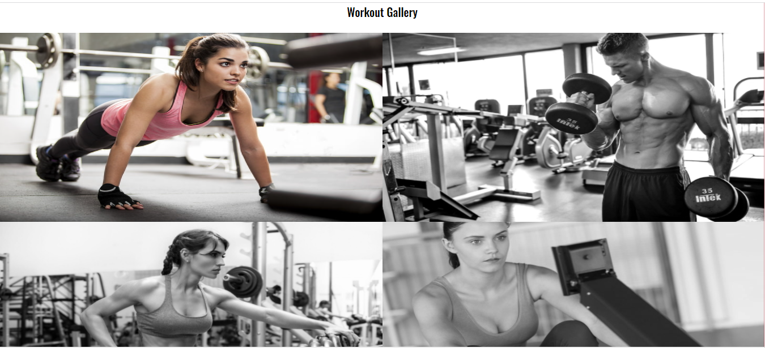

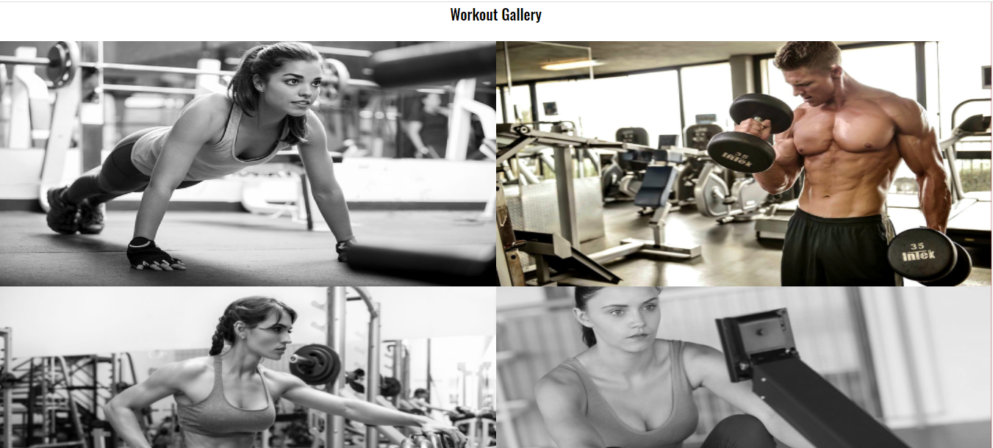

Figure . Interface of the fourth section of user homepage

According to the Figure 4.3.4 above, it showed the interface of the fourth section of the user homepage showed successfully. The images will become from grey to color after the users mouse clicked on the images.

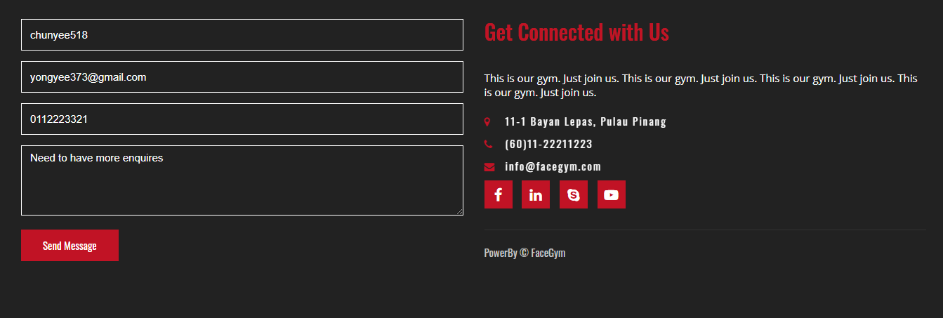

Figure . Interface of the footer section of user homepage

According to the Figure 4.3.5 above, it showed the interface of the footer section of the user homepage showed successfully. It can let the logged users to comment to the gym.

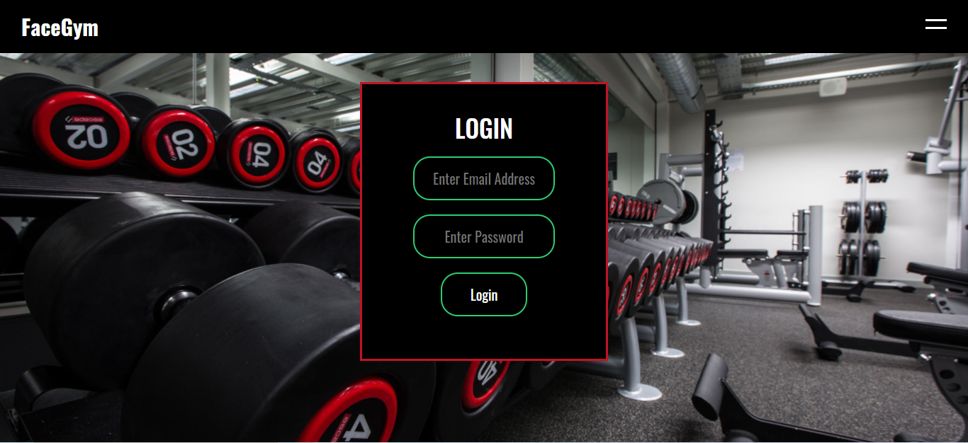

Figure . Interface of the user login webpage when the user sending messages unsuccessfully

According to the Figure 4.3.6 above, it showed the user login webpage when the user clicked on the button of the send message without login.



Figure . Interface of the user homepage when the user sending messages successfully

According to the Figure 4.3.7 above, it showed the user homepage again with flashing the message “Successful Inserted Comments” after the logged user sending the messages successfully.

### User Sign Up

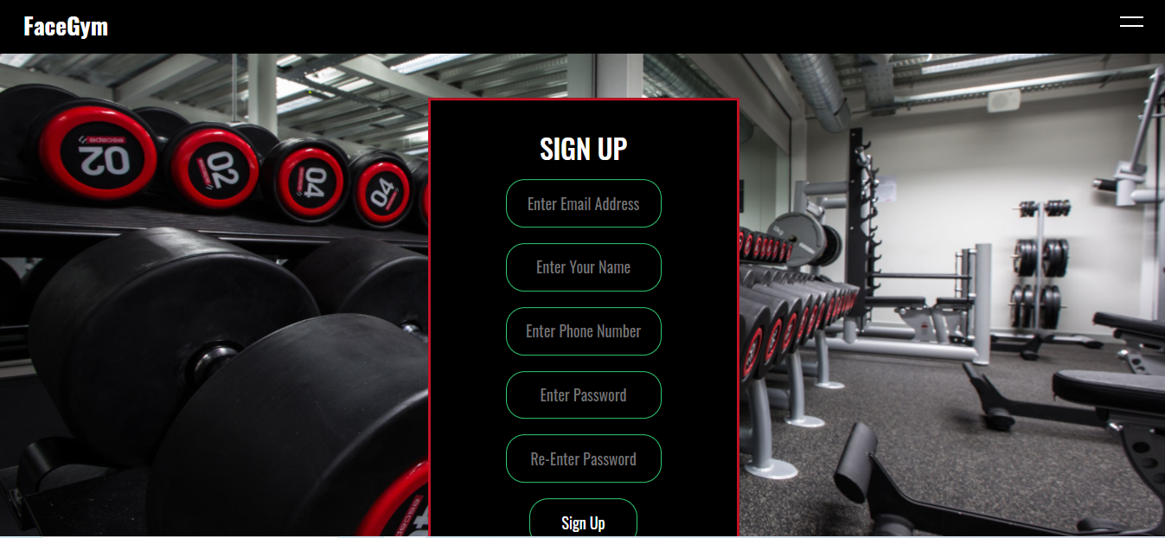

Figure . Interface of the user sign up webpage

According to the Figure 4.3.8 above, it showed the interface of the user sign up showed successfully. The new user can insert the credentials inside the form provided.

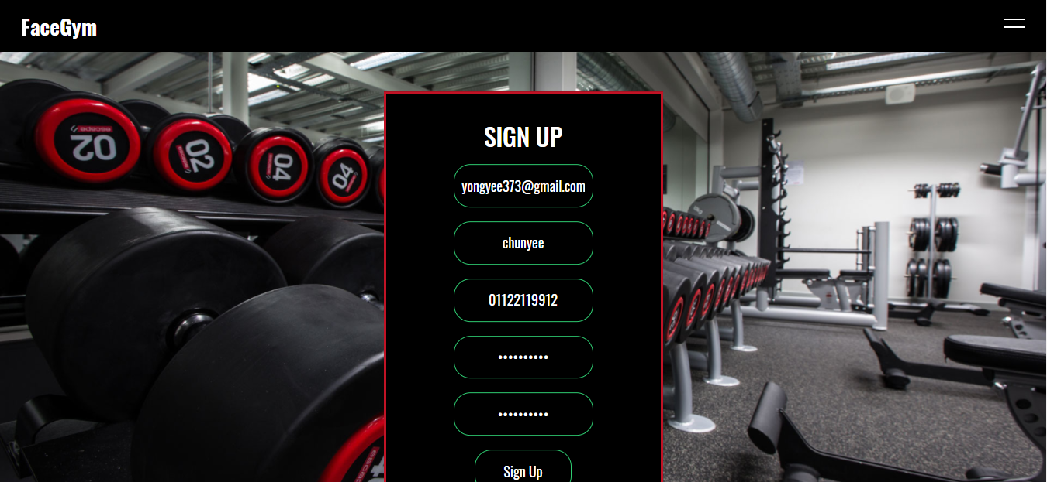

Figure . Interface of inserting existing email address

According to the Figure 4.3.9 above, it showed that it tests to sign up with the existing email.

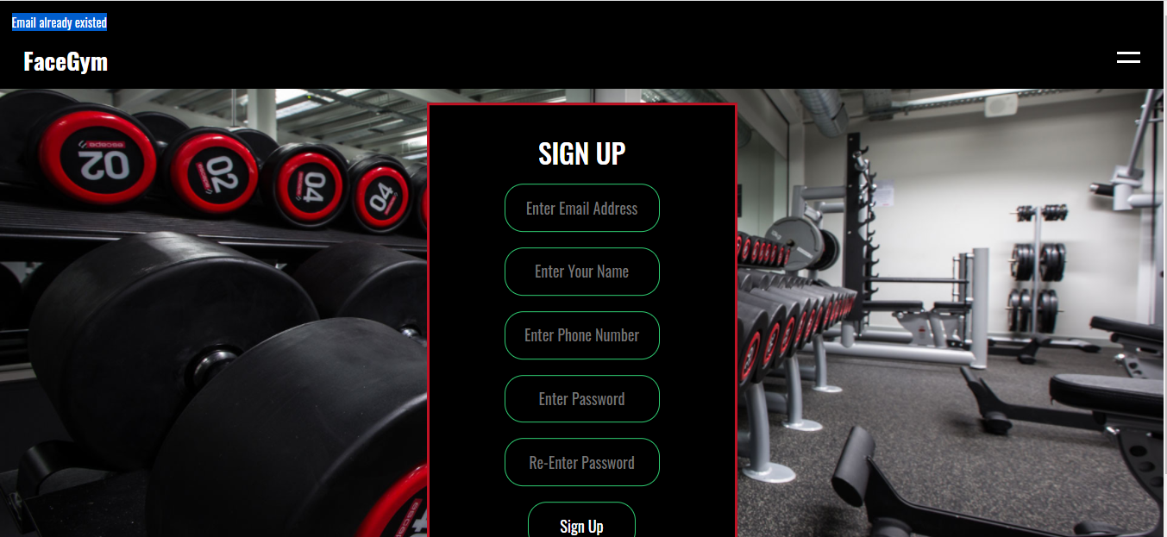

Figure . Interface of showing error when the email existed

According to the Figure 4.3.10 above, it flashed the error message “Email already existed” when it clicked the sign up button, it will ask the user to insert a new email to sign up.

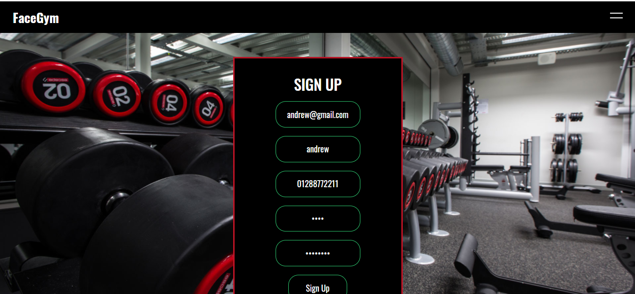

Figure . Interface of the inserting not matching passwords

According to the Figure 4.3.11 above, it showed that it tests to sign up with the not matching password and the confirm password column.

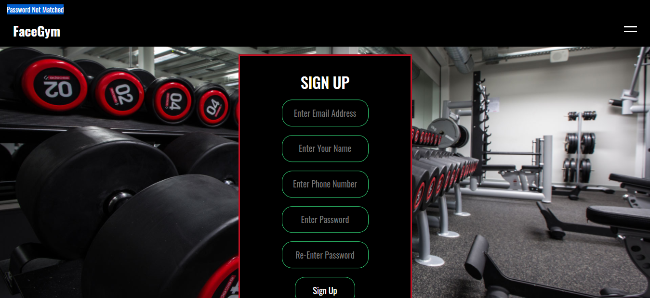

Figure . Interface of showing error when the password not matched

According to the Figure 4.3.12 above, it flashed the error message “Password Not Matched” when it clicked the sign up button, it will ask the user to sign up again.



Figure . Interface of showing sign up successfully on user homepage

According to the Figure 4.3.13 , it flashed the message “Successful Sign Up” after the sign up process is successfully done and redirect to the user homepage.

### User Login

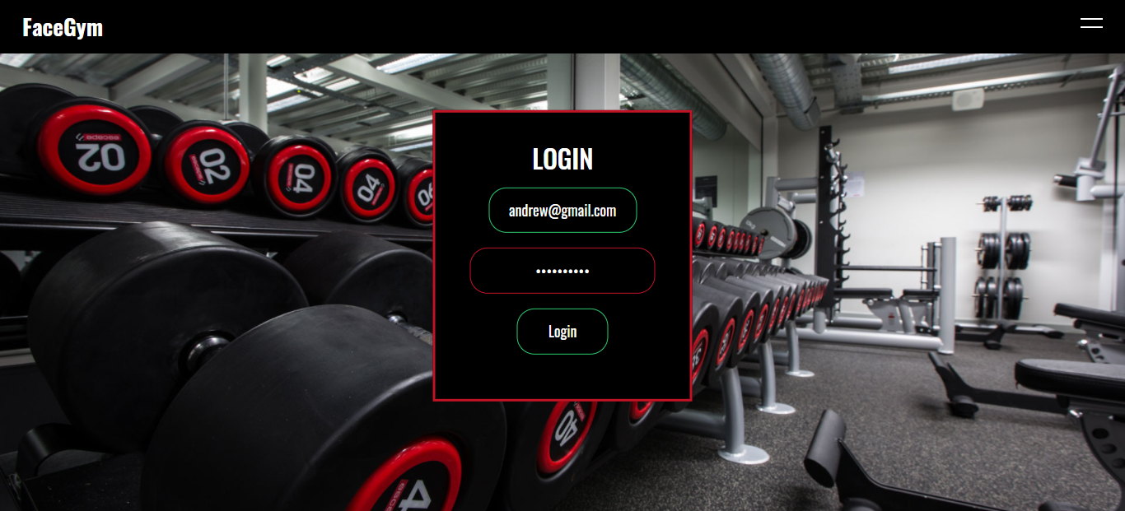

Figure . Interface of the user login webpage

According to the Figure 4.3.14 above, it showed the interface of the user login showed successfully. The existed user can insert the credentials inside the form provided.

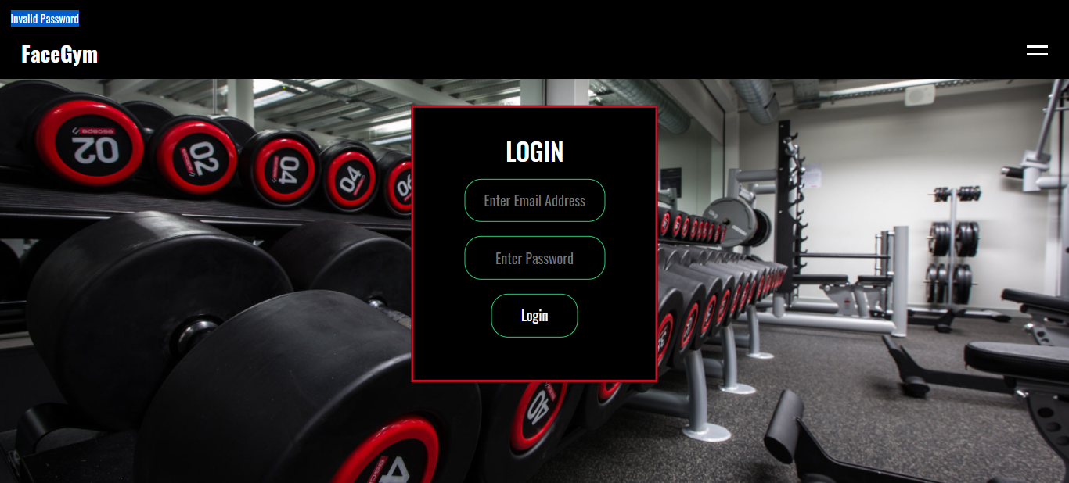

Figure . Interface of showing error when the password incorrect

According to the Figure 4.3.15 above, it flashed the error message “Invalid Password” when the password is incorrect, it will ask the user to login again.

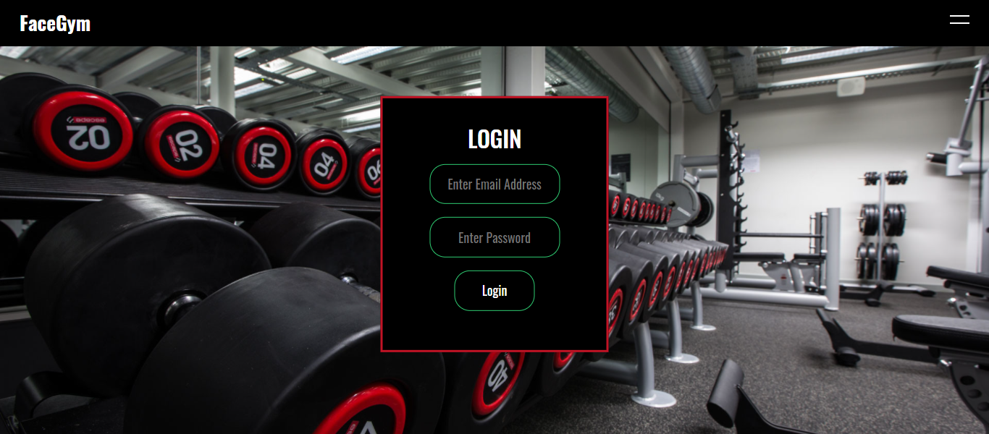

Figure . Interface of not inserting in the user login form

According to the Figure 4.3.16 above, it showed that it tests to login without inserting any credential information.

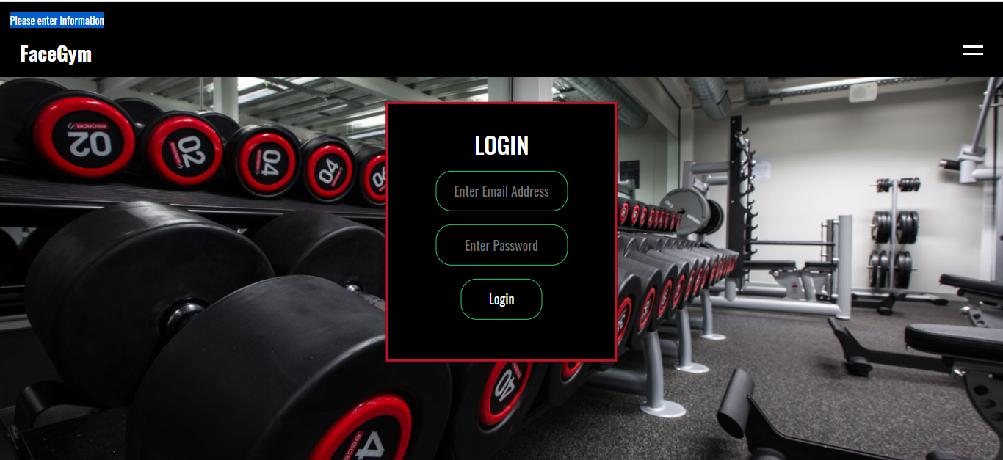

Figure . Interface of showing error message when no information inserted

According to the Figure 4.3.17 above, it flashed the error message “Please Enter Information” when there is no information inserted. It will ask the user to login again.

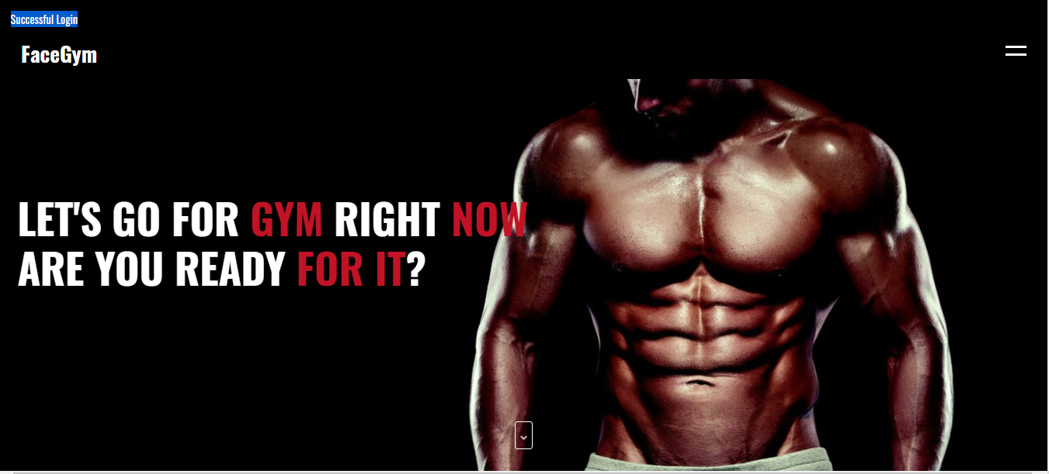

Figure . Interface of showing login successfully on user homepage

According to the Figure 4.3.18 , it flashed the message “Successful Login” after the login process is successfully done and redirect to the user homepage.

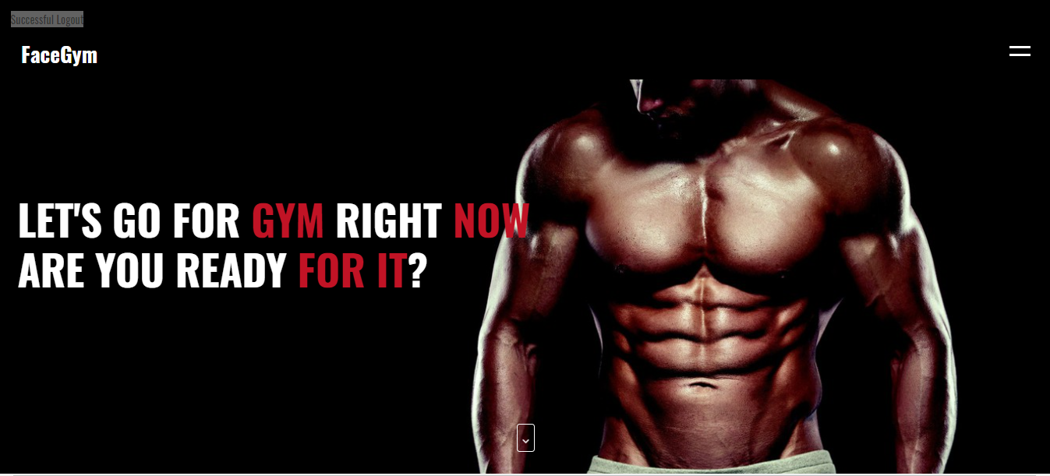

Figure . Interface of showing logout successfully on user homepage

According to the Figure 4.3.19, it flashed the message “Successful Logout” after the user logout successfully and redirect to the user homepage.

### User Profile

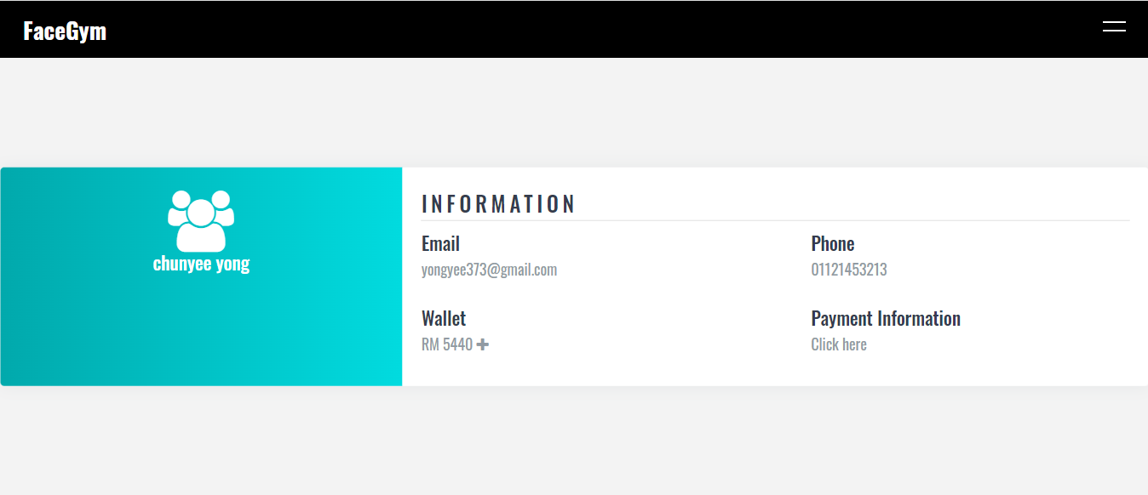

Figure . Interface of user profile webpage

According to the Figure 4.3.20 above, it showed the interface of the user profile webpage. It showed the logged user’s name at the left side, the information such as email address, phone number, wallet amount and payment information will show at the right side.

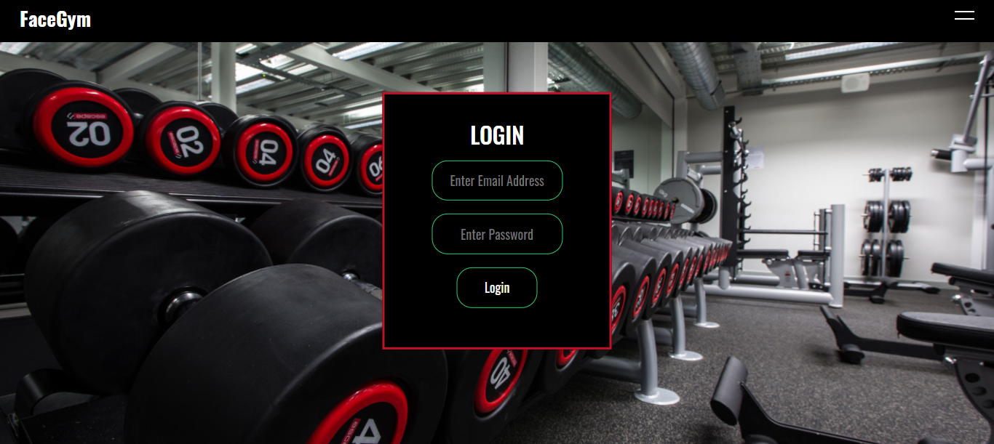

Figure . Interface of user login webpage

According to the Figure 4.3.21 above, it will redirect the user to the login webpage if the user not logged in and entering to the profile webpage manually.

### User Top Up

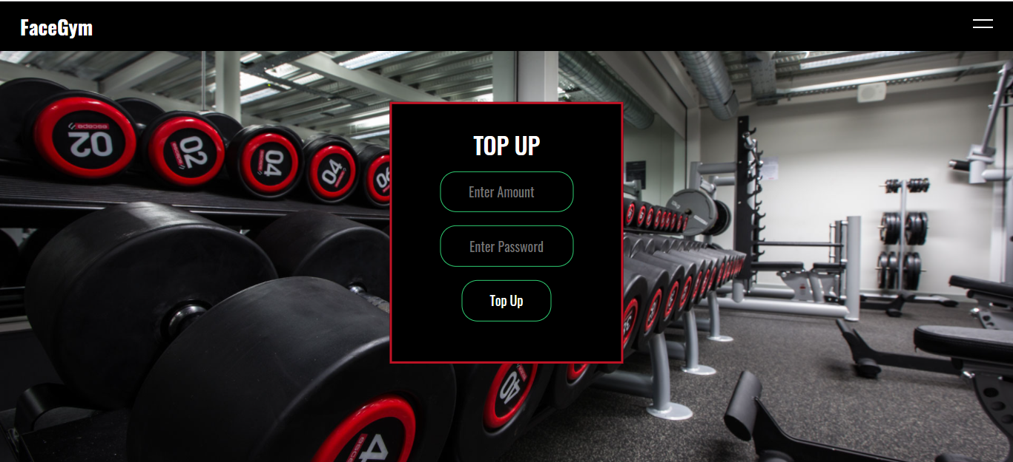

Figure . Interface of top up webpage

According to the Figure 4.3.22 above, it showed the interface of the user top up webpage after clicking the plus button on the wallet amount based on Figure 4.1.3.20. It showed the amount to top up and the password of the logged user to fill in before top up.

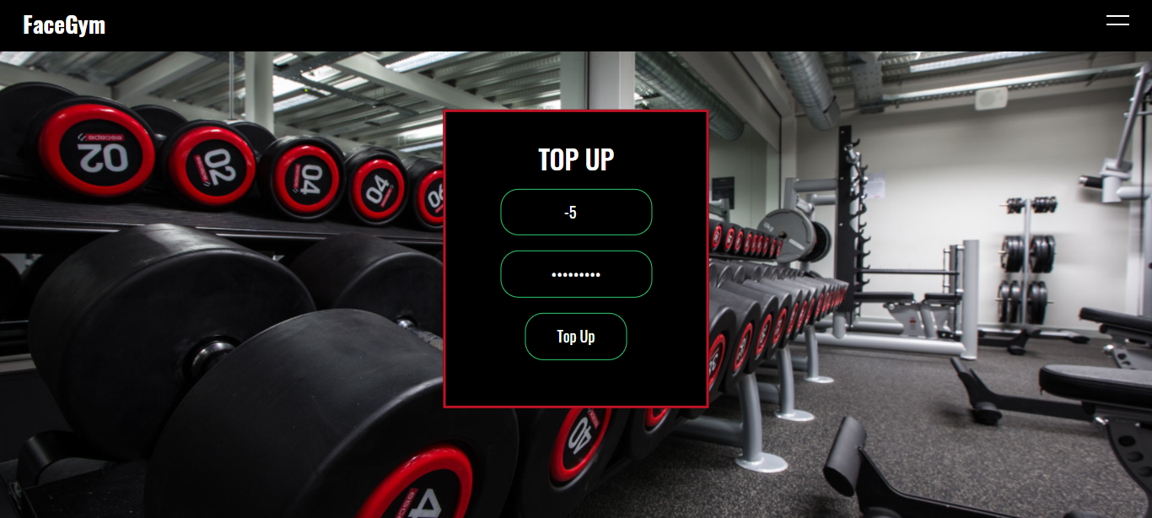

Figure . Interface of inserting negative top up amount

According to the Figure 4.3.23 , it showed that it tests to top up the amount with the negative value on the top up interface.

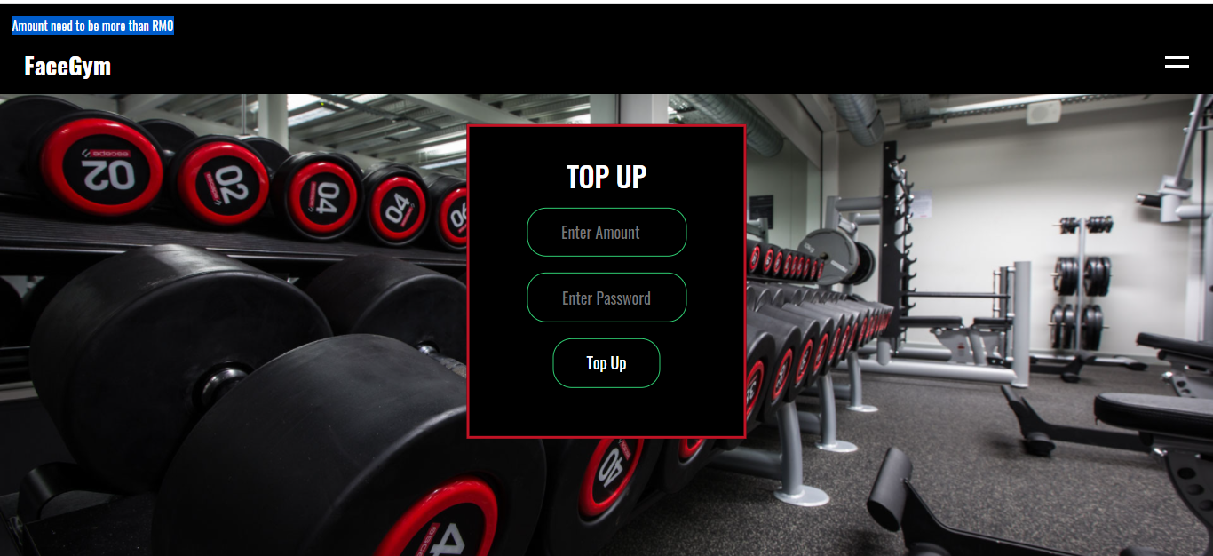

Figure . Interface of showing error message when negative amount inserted

According to the Figure 4.3.24 above, it flashed the error message “Amount need to be more than RM0” when the top up amount is negative value. It will ask the user to top up again.

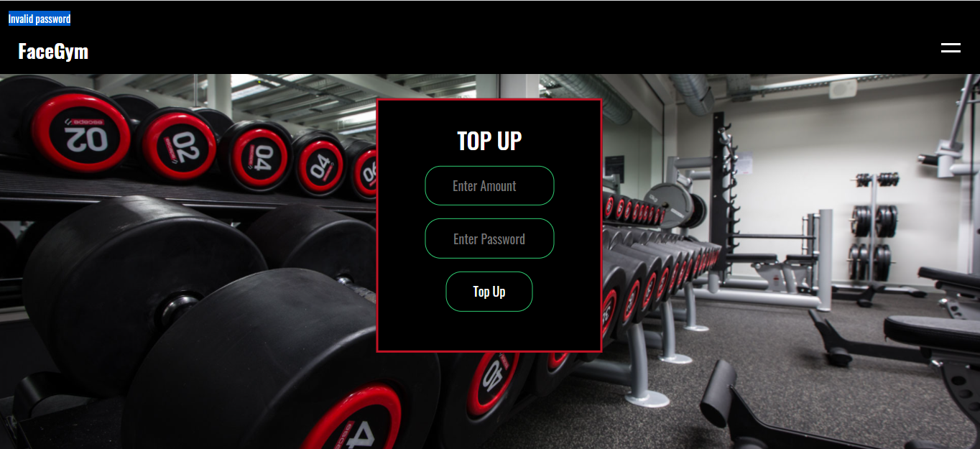

Figure . Interface of showing error when the password incorrect on top up webpage

According to the Figure 4.3.25 above, it flashed the error message “Invalid Password” when the password is incorrect, it will ask the user to top up again.

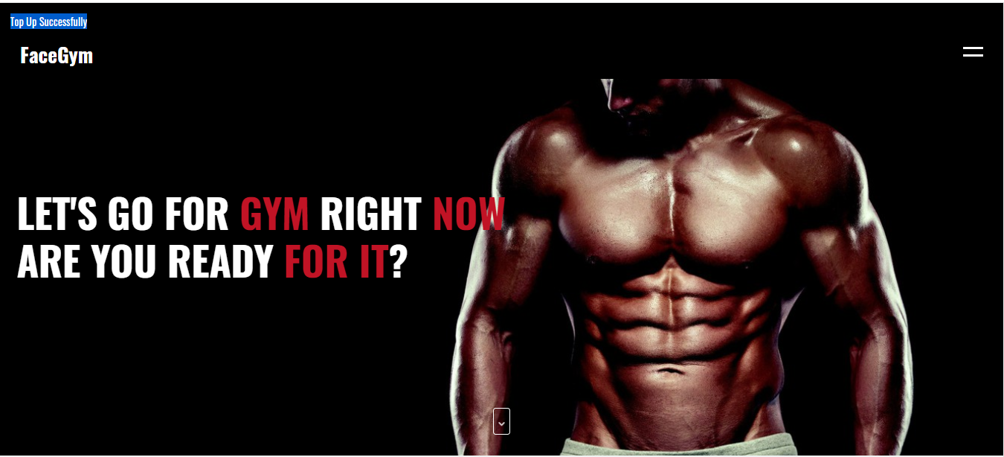

Figure . Interface of showing top up successfully on user homepage

According to the Figure 4.3.26, it flashed the message “Top Up Successfully” after the top up process is successfully done and redirect to the user homepage.

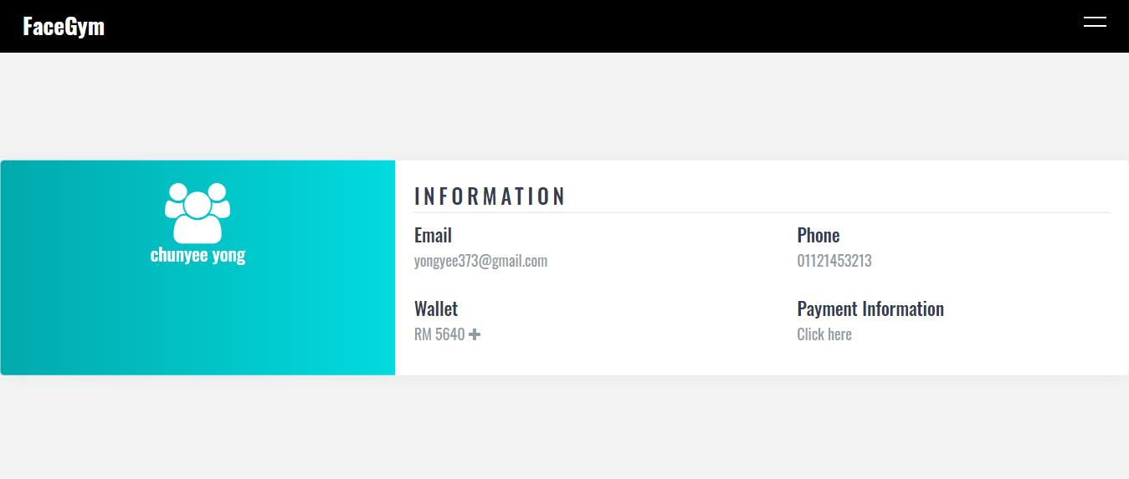

Figure . Interface of user profile webpage

According to the Figure 4.3.27 above, it showed that the wallet has successfully topped up with the amount of RM200 based on the Figure 4.1.3.20.

### User Membership & Checkout

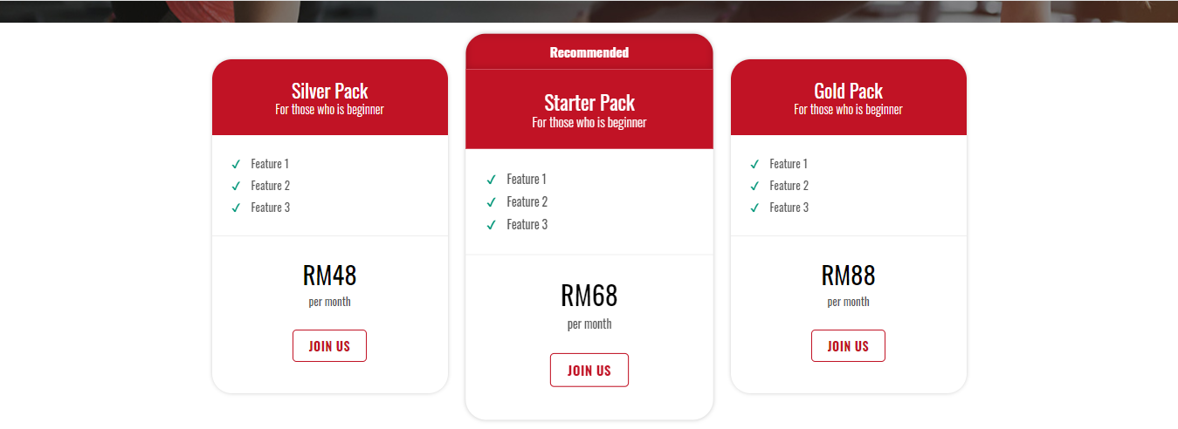

Figure . Interface of user profile webpage

According to the Figure 4.3.28 above, it showed the interface of the user membership webpage. It showed the packages and the prices of the gym. The packages have the button “Join Us” to let the users to click in to join as the membership.

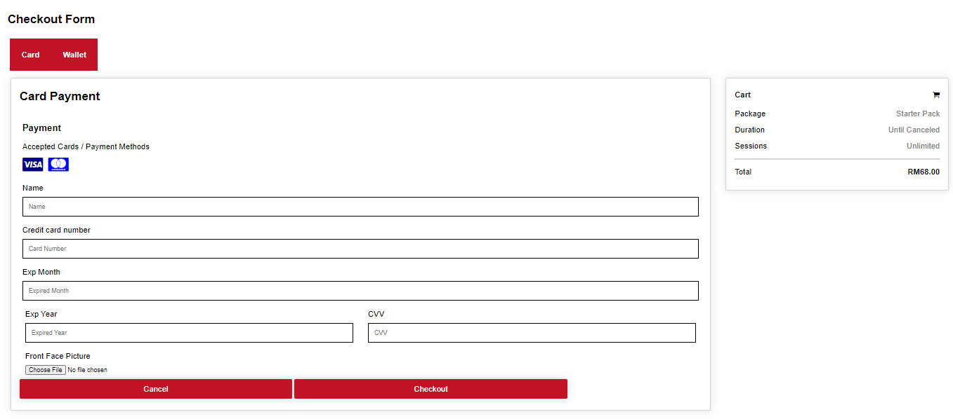

Figure . Interface of user checkout with card webpage

According to the Figure 4.3.29 above, it showed the interface of the checkout with the card webpage. It showed the package, price, and the session. It has the form to let the logged user to fill in the credential. 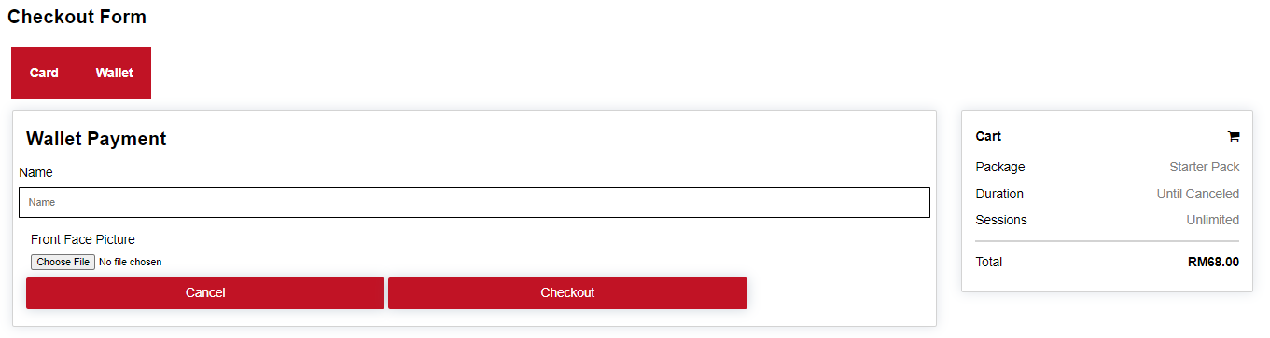

Figure . Interface of user checkout with wallet webpage

According to the Figure 4.3.30 above, it showed the interface of the checkout with the wallet webpage.

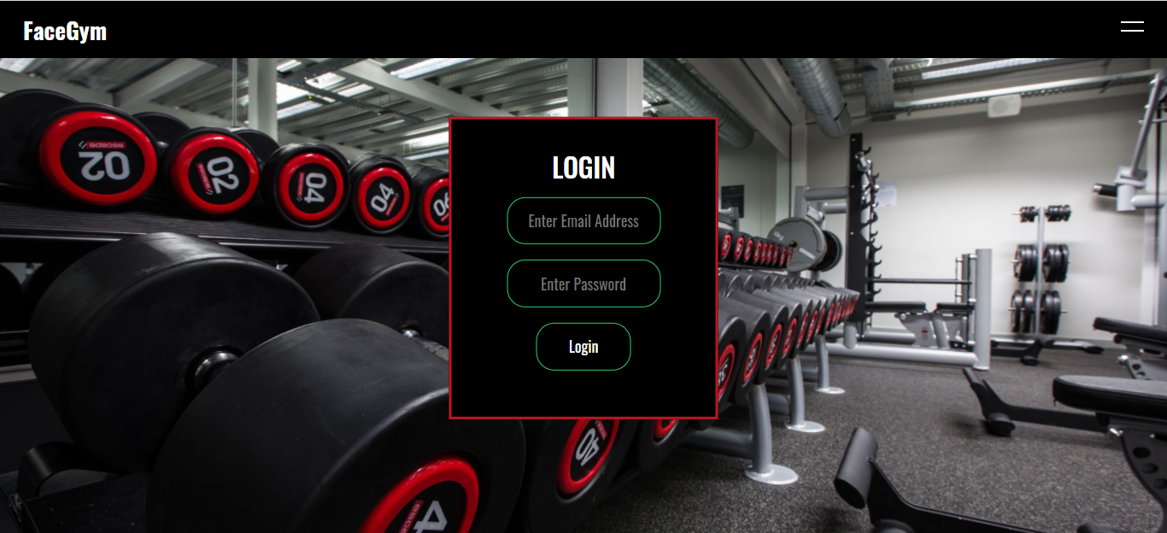

Figure . Interface of user login webpage

According to the Figure 4.3.31 above, it will redirect the user to the login webpage if the user not logged in and entering to the checkout webpage.

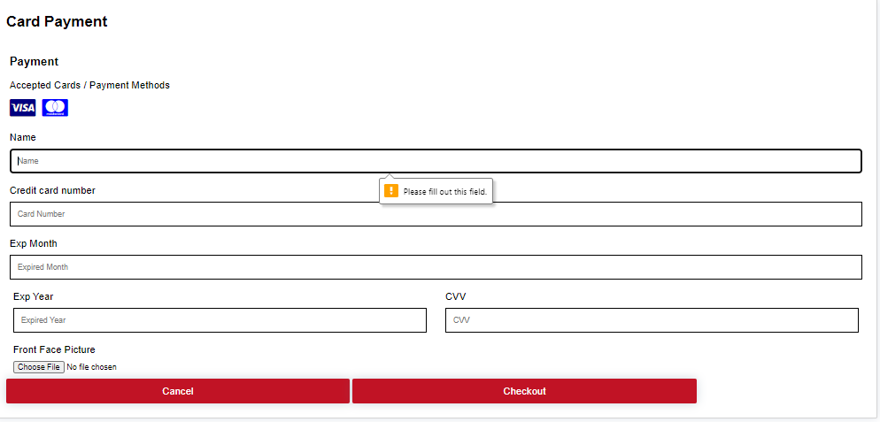 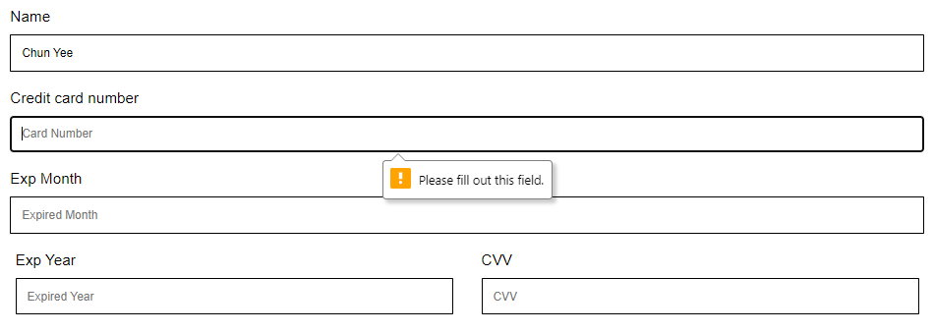

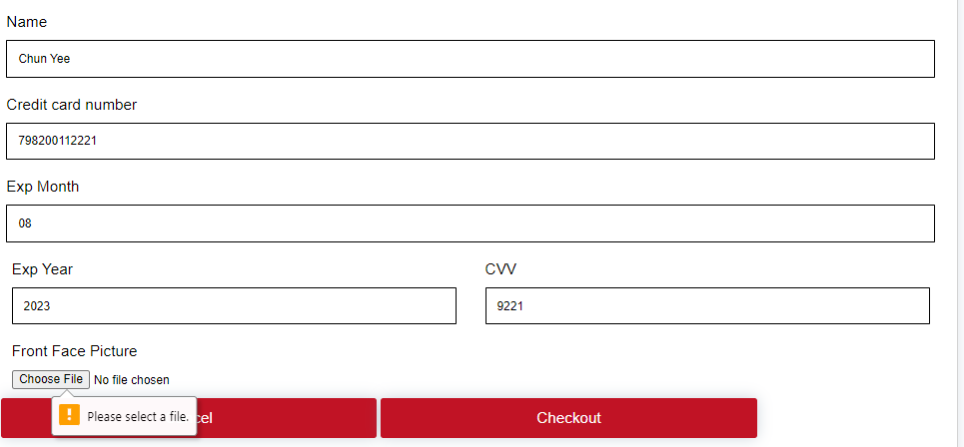

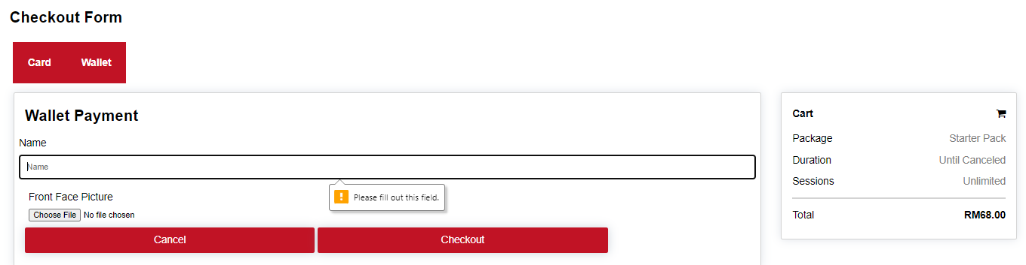

Figure . Interfaces of the showing error messages

According to the Figure 4.3.32 above, it showed the error messages to ask the logged user to fill in the information whenever the columns in the form are not filled in either in the checkout with card webpage or checkout with wallet webpage.

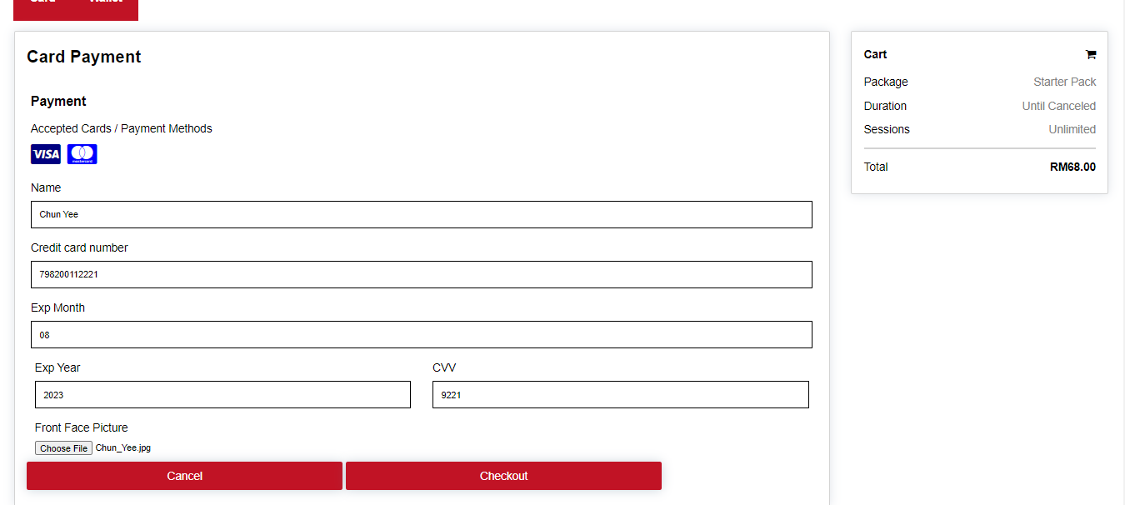

Figure . Interface of filling the new member information

According to the Figure 4.3.33, it showed the information of the filled in credential and the front face image of the member.

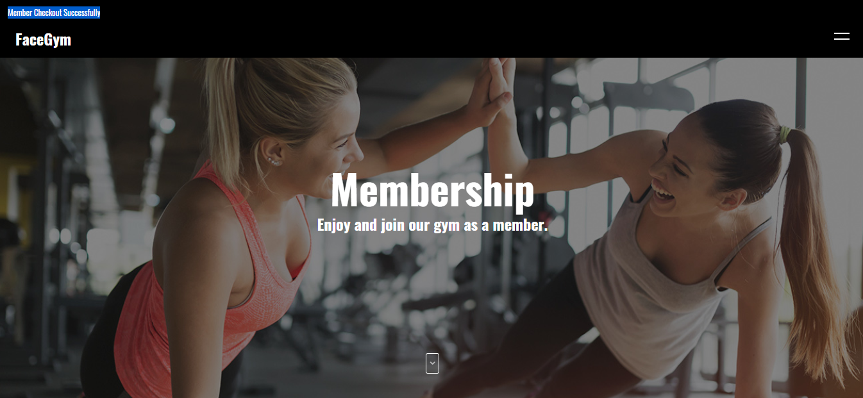

Figure . Interface of membership checkout successfully

According to the Figure 4.3.34 above, it showed the flashed message “Member Checkout Successfully” when the new member checkout successfully and redirect to the membership webpage.

### User Realtime

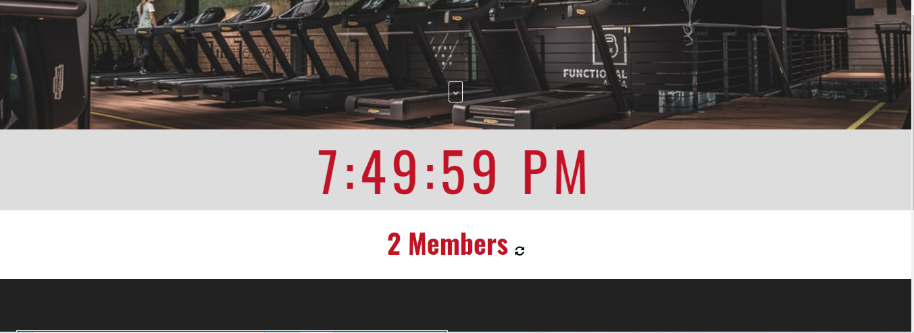

Figure . Interface of user real time webpage

According to the Figure 4.3.35, it showed the information the real time members in the gym center with the real time clock.

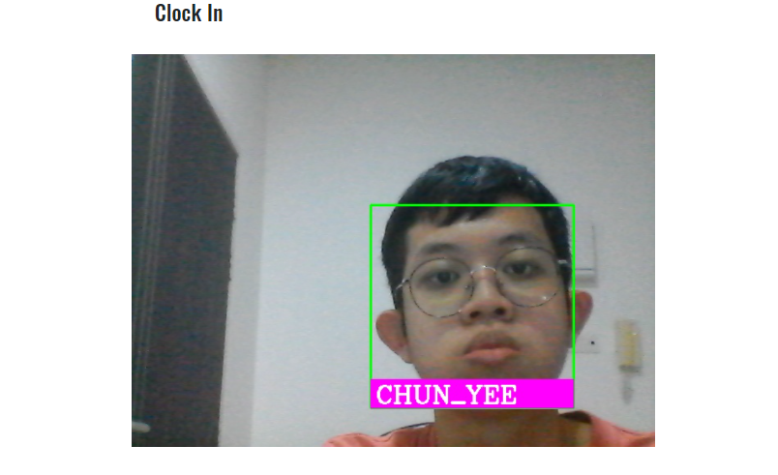

Figure . Interface of performing clock in

According to the Figure 4.3.36, it showed the interface of the member clocking in in the gym center.

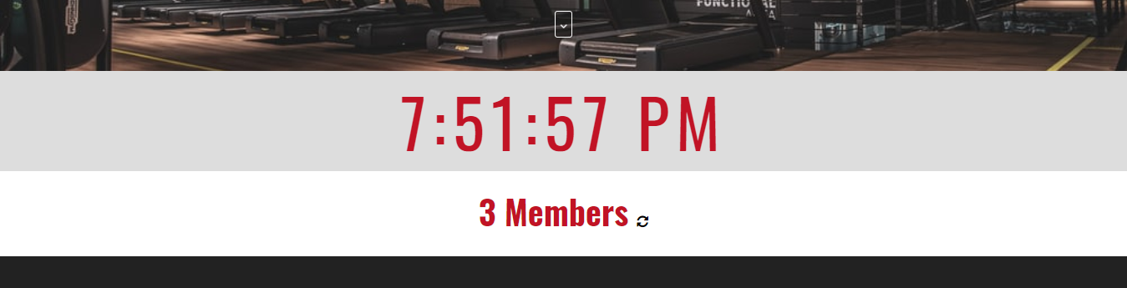

Figure . Interface of user real time webpage

According to the Figure 4.3.37, it showed the information the updated real time members which from 2 members to 3 members in the gym center with the real time clock after the member clocked in successfully.

### Admin Login

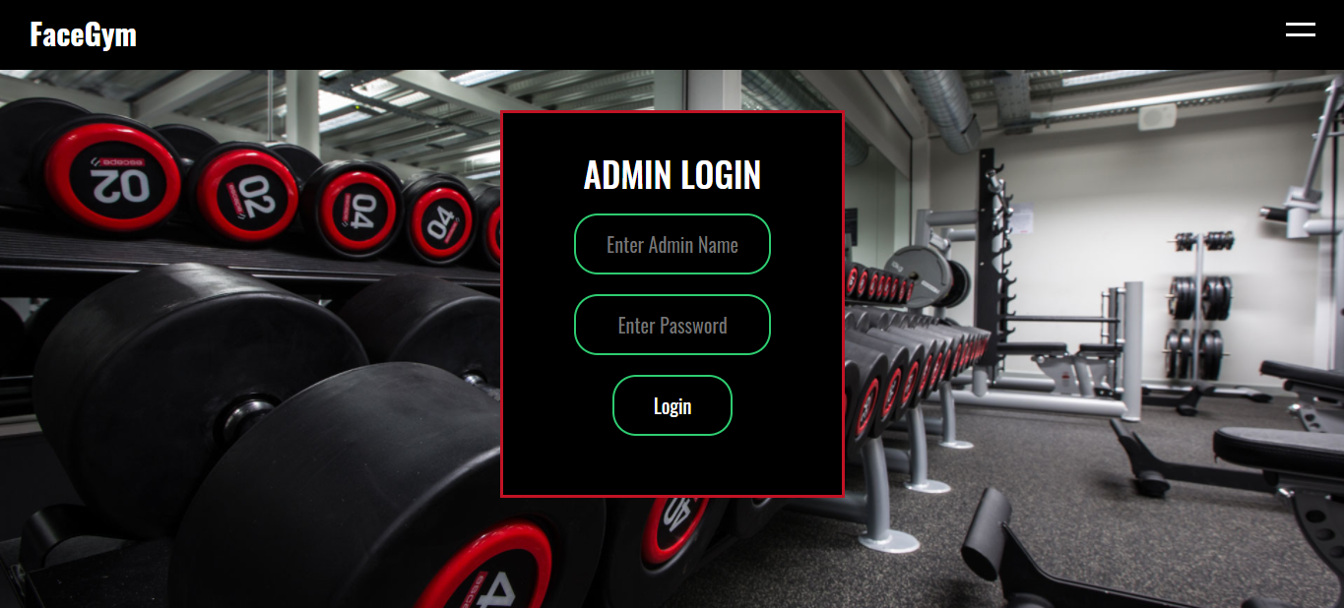

Figure . Interface of the admin login webpage

According to the Figure 4.3.38 above, it showed the interface of the admin login showed successfully. The admin can insert the credentials inside the form provided.

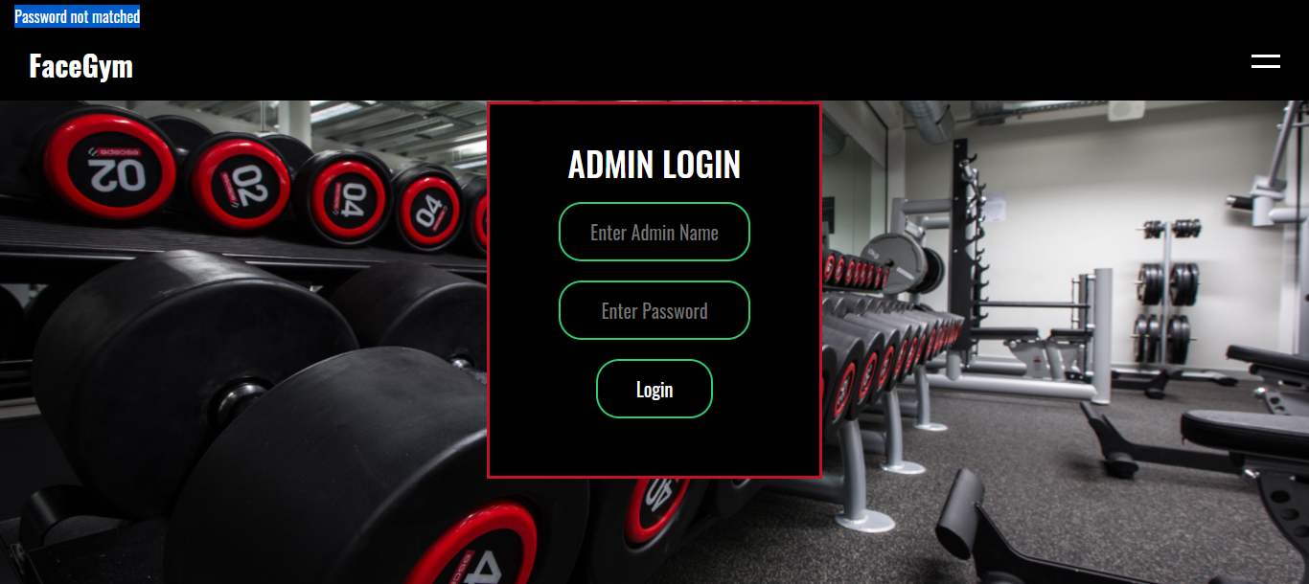

Figure . Interface of showing error when the password incorrect

According to the Figure 4.3.39 above, it flashed the error message “Password not matched” when the password is incorrect, it will ask the admin to login again.

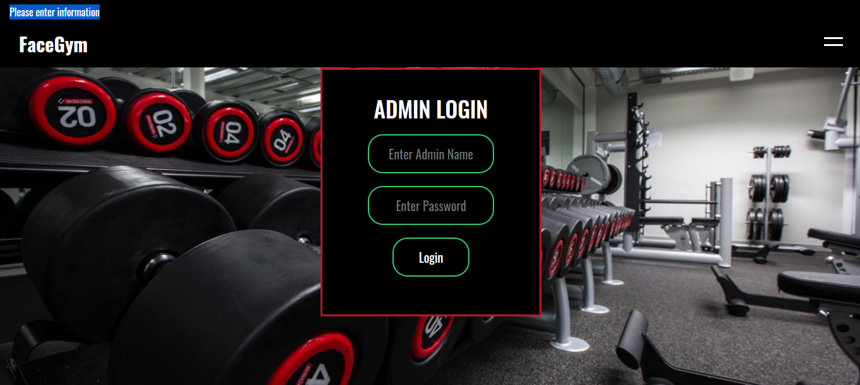

Figure . Interface of showing error when the not filling credential

According to the Figure 4.3.40 above, it flashed the error message “Please enter information” when the credential of the admin not filling in, it will ask the admin to login again in the admin login webpage.

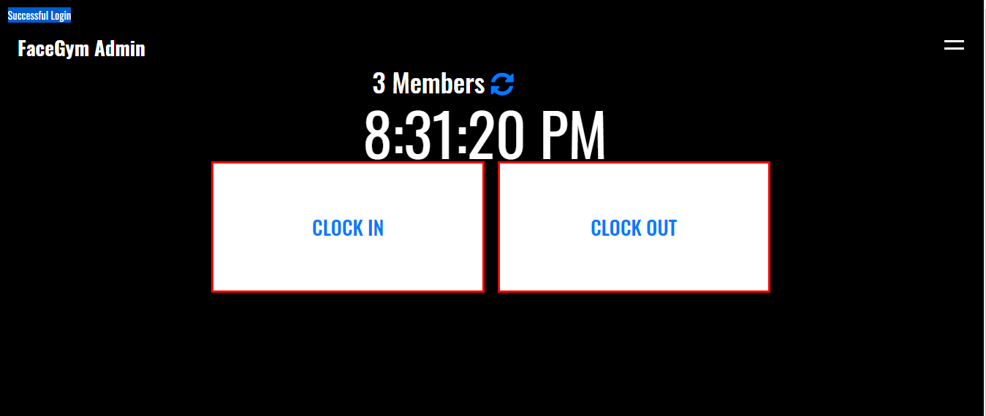

Figure . Interface of showing login successfully on admin homepage

According to the Figure 4.3.41, it flashed the message “Successful Login” after the admin login process is successfully done and redirect to the admin homepage.

### Admin Logout

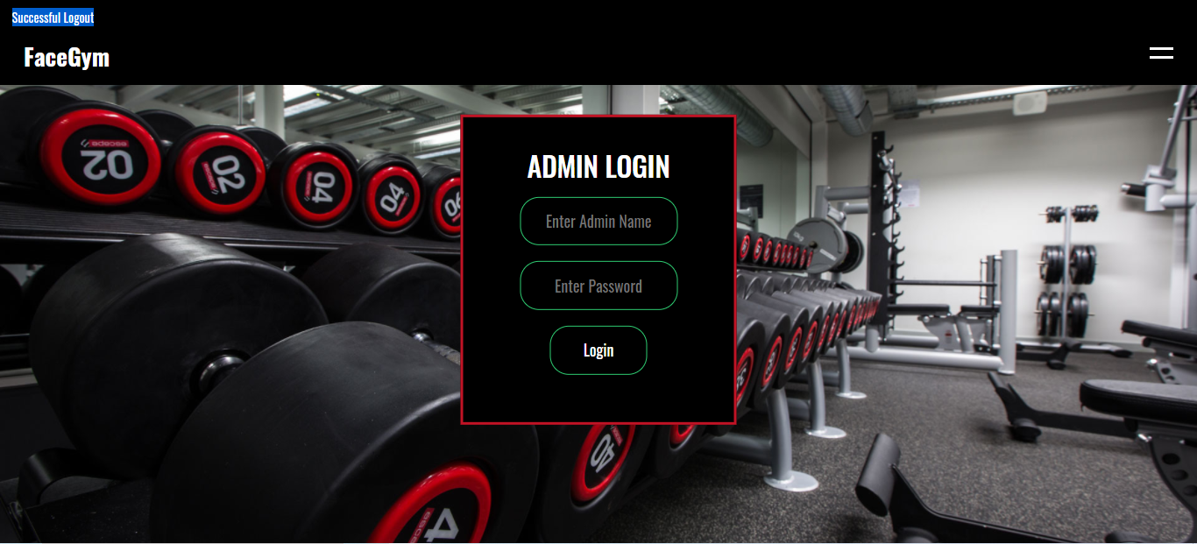

Figure . Interface of admin login webpage after logout

According to the Figure 4.3.42 above, it showed it redirect the admin to the admin login webpage after the admin logout successfully with the flash message “Successfully Logout”.

### Admin Homepage

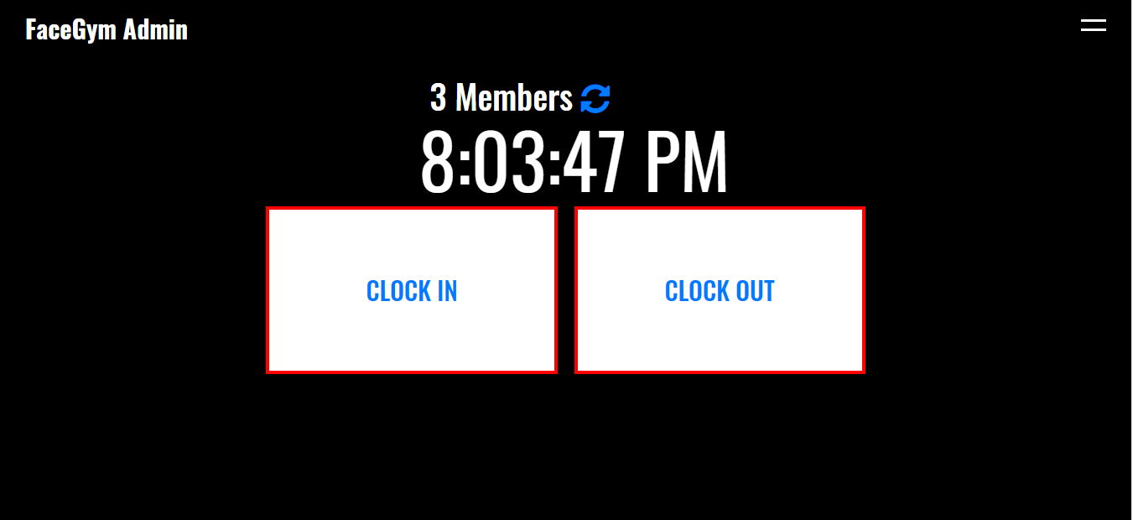

Figure . Interface of the admin homepage

According to the Figure 4.3.43 above, it showed the interface of the admin homepage when the admin logged in. The admin homepage showed the real time members, the real time clock and the function of clock in & clock out to let the members to clock in or clock out.

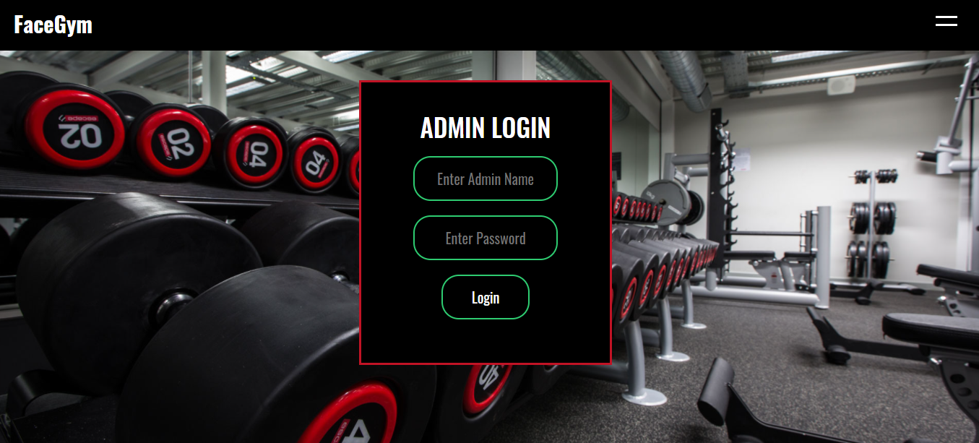

Figure . Interface of the admin login webpage

According to the Figure 4.3.44 above, it will redirect the admin to the admin login webpage if the admin not logged in and entering to the admin homepage.

### Admin Dashboard

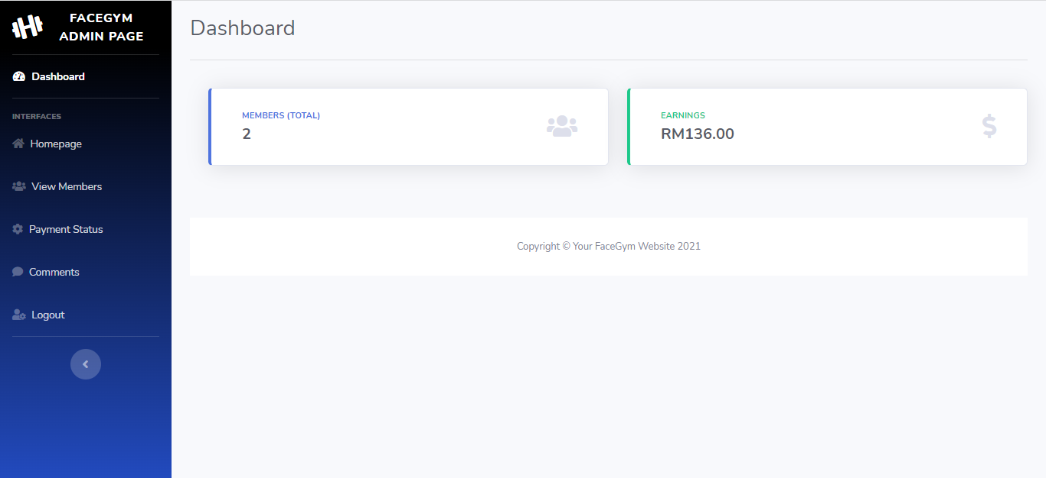

Figure . Interface of the admin dashboard

According to the Figure 4.3.45 above, it showed the interface of the admin dashboard successfully after the admin logged in. It showed the total members in the gym and the total revenue in the gym.

### Admin other interfaces

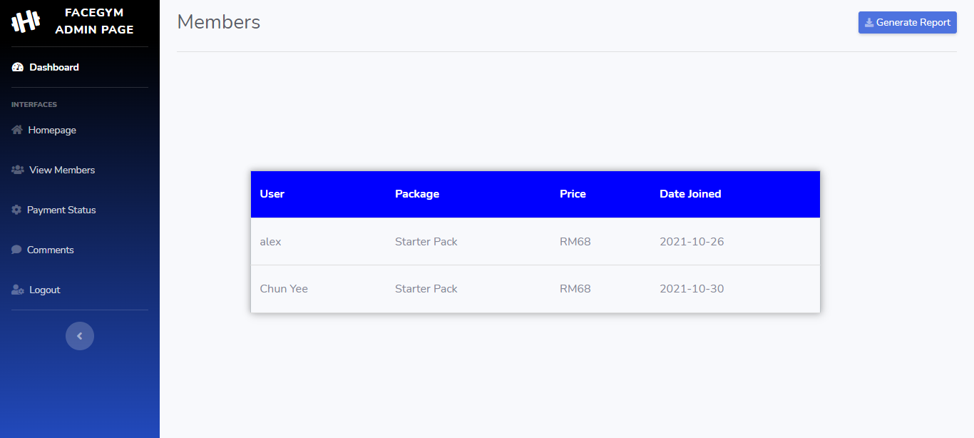

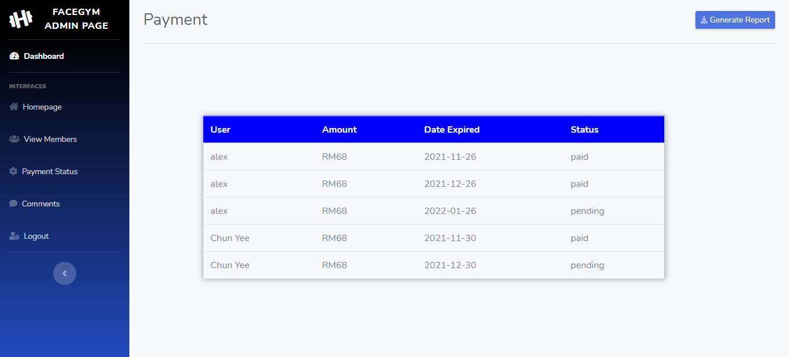 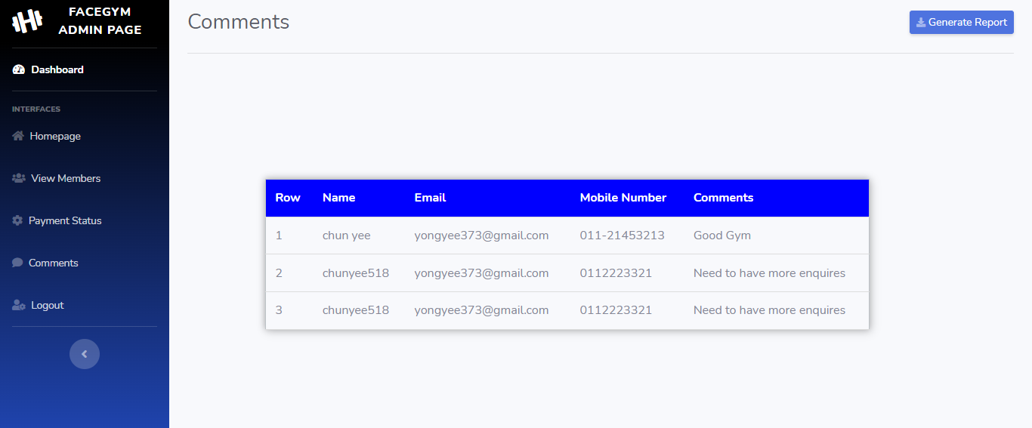

Figure . Interface of the admin other interfaces

According to the Figure 4.3.46 above, it showed the interfaces of the view members, payment status and view comments interfaces successfully after the admin logged in successfully.

# 

# Discussion

In this section, the discussion will discuss the achievement in the project, the limitation, and the future enhancement in the project. The discussion will be conducted after the development and the testing are completed.

## Achievement

In this section, the achievement is discussing the achievement gained throughout the whole progress in the project which consumed about six months. The project is developed based on the objectives stated in the project definition phase. The first objective of the project is “*To develop a system that able to capture the clock in and out of the member through facial recognition*”, the members in the gym center can clock in and clock out through face recognition. The research for the algorithms for face detection and face recognition is conducted at the research phase. After the research phase, it used the library of OpenCV, dlib, and the face_recognition in the development phase. In the face detection of the face images, it used face_recognition.face_locations to detect the location of the face in the images after the images were converted to grey color using the HOG algorithm. It will then encode the detected faces in the images into 128 measurements generated by the neural net. After that in the live webcam feed, it detects the face in front of the webcam with the face_recognition.face_locations to detect the location of the member instead of using the haar cascade to detect faces. After detecting the face in front of the webcam, it will encode the faces into 128 measurements and then compare the measurements with the encoded face images stored in the path folder. It will recognize the face successfully when there have the closest measurements in the face measurements. The data will then be inserted into the CSV files, the data also used to show the real-time members in the gym.

The second objective is “*To develop a system that allows admin to generate reports such as sales reports and member reports*”. To achieve this objective, it needed to retrieve the data from the tables in the database. The tables retrieved are the payment_status and the members_joined which are storing the data of sales and members. After retrieving the tables successfully, it generated the reports into the PDF format to view the reports on any platform such as computer or smartphone easily without using any paperwork.

The third objective is “*To develop a web-based gym management system that allows the automation of gym management instead of paper-based*”. On the user side, it needed to develop the sign-up, login webpage for the users to become the users of the gym on the website, it also needed to develop top-up, membership, and checkout webpages to let the logged users join as the members of the gym through online easily instead of paper-based. The members can join the membership through the website instead of filling in the information on the paper provided by the gym center, it will have the risk of losing the information of the gym member with paperwork due to human error. The members also can top up their wallets to pay for the membership fees through the website instead of paying cash to the gym center, it may reduce the risk of the members losing the cash. On the admin side, it needed to develop the admin dashboard webpage to show the total members and the revenue, it will automatically show the updated total members and revenue after there is a new member and the revenue in the gym. It will reduce the trouble of calculating the amount of the members and revenue manually which will cause a lot of times. To view the total members and the revenue, it counted the total members and summed the total revenue in the table of the members_joined.

## Limitation

After the objectives of the project had been developed completely, there is a limitation in the project development for the project. The first limitation in this project does not have an actual payment gateway process that connects with the actual bank system or the e-wallet system such as Touch and Go, the data filling in the checkout page is just dummy data, the top-up system is requiring the user’s password before topping up the wallet.

Besides that, the limitation in this project the data of the token is unable to send to the user’s email when the user is forgetting the password. The database can show tokens randomly when the user inserted the email in the forgot password webpage. The user can change the password successfully in the reset password webpage through the data of the token easily. However, it failed to send token information to the email of the user, it was only able to reset the password through the manual way. The third limitation in this project is the face image of the user stored in the specific folder for comparing purposes. It will affect the accuracy of the face recognition when the two face images are taken under a similar environment, it will result in it might recognize the person’s face with the other person’s face. Besides that, it sometimes will not detect the face of the person in front of the webcam when the light is shining on the person’s face and it will not recognize the person although the person’s face is already existed in the specific folder storing the image faces, the person also can use the other person’s face image to perform the face recognition function without the real person available in front of the webcam. The people can insert the image of the side face, other people's face, the blurred image of the front face into the specific folder which will influence the face recognition.

Moreover, the project only can run through the localhost server and it is not able to deploy to the real server for the people to use and experience the gym website. The FaceGym requires WIFI to run the website to perform all the functions provided such as clock in and clock out with face recognition, member checkout, member login or sign up and others are very relying on the internet connection, it may not work when there does not have the internet connection. The last limitation in this project is the touch on the screen. As mentioned above, it mentioned that it can let the members clock in and clock out with face recognition without touching. However, it needs to click on the clock in or clock out button to perform the functions which required hand touching on the screen, which is one of the challenges in this project.

## Future Enhancement

In this section, the future enhancement will be conducted and discussed. The limitations in this project are the ideal way to provide ideas for future enhancement for the project. The first future enhancement is the actual payment gateway, the checkout or top-up can connect with the actual banking system or e-wallet system. With the actual banking system, it will enhance the convenience of the users when they are making payments on the FaceGym website.

Besides that, the token can be sent to the inbox of the user’s email. The reason why it needed to send to the email of the user is due to the privacy issue, it may let the other users reset the password and log in as the user on the website. To prevent the problem, sending the token to the email needed to be completed in the future. The third future enhancement in this project is improving the accuracy of the face recognition, it can be enhanced by using a high-quality webcam or using other algorithms which prevent the person’s face from being recognized as another person’s face and also not detecting the face of the person when the light shining on the face of the person. Using the face image of the person without the real-time person in front of the webcam on the spot can be improved by implementing the iris function into the face recognition function, it can detect the face of the person when it detected the iris of the person in front of the webcam. For the images stored in the specific folder, it will determine the image inserted by the member and it will require the member to insert a clearer front face image again in the checkout webpage when the image inserted is not passed.

The website will also deploy to the real server to let the users use and experience the gym website in the future. For the touching problem when performing the clock in and clock out functions, it can be improved by implementing the hand gestures into it. The member-only needs to perform some specific hand gesture action and it will redirect the member to the clock in or clock out webpage easily without any touching. As such improvement, it may enhance the experience of the users and encourage the users to use the website and join as members of the gym to increase the revenue of the gym.

# 

# Reflection

In this section, the reflection will be conducted and discussed after all the development of the FaceGym website. This section will include the strengths, issues countered, and the weakness met during the development and implementation of the project.

## Strength in development

In this section, the strength of the project will be discussed. Before starting the research of the project, I already have the basic knowledge in website development which I learned from the previous semester Developing the Modern Web 1. After that, I decided to do the research and development which is relevant to website development. In this project, the first objective is letting the members clock in or clock out with face recognition. The face recognition needed the knowledge of Artificial Intelligence which I have never learned before. To achieve this objective, I spend more time focusing on face recognition researches and the way to implement it on the FaceGym website. During the development, it spent the most time in the development of face recognition. Besides that, the other features and functions are developed just in time through the schedule I planned with the more attractive and responsive interface design for the users to have a good experience when using the FaceGym website.

## Issues countered and solution

In this section, the issues countered and solutions in the project will be discussed. During the proposal of the project during the first stage, I proposed the web-based gym system to reduce the paperwork and provide automation to bring convenience to the people. However, the proposal got rejected because the proposal did not fill the degree level, I was told that this kind of development already existed in the market, I also was told that I need to implement a new feature that does not exist in the market or propose need system to convince the supervisors. To fill the degree level, I proposed that to implement the face recognition feature in the web-based system to let the members clock in or clock out with the face recognition easily and the proposal got approved during the proposal defense.

The project itself took two semesters which consumed six months period to complete the whole project. I had faced the issue of time management to arrange the tasks to be completed on time because there are few subjects taken during the two semesters which are consisted of huge processes in each of the subjects. To solve the issue, I scheduled the timetable to finish the tasks before that date, I also scheduled that for other subjects. The schedule made me able to finish all the tasks on time successfully.

During the development phase of the project, I countered the problem of using the Flask framework because I only have the basic knowledge of website development and I never learned the Flask framework before. To solve this problem, I learned the basic knowledge online for almost 1 month to understand the basic knowledge of the framework. Besides that, I also countered the problem of implementing which algorithms into the face recognition in the project. To solve the problem, I searched for some solutions online and I ended up using the library embedded in Python which has an accuracy of 99.38%. I followed the tutorial provided online and I also modified the code to ensure the member’s name and time were inserted into the CSV file and deleted from the CSV file.

## Weakness and self-improvement

In this section, the weakness and the self-improvement in the project will be discussed. Although I had learned the basic knowledge of the process of face recognition, I still lacked deep knowledge of the process running during the background. To improve this weakness, I planned to understand the knowledge deep through the articles and the journals online, I also planned to have a conversation with the programmers who are experts in this field to get the knowledge from them. Besides that, my FaceGym website still consists of a lot of bugs that needed to test frequently to detect the problems and reduce the bugs because there is impossible bug-free in the project based on the research (Harvey, 2013).

Besides that, I have the weakness of uploading the codes frequently on GitHub every time the tasks I completed. GitHub includes the issue tracker to let the developers include the documentation through the project development. To improve the weakness, I need to learn and upload the code I completed when the tasks are completed, it will ensure the code will not disappear from the GitHub repository.

# 

# Conclusion

To conclude the project, the project aims to provide the members to clock in or clock out with face recognition, it also aims to generate the reports into the PDF format to view the report of the gym easily. Besides that, it aims to automate without using paperwork which almost all the actions can be done through the FaceGym website.

Finally, the project is successfully developed based on the objectives proposed. The project lets me learn a lot of new knowledge which is very priceless and valuable in the future. However, there are some bad habits to change and improve because nobody is perfect in this world, all of us need to learn from the mistakes and improve ourselves through the mistakes. I was satisfied and enjoyed the whole journey of the project.

# References

Abdullah, N. A., 2017. Face Recognition for Criminal Identification: An implementation of principal component analysis for face. p. 7.

ABUZNEID, M. A., 2018. Enhanced Human Face Recognition Using LBPH Descriptor, Multi-KNN, and Back-Propagation Neural Network. Volume 6, p. 11.

Ahmed, A., 2018. LBPH Based Improved Face Recognition At Low Resolution. p. 4.

AL-Allaf, O. N. A., 2014. REVIEW OF FACE DETECTION SYSTEMS BASED ARTIFICIAL NEURAL NETWORKS ALGORITHMS. Volume 6, p. 17.

Alto, V., 2019. *medium.* [Online]   
Available at: https://medium.com/dataseries/face-recognition-with-opencv-haar-cascade-a289b6ff042a  
[Accessed 15 6 2021].

analysticsinsight, 2019. *analysticsinsight.* [Online]   
Available at: analysticsinsight  
[Accessed 15 5 2021].

Anggo, M., 2018. Face Recognition Using Fisherface Method. p. 10.

Anon., 2019. COMPARISON BETWEEN PHYSIOLOGICAL AND BEHAVIORAL. *SOUTHWEST JIAOTONG UNIVERSITY,* 54(6), p. 9.

Bajaj, S., 2020. *Swiftlane.* [Online]   
Available at: https://www.swiftlane.com/blog/face-recognition-door-access-control/#:~:text=Facial%20Recognition%20Access%20Control&text=Along%20with%20other%20benefits%2C%20face,entry%20using%20the%20person's%20face.  
[Accessed 6 6 2021].

Behera, G. S., 2020. *Towardsdatascience.* [Online]   
Available at: https://towardsdatascience.com/face-detection-with-haar-cascade-727f68dafd08  
[Accessed 15 6 2021].

Bell, A. S., 2012. Job Stress, Wellbeing, Work-Life Balance and Work-Life Conflict Among Australian Academics. pp. 25-37.

Blocken, B., 2020. Can indoor sports centers be allowed to re-open during the COVID-19 pandemic based on a certificate of equivalence?. p. 9.

Chinimilli, B. T., 2020. Face Recognition based Attendance System usingHaar Cascade and Local Binary Pattern HistogramAlgorithm. p. 4.

Deeba, F., 2019. LBPH-based Enhanced Real-Time Face Recognition. Volume 10, p. 7.

deepvisionai, 2021. *deepvisionai.* [Online]   
Available at: https://www.deepvisionai.com/smart-city  
[Accessed 15 5 2021].

Desk, A. N., 2019. Top 10 Countries and Cities by Number of CCTV Cameras. *aithority,* p. 1.

docs-opencv, 2021. *docs-opencv.* [Online]   
Available at: https://docs.opencv.org/master/d0/de3/tutorial_py_intro.html  
[Accessed 21 6 2021].

flask, 2021. *flask.* [Online]   
Available at: https://flask.palletsprojects.com/en/0.12.x/license/#:~:text=Flask%20is%20licensed%20under%20a,and%20the%20disclaimer%20is%20present.  
[Accessed 25 6 2021].

gcfglobal, 2021. *gcfglobal.* [Online]   
Available at: https://edu.gcfglobal.org/en/internetbasics/what-can-you-do-online/1/  
[Accessed 13 5 2021].

GeeksforGeeks, 2021 . *GeeksforGeeks.* [Online]   
Available at: https://www.geeksforgeeks.org/opencv-overview/  
[Accessed 21 6 2021].

Gill, N. S., 2018. *xenonstack.* [Online]   
Available at: https://www.xenonstack.com/insights/what-is-unit-testing  
[Accessed 27 10 2021].

Harvey, R., 2013. *StackExchange.* [Online]   
Available at: https://softwareengineering.stackexchange.com/questions/195571/is-it-possible-to-reach-absolute-zero-bug-state-for-large-scale-software

Hudson, M., 2020. *thebalancesmb.* [Online]   
Available at: https://www.thebalancesmb.com/retail-marketing-terms-2890015  
[Accessed 20 5 2021].

Idiap, 2021. *Idiap.* [Online]   
Available at: https://www.idiap.ch/~marcel/labs/faceverif.php

Incredibuild, 2021. *Incredibuild.* [Online]   
Available at: https://www.incredibuild.com/integrations/visual-studio  
[Accessed 19 6 2021].

Jackson, 2013. The Role of Exercise in Stress Management. 17(3), pp. 14-19.

Jangir, B. K., 2018. Facial Recognition System. p. 5.

Kak, S. F., 2018. A Review of Person Recognition Based on Face Model. *A Review of Person Recognition Based on Face Model,* 4(1), p. 13.

Kashyap, S., 2021. *proofhub.* [Online]   
Available at: https://www.proofhub.com/articles/agile-team  
[Accessed 12 5 2021].

Kortli, Y., 2019. Face Recognition Systems: A Survey. 20(342), p. 36.

Lal, M., 2018. Study of Face Recognition Techniques: A Survey. 9(6), p. 8.

Lin, S.-H., 2000. An Introduction to Face Recognition Technology. *Informing Science Special Issue on Multimedia Information Technologies,* Volume 3, p. 7.

Li, Y., 2021. Evaluating the Performance of Eigenface, Fisherface, and Local Binary Pattern Histogram-Based Facial Recognition Methods nder Various Weather Conditions. Volume 9, p. 12.

L, S. S., 2018. Real Time Face Recognition of Human Faces by using LBPH and Viola. Volume 6, p. 5.

MANCHESTER, P. W. D., 2021. *pumpkinwebdesign.* [Online]   
Available at: https://www.pumpkinwebdesign.com/web-design-manchester/the-importance-of-alignment-in-web-design/#:~:text=This%20will%20ensure%3A,the%20rest%20of%20the%20page  
[Accessed 26 5 2021].

Melo, S., 2019. *mydatascope.* [Online]   
Available at: https://mydatascope.com/blog/en/8-disadvantages-of-paper-document-management-system/  
[Accessed 11 5 2021].

Mishra, P., 2019. *timesofindia.* [Online]   
Available at: https://timesofindia.indiatimes.com/readersblog/beingprak/hectic-lifestyle-leading-people-to-stress-and-hypertension-5480/  
[Accessed 11 5 2021].

Myers, J., 2003. Exercise and Cardiovascular Health. 107(1,7), p. 5.

Nkosi, M., 2020. Causes and Impact of Human Error. p. 9.

Nolan, S., 2021. *streamlinetelecom.* [Online]   
Available at: https://www.streamlinetelecom.com/uncategorized/two-high-profile-crimes-solved-with-help-from-security-camera-footage/  
[Accessed 6 6 2021].

Orman, Z., 2011. A STUDY ON FACE, EYE DETECTION AND GAZE. Volume 2, p. 18.

palletsprojects, 2021. *palletsprojects.* [Online]   
Available at: https://palletsprojects.com/p/flask/  
[Accessed 25 6 2021].

Parmar, D. N., 2014. Face Recognition Methods & Applications. Volume 4, p. 4.

phpMyAdmin, 2021. *phpMyAdmin.* [Online]   
Available at: https://www.phpmyadmin.net/  
[Accessed 24 6 2021].

PISSARENKO, D., 2002. Eigenface-based facial recognition. p. 6.

PyCharm, 2021. *jetbrains.* [Online]   
Available at: https://www.jetbrains.com/pycharm/

Research, C. E., 2021. *CNN.* [Online]   
Available at: https://edition.cnn.com/2013/06/03/us/boston-marathon-terror-attack-fast-facts/index.html  
[Accessed 6 6 2021].

Saez-Trigueros, D., 2018. Face Recognition: From Traditional to Deep Learning Methods. *ArXiv,* Volume abs/1811.00116, p. 13.

Sareen, S., 2018. *Medium.* [Online]   
Available at: https://medium.com/@shivangisareen/flasks-in-python-213487534017  
[Accessed 25 6 2021].

Selvi.R, S., 2019. Face Recognition Using Haar - Cascade Classifier for Criminal Identification. 7(685), p. 6.

Sharma, L., 2021. *toolsqa.* [Online]   
Available at: https://www.toolsqa.com/software-testing/istqb/why-is-testing-necessary/#:~:text=The%20testing%20is%20important%20since,and%20high%2Dperformance%20software%20operation.  
[Accessed 27 10 2021].

SiteGround, 2021. *SiteGround.* [Online]   
Available at: https://www.siteground.com/tutorials/phpmyadmin/  
[Accessed 24 6 2021].

SiteGround, 2021. *SiteGround.* [Online]   
Available at: https://www.siteground.com/tutorials/phpmyadmin/features/  
[Accessed 24 6 2021].

softwaresuggest, 2021. *softwaresuggest.* [Online]   
Available at: https://www.softwaresuggest.com/us/deep-vision-ai  
[Accessed 15 5 2021].

Staff, H., 2020. *uofmhealth.* [Online]   
Available at: https://www.uofmhealth.org/health-library/hw114892#:~:text=Physical%20activity%20is%20one%20of,heart%20attack%20or%20a%20stroke.  
[Accessed 11 5 2021].

studio1design, 2021. *studio1design.* [Online]   
Available at: https://studio1design.com/how-important-is-color-in-website-design/  
[Accessed 26 5 2021].

Tillman, M., 2021. *pocket-lint.* [Online]   
Available at: https://www.pocket-lint.com/phones/news/apple/142207-what-is-apple-face-id-and-how-does-it-work  
[Accessed 6 6 2021].

Tolba, A., 2005. Face Recognition : A Literature Review. Volume 2, p. 17.

tutorialspoint, 2021. *tutorialspoint.* [Online]   
Available at: https://www.tutorialspoint.com/sdlc/sdlc_waterfall_model.htm  
[Accessed 12 5 2021].

Visualstudio, 2021. *Visualstudio.* [Online]   
Available at: https://code.visualstudio.com/docs/editor/intellisense  
[Accessed 19 6 2021].

Wójcik, W., 2016. Face Recognition: Issues, Methods and Alternative. p. 23.

Yashwant, 2021. *OpenGenus.* [Online]   
Available at: https://iq.opengenus.org/face-recognition-using-fisherfaces/  
[Accessed 12 6 2021].

Yeong, Y. K., 2020. *straitstimes.* [Online]   
Available at: https://www.straitstimes.com/forum/forum-hard-to-book-a-slot-at-activesg-gyms

# Appendix

Github Link : <https://github.com/p19011257/FaceRecognitionProjects>

SafeAssign Originality Report

